Grade 10 Biology Review

Part A Cell Diagrams

- a) Label the parts of the plant cell

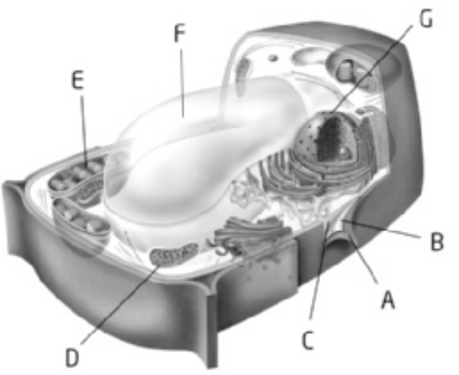

b) label the parts of the animal cell

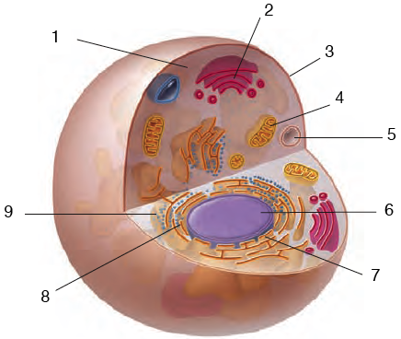

Part B Matching
Match the description in column a with a term in column B. Write the letter of the response in the blank on the left. (1 mark each)

Column A Column B

_____1. Manufactures ribosome parts, RNA. A. cell membrane
_____2. Structure that forms the outer boundary of B. nucleolus
an animal cell. C. mitochondria
_____3. Not found in animal cells. D. ribosome
_____4. Site of protein synthesis. E. organelles
_____5. Special structures in the cell that perform F. cell wall
specific functions. G. nuclear membrane
H. nucleus

Part C Fill in the Blanks
Complete the following table by filling in the correct cell part or function.
Cell Part | Function
 | Gel-like material inside cells
 | Directs cell activities
Endoplasmic Reticulum
 | Manufactures proteins
 | Produces ATP energy
Chromatin
Chloroplast
 | Stores water, food, and waste
Golgi body
 | Digests wastes
Part D Plant cells vs. Animal Cells
1. State the cell theory.

2. What structures can you find in plants that you cannot find in animals?
Plants only | Animals only

Part E Mitosis:
- label the phases of mitosis
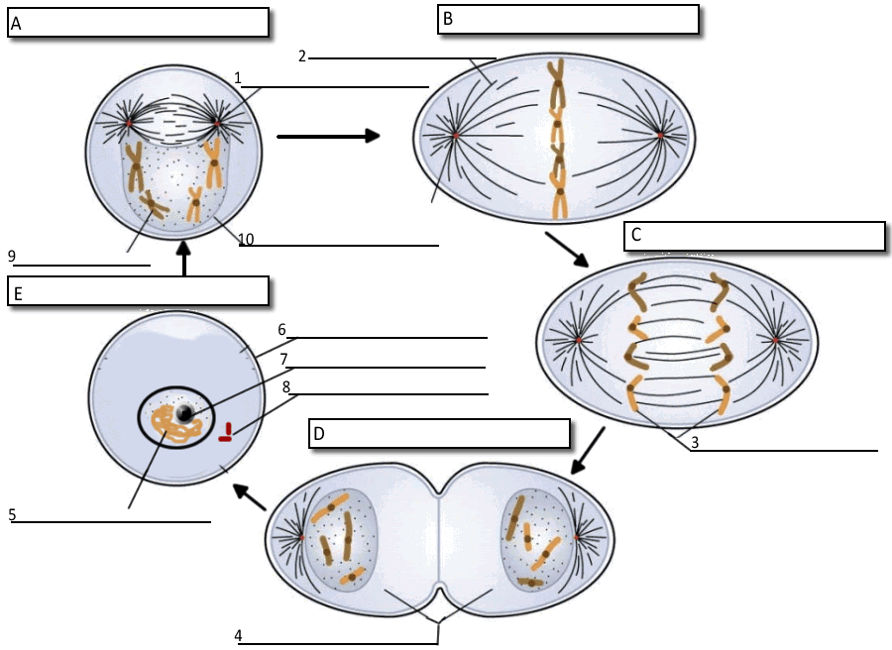
2. What happens during each phase?
Phase | Description of what happens
Interphase
Prophase
Metaphase
Anaphase
Telophase

- Why do cells divide?

- How is cytokinesis in animal cells different from cytokinesis in plant cells?

- How do DNA, chromosomes, genes and protein relate to each other?

- What causes a mutation in DNA?

- What is a tumour?

- What is cancer?

Part F. Label the diagram of the leaf. Describe the function of each part.
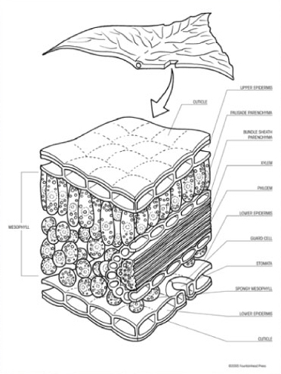

- Where is meristem found in plants?

- What kinds of tissue can a meristem cell become?

- Why do lateral buds not grow until the apical meristem is removed?

- Draw a plant. Label the four organs of the plant.

- Explain the difference between fibrous roots and tap roots.

- Explain the process of transpiration

- What enters and exits through the stomata?

- What do guard cells do?

- What is photosynthesis? Where does photosynthesis occur?

- What happens to a leaf when you turn out the lights?

- What is diffusion? Explain why water enters a root and leaves a leaf?

- a) Where does sugar travel in the plant? What forms of sugar are involved when sugar is made in the leaves, traveling in the stems, and stored in the roots?

b) Where does water travel in the plant?

13. What is a plant gall?

Part G: Cells, Tissues, Organs and Organ Systems
- Arrange the following terms in order from least complex to most complex:
ORGAN, TISSUE, CELL, ORGAN SYSTEM
- What are the four major types of animal tissues? Give some examples of each type.
Type | Examples
3. What is a stem cell?

4. What kinds of medical imaging technology are used to explore the human body?

5. What factors influence cell specialization in animals?
Digestion: Match the function with the part
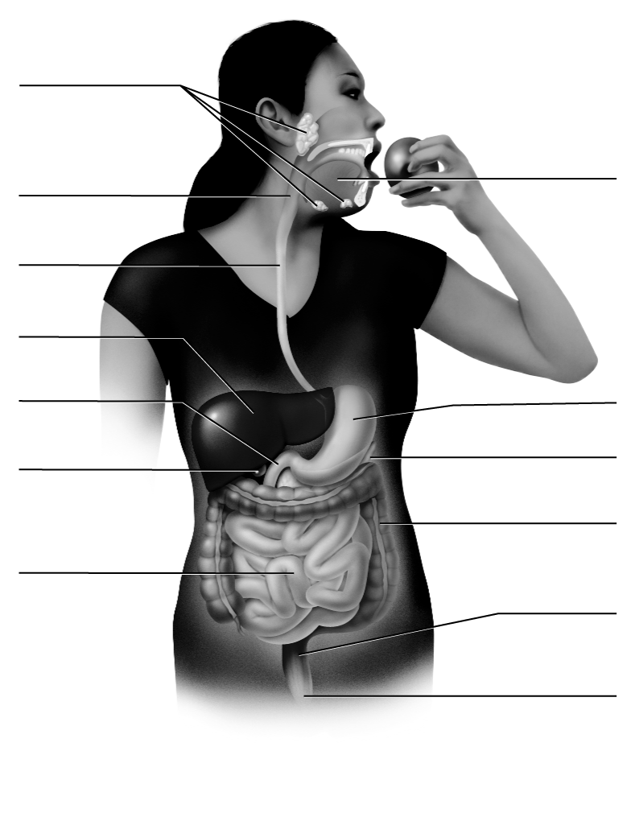
Word list: esophagus, rectum, anus, K, villi, mouth, stomach, large intestine, bile, salivary glands, small intestine, pancreas

Digestion begins in the __________. Teeth chew the food, saliva wets the food and the __________________ secrete salivary amylase to begin the digestion of carbohydrates.

Food travels down the ________________ into the J-shaped ___________ where the following happens:
- Churning
- Acid and pepsin work to digest protein

Next, food passes into the __________________ where digestion of protein, carbohydrate, and fats occurs. Food is absorbed. Tiny _________ increase the surface area for absorption.

Three organs secrete substances for digestion. The liver makes digestive enzymes and _________ which is stored in and released from the gall bladder. The ____________ also releases digestive enzymes into the small intestine.

The food passes into the colon or _________________ next. Here the water is absorbed. Vitamin ____ is produced.

Lastly, waste is stored in the ________________ and passed out the hole called the _______________.

6. Structure of the Heart: Label the following parts of the human heart on the diagram below

- aorta
- left atrium
- right ventricle
- pulmonary vein (from lung)
- pulmonary artery (to lung)
- right atrium
- left ventricle
- vena cava

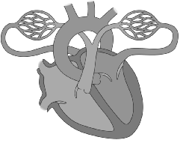

7. Human Circulatory System: Starting from and ending with the right atrium, trace the flow of blood through the heart and body by numbering the following in the correct order.

- ____ right atrium
- ____ left atrium
- ____ pulmonary artery
- ____ vena cava
- ____ aorta
- ____ lungs
- ____ right ventricle
- ____ left ventricle
- ____ body cells
- ____ pulmonary veins

For questions 1-3, fill in the name of the blood vessel.

____________ 1. vessels which carry blood away from the heart.

____________ 2. vessels which carry blood toward the heart.

____________ 3. tiny blood vessels with walls that are only one-cell thick.

For questions 4-5, fill in the letter of the part.

____ 4. upper chambers of the heart that receive blood.
____ 5. lower chambers that pump blood out of the heart.
____ 6. the only artery in the body rich in carbon dioxide
____ 7. the only vein in the body rich in oxygen

8. Label the figure correctly with the words from the list below.
Choices: lung, diaphragm, trachea, bronchus, bronchiole, alveoli, larynx, nasal cavity.

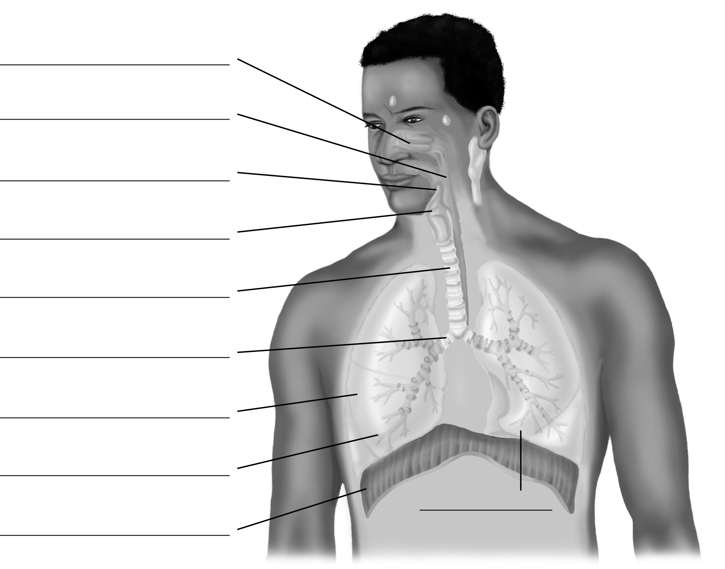

10. Describe the function of each organ system:
a) circulatory system:

b) endocrine system:

c) nervous system:

e) urinary system:

f) digestive system:

g) respiratory system:

11. a) How does the human digestive system cooperate with the circulatory system?

b) How does the human respiratory system cooperate with the circulatory system?

