Testing Plant Variables in a Lab and Infographic RST

In this investigation, you will be testing one variable that can affect the growth of your plant:
- pH - soapy water, water, vinegar/water
- Water - How much? 15mL,30mL and 45mL Water Mon, Wed and Frid.
- Light/dark - Total darkness? Full time light? Day and Night?
- You and a partner will be growing corn seeds.

- Once growth occurs:
  - Choose a factor to test (a-c above): one pot is your control pot and one is your test pot.
    - Example: water – control pot is watered regularly 20mL and test pot is +/- 10mL
  - Check & record the height of plants for 14 days in a table and make qualitative observations.
  - Once completed place plants in garbage and soil back in container.
  - Collect all class data – 1 table for each of the 3 variables. Make a graph of class data for each variable.
- In pairs complete one printed lab report including:
  - Problem
  - Hypothesis
  - Material list
  - Procedure from the start (planting seed day)
  - Observations: Class data only
    - 3 tables with titles, full format.
    - 3 graphs of day vs average growth, with title, full format.
- Next you must produce an infographic using your lab information but only show:
  - Problem: Same statement as in report.
  - Introduction: Research what plants need to grow as it relates to this experiment. You should include at least one fully formatted picture or graphic. Don’t forget to use all references.
  - Analysis:
    - Conclusions: What did you learn from the data in this experiment about how these factors affect plant growth?
    - Discussion: Design a greenhouse we could use on any planet other than Earth or Mars to grow plants for a long term mission. Explain 5 design features that cope with the challenges of life on this planet.
  - References. Proper APA format and use.
Example of an infographic:
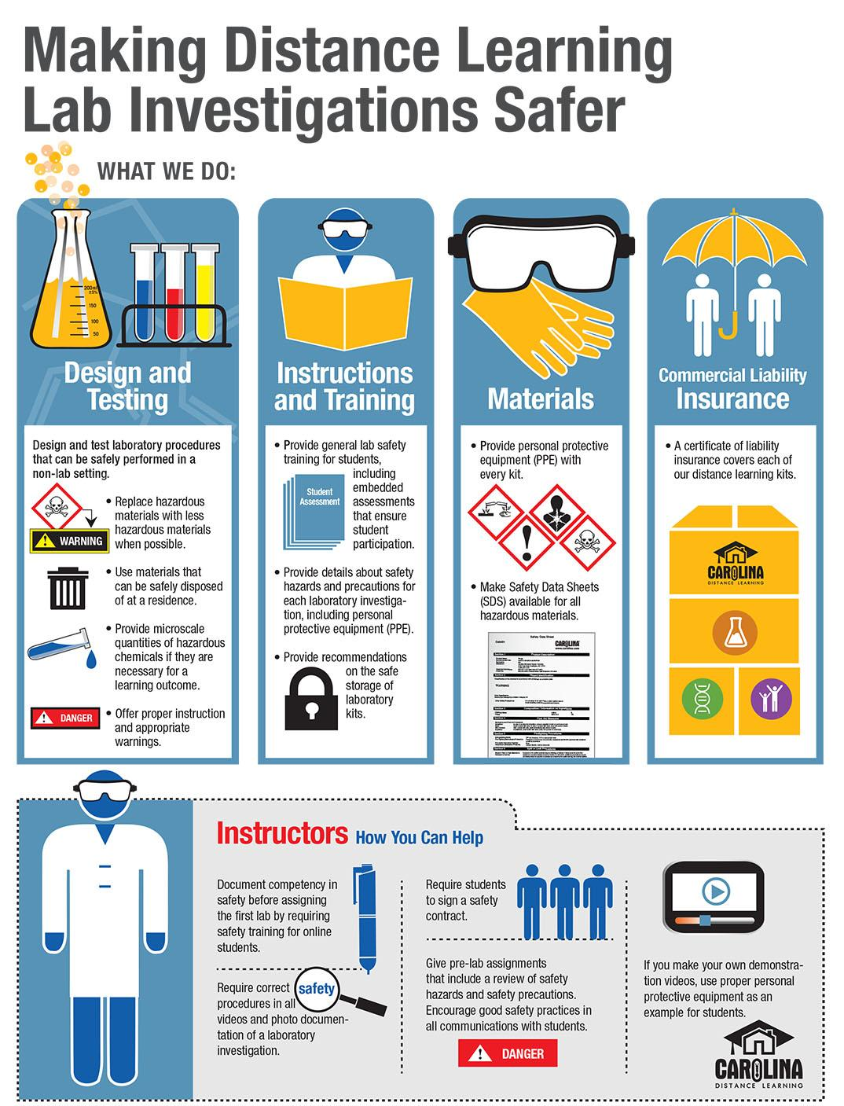

<iframe src="https://player.vimeo.com/video/25328216" width="500" height="375" frameborder="0" webkitallowfullscreen mozallowfullscreen allowfullscreen></iframe>

Rubric for infographic/media and the lab the rubric on hapara will be used
Components | Level 4
Topic/Content | - Topic allows viewers to understand what information will be conveyed  - An illustration is used to describe and summarize how the product uses concepts learned throughout the optics unit  - Lab variable is clearly and correctly demonstrated  - Marketing angle is clever and appropriate for the demographic  - Lab test confirm variable results are realistic and its uses are realistic
Appearance | - Font sizing is appropriate and clear  - Infographic is neat and easy to read (legible, spacing)  - Info on 11x17 paper

