SBI 3U STEM STRUCTURE Name: ________________

Stems are more interesting than you think. Asparagus is a stem, and cinnamon comes from the bark of a tree. One of the main ingredients of chewing gum also comes from the trunk of a tree!

A stem is the connection between roots and leaves. Stems grow above ground, supporting and elevating leaves, flowers and often fruit. They can store nutrients for the plant and contain vascular tissue for transport of food and water.

The only cells that divide are at the shoot and root apical meristems; all other cells just elongate (get longer).

VASCULAR TISSUE
XYLEM | PHLOEM
*carries water _____________ through a process called transpiration  *cells are generally larger  *dead tissue | *carries __________ from leaves to other parts of plant through a process called translocation  *cells are smaller  *living tissue

Monocot | Dicot
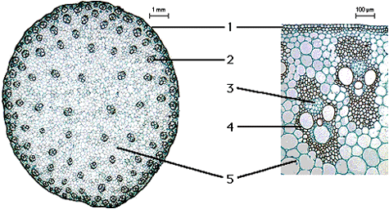  A monocot vascular bundle looks like a ___________.  d | 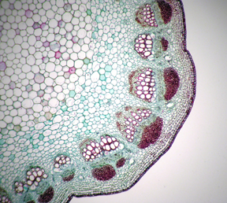  cortex: storage & photosynthesis  b  c  e  f  a  pith: support  b, c, d together is called a ________________
Woody Stems
- trees, some shrubs
- involves secondary growth

Herbaceous Stems
- green and fairly bendable
- usually die to their roots over the winter
- primary growth only

- Label the cross-section of a typical woody stem on the back of this sheet.

As stems become larger, a new meristemic region called the vascular cambium forms, which separates xylem from phloem. Secondary xylem grows to the inside of the vascular cambium, and secondary phloem to the outside, thus, increasing the width of the plant. At the end of each growing season, the vascular cambium stops growing, this produces a growth ring.

In the spring, lots of xylem is produced. The cells are larger and the wood is less dense. In the fall, fewer and smaller xylem is produced, and the wood is very dense (this is what we see as a ring).
Cork and bark provide protection to the stem: bark being the outermost layer. Bark is made of dead cork cells.

Typical Woody Stem
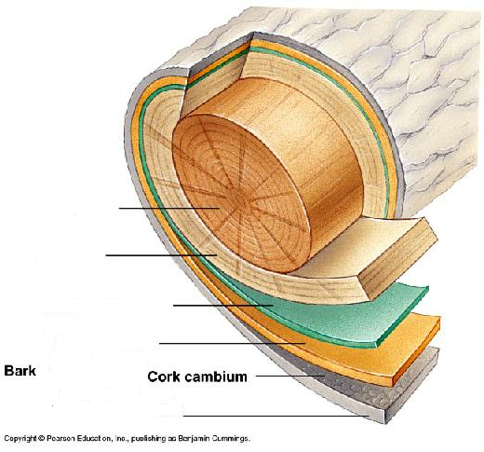

Use page 518-522 to answer the following:

a) What type of tissue is sapwood composed of and what is its purpose?

b) What type of tissue is heartwood composed of, how is it formed and what is its purpose?

c) What is the difference between summer and spring wood?

