SBI 3U Monocot and Eudicot Plants and Seeds Name: _____________________

Date: ______________________
Review:Organizing Living Organisms:
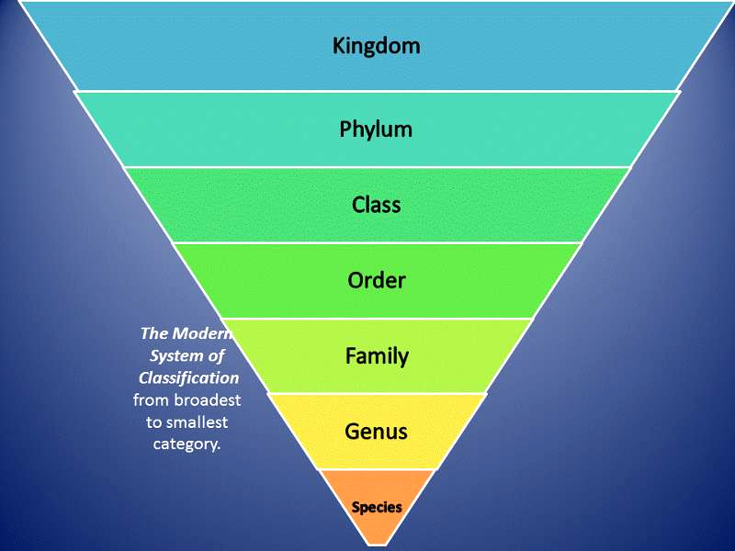
Each group has the characteristics of the level above it, but has some distinguishing features.
- The further down the scale you go, the more minor the differences become, until you end up with a classification which applies to only one plant.

VASCULAR PLANTS:
- have vascular vessels to transport water and food
- examples: flowers, trees
NON-VASCULAR PLANTS:
- small, simple plants without a vascular system
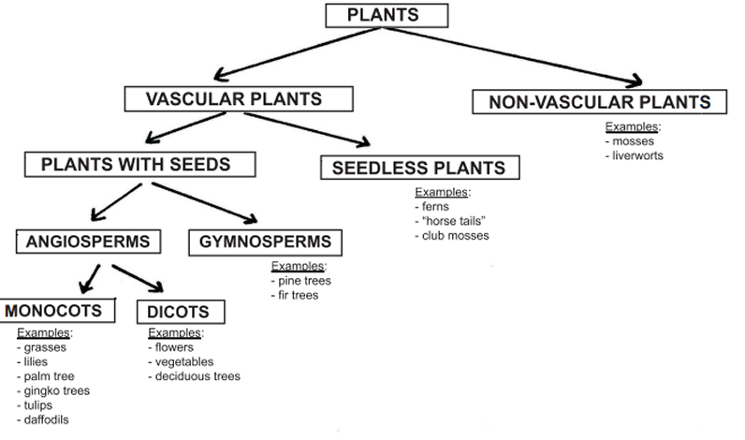
- cannot transport food or water very far
- lack roots, have rhizoids (small hairs that keep the plant in place)
- commonly found in moist environments
- reproduce sexually by creating single-celled spores or asexually by vegetative propagation
- examples: mosses, liverworts

PLANTS WITH SEEDS:
- allow plants to reproduce sexually without needing water and provide protection
- appeared about 280 million years ago
- climate colder and drier so spore producing plants could not survive the drought and freezing so they became extinct
- divided into 2 groups - angiosperms and gymnosperms

SEEDLESS PLANTS:
- do not produce seeds, are dispersed by windblown spores or by water
- formed first forests 350 million years
- examples: ferns, whisk ferns, club mosses, and horsetails.

Angiosperms | Gymnosperms
- Flower producing plants  - Mature seed is surrounded by the ovule (e.g. apple).  - Group is often referred to as hardwoods.  - Trees have broad leaves that usually change color and die every autumn | - Plants which DO NOT produce flowers  - Seeds are not enclosed in an ovule (e.g.pine cone).  - Group referred to as softwoods.  - Usually have needles that stay green throughout the year

CHARACTERISTICS OF MONOCOTS AND DICOTS
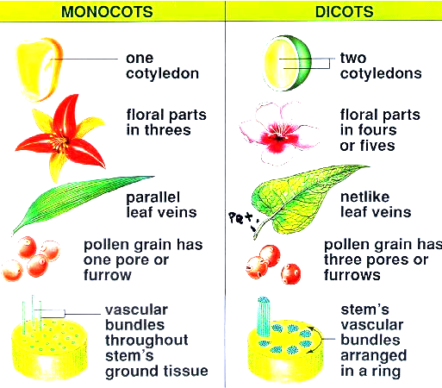

CHARACTERISTIC | MONOCOTS | DICOTS
VASCULAR TISSUE | SCATTERED | ARRANGED IN RING
ROOTS | FIBROUS | TAPROOT
POLLEN GRAIN | 1 OPENING | 3 OPENINGS
FLOWER PETALS | MULTIPLES OF 3 | GROUPS OF 4 OR 5
COTYLEDONS | 1 | 2
LEAF VENATION | PARALLEL | NET-LIKE

MONOCOT AND DICOT SEEDS:
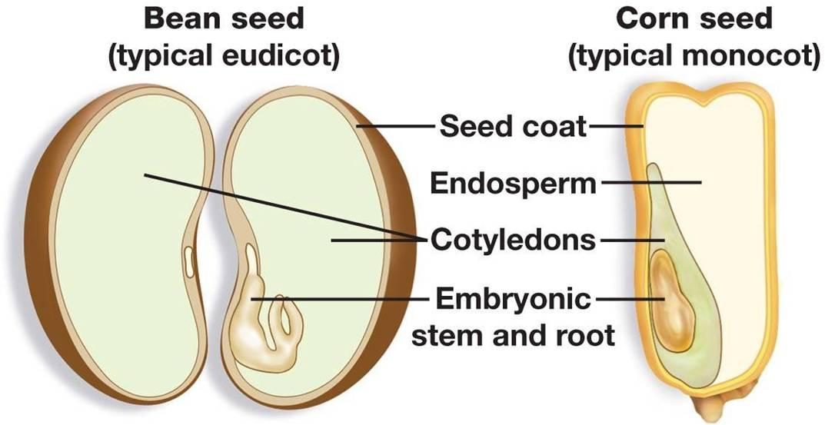
Dicot
- 2 cotyledons
- cotyledons are fleshy and store food
- endosperm absent
Monocot
- only one cotyledon
- cotyledon is thin, small and lacks food materials
- endosperm present and stores food

