SNC 2D – Optics Unit Review Sheets

Name: ___________________________________________

The following concepts are all important in the chemistry unit. Add as much information as you can to help you prepare for the test. Use questions from the Unit review (pg 524-526) Lens/Mirror and refraction worksheets to better understand the math portion of the unit

What is Light
(Electromagnetic Spectrum, ROYGBIV, Sources of Light, LED, Lasers)

Law of Reflection & Reflection off Plane Mirrors
(angle of incidence = angle of reflection, reflection of objects)

S.A.L.T. | Specular and Diffuse Reflection
Images in Concave (Converging Mirrors)
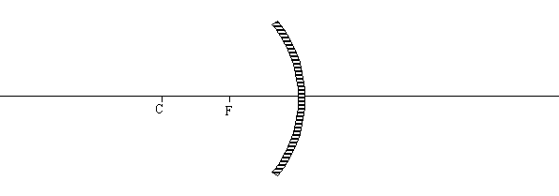
Images in Convex (Diverging Mirrors)

Refraction
Converging Lenses (Concave)
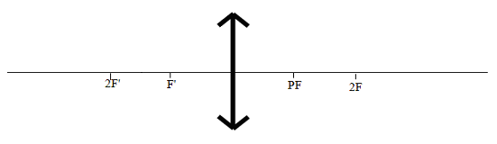
Diverging Lenses (Convex)
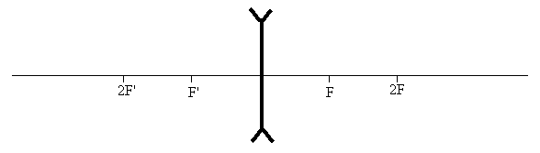
How does the human eye work? What are the key parts in it that allow us to see? What is myopia, hyperopia, presbyopia and astigmatism?

What is Total Internal Reflection and a critical angle? When will this occur?

