SBI 3U: VIRUSES

IS A VIRUS ALIVE?
Common Characteristics
- move
- can’t respond to stimuli
- can’t develop (grow)
- contain complex components
- die (destroyed)
Fundamental Characteristics
- not made of cells
- no metabolism
- can’t reproduce (without infecting a living host)
- can reproduce within a host and kill it
- no homeostasis

Since viruses don’t have all the fundamental characteristics of life, and they must rely on other living things, they are not quite alive.

WHAT ARE VIRUSES?
- small, infectious, non-living, non-cellular particles
- contain no cytoplasm
- cannot grow or reproduce on their own (need a host)
- do not produce or use energy
- do not create waste
- do have genetic material which takes control of other cells to create “virus copies”
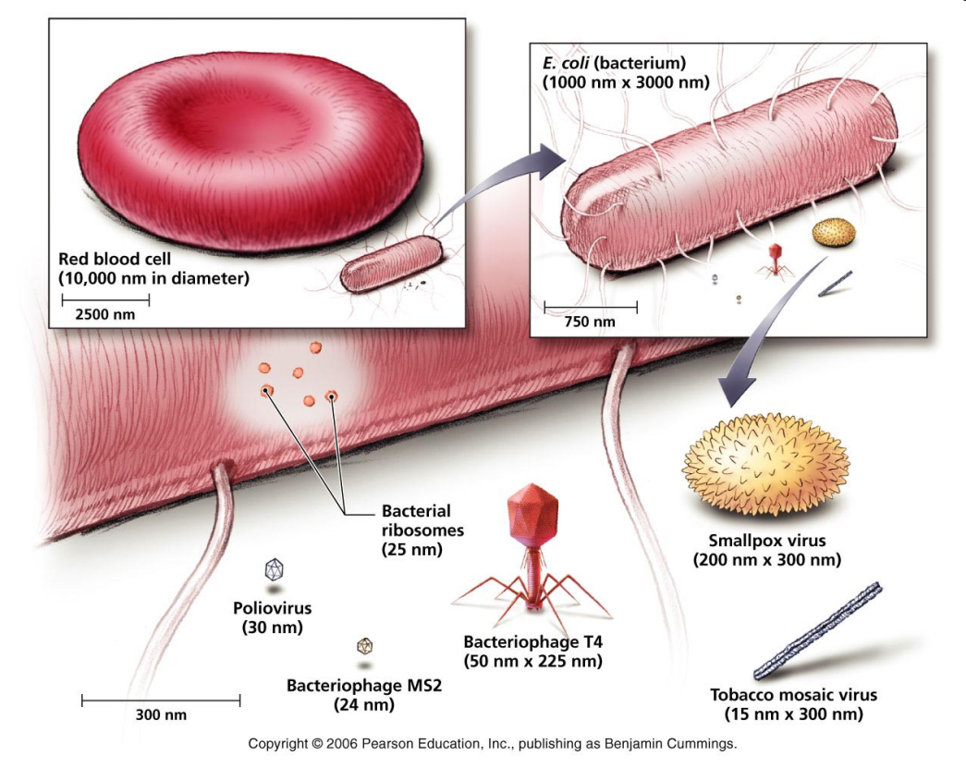
SIZE OF VIRUSES
- less than 0.1 µm in diameter
- Hundreds of thousands can fit inside a typical human cell.

BASIC STRUCTURE OF A VIRION (VIRUS PARTICLE)
- Genetic material– RNA (ss) or DNA (ds) core
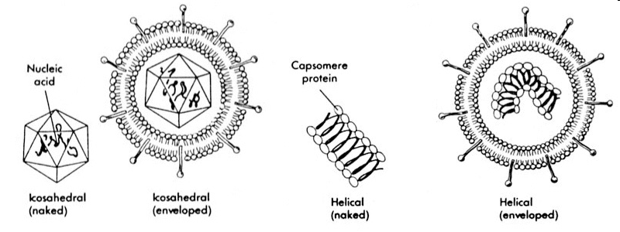
- Capsid (or head) – protein coat that surrounds and protects the genetic material

Note: Some viruses are surrounded by an envelope, which is created when a virus leaves a host cell and part of the host cell membrane wraps around the virus.

DIAGRAMS OF VIRUSES:
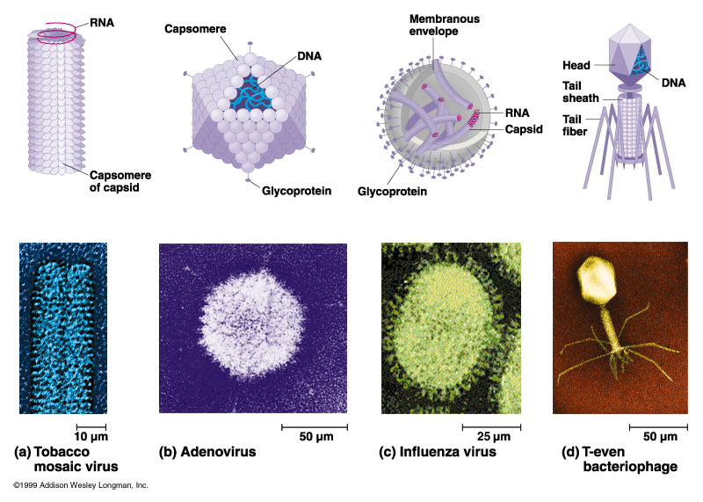

RNA OR DNA
Viruses with RNA (called retroviruses, higher mutation rate)
  - Human immunodeficiency virus (HIV)
  - Influenza viruses
  - Rabies
  - Measles, mumps, pneunomia, polio, common cold
  - SARS
Viruses with DNA (usually stable/constant, vaccines effective )
  - Chickenpox, cold sores, genital herpes
  - Mononucleosis
  - Hepatitis
  - Respiratory infections, tumours
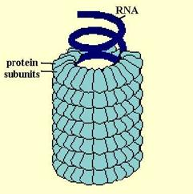
VIRUS SHAPES
1) Helical – rod-like with capsid proteins winding around the core in a spiral

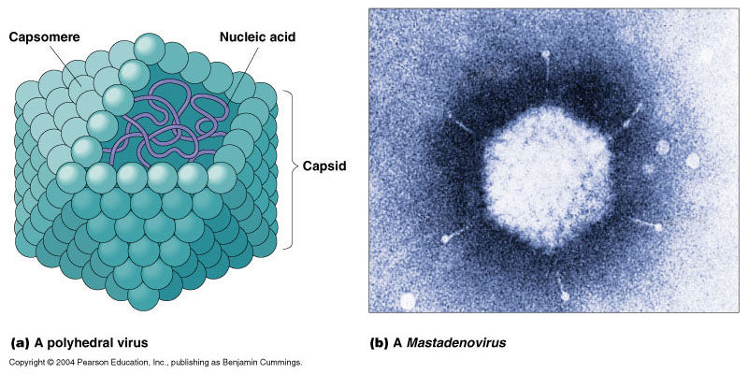
2) Polyhedral
- has many sides
- most polyhedral capsids have 20 sides and 12 corners

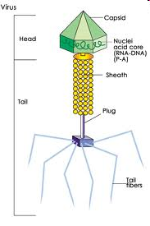
3) Complex - Polyhedral capsid attached to a helical tail
The tail is made of protein, which aids in binding to host cells.
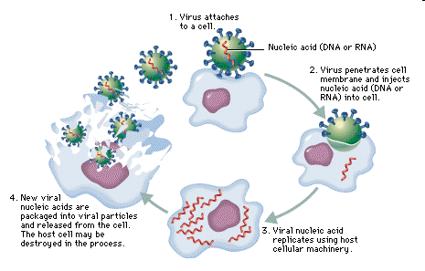
- This is the typical structure of Bacteriophages (viruses that attack bacteria)

VIRAL REPRODUCTION
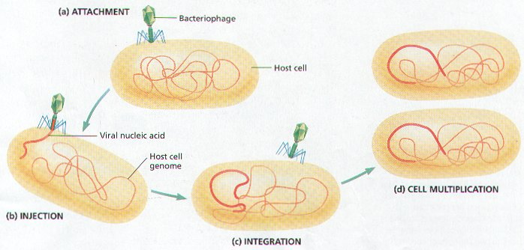
1) Lytic Cycle – the virus enters the cell, replicates itself hundreds of times, and then bursts out of the cell destroying it
1. Attachment
2. Injection/Entry
3. Replication
4. Assembly
5. Release
(lysis = breaking open)
- Lysogenic Cycle
– the virus enters the cell, viral DNA integrates with the host DNA and becomes inactive, the host functions normally
- an environmental change may then cause the virus to enter the Lytic Cycle
1. Attachment
2. Injection/Entry
3. Integration into host cell’s DNA
4. Dormancy/Normal cell functions
5. Triggering of viral DNA to be
released and then Lytic cycle begins
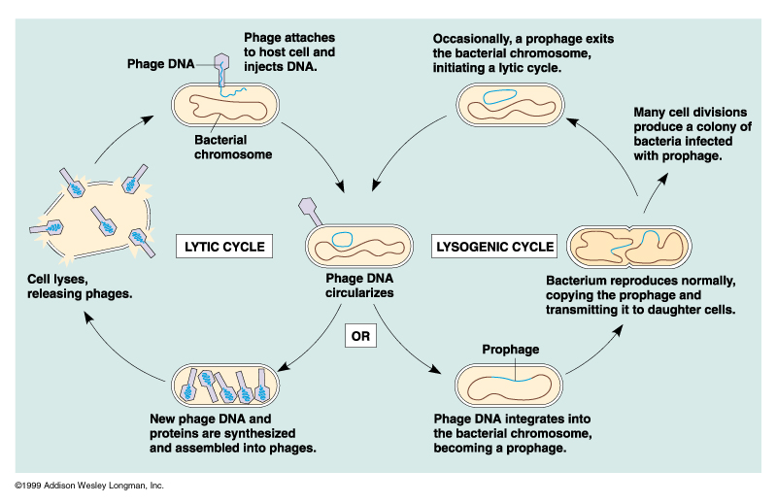

DIFFERENCES BETWEEN LYTIC AND LYSOGENIC CYCLE:
In the Lytic Cycle:
- Viral DNA destroys Cell DNA, takes over cell functions and destroys the cell.
- The virus replicates and produces progeny phages.
- There are symptoms of viral infection.

In the Lysogenic Cycle:
- Viral DNA merges with cell DNA and does not destroy the cell.
- The virus does not produce progeny.
- There are no symptoms of viral infection.

3 WAYS VIRUSES ENTER LIVING CELLS:
- enter bacterial cells by punching a hole in the cell wall and injecting its DNA
- enter plant cells through tiny rips in the cell wall
- enter animal cells by endocytosis

VIRUSES ARE HOST-CELL SPECIFIC
- can usually infect one type of host or even an organ, tissue or cell type (called its HOST RANGE)
- a protein on the surface of the virus has a shape that matches a molecule in the plasma membrane of its host, allowing the virus to lock onto the host cell (like a key fits in a lock)
Examples:
- a plant virus can only attack a plant cell and not an animal cell
- HIV (human immunodeficiency virus) infects only certain immune system cells

- some viruses can infect many species
Examples:
- rabies (rhabdovirus) – infects all birds and mammals
- swine flu virus can infect swine or humans

HOW ARE VIRUSES SPREAD?
- VECTORS - carry the virus from one host to another
- Vectors include:
Insects (yellow fever – mosquitos)
Animals (rabies)
Water (polio)
Air (influenza, common cold, chicken pox)
Humans (influenza, hepatitis, HIV)

