SBI3U Unit 1: Diversity of Living Things

Classifying Living Organisms The Kingdoms

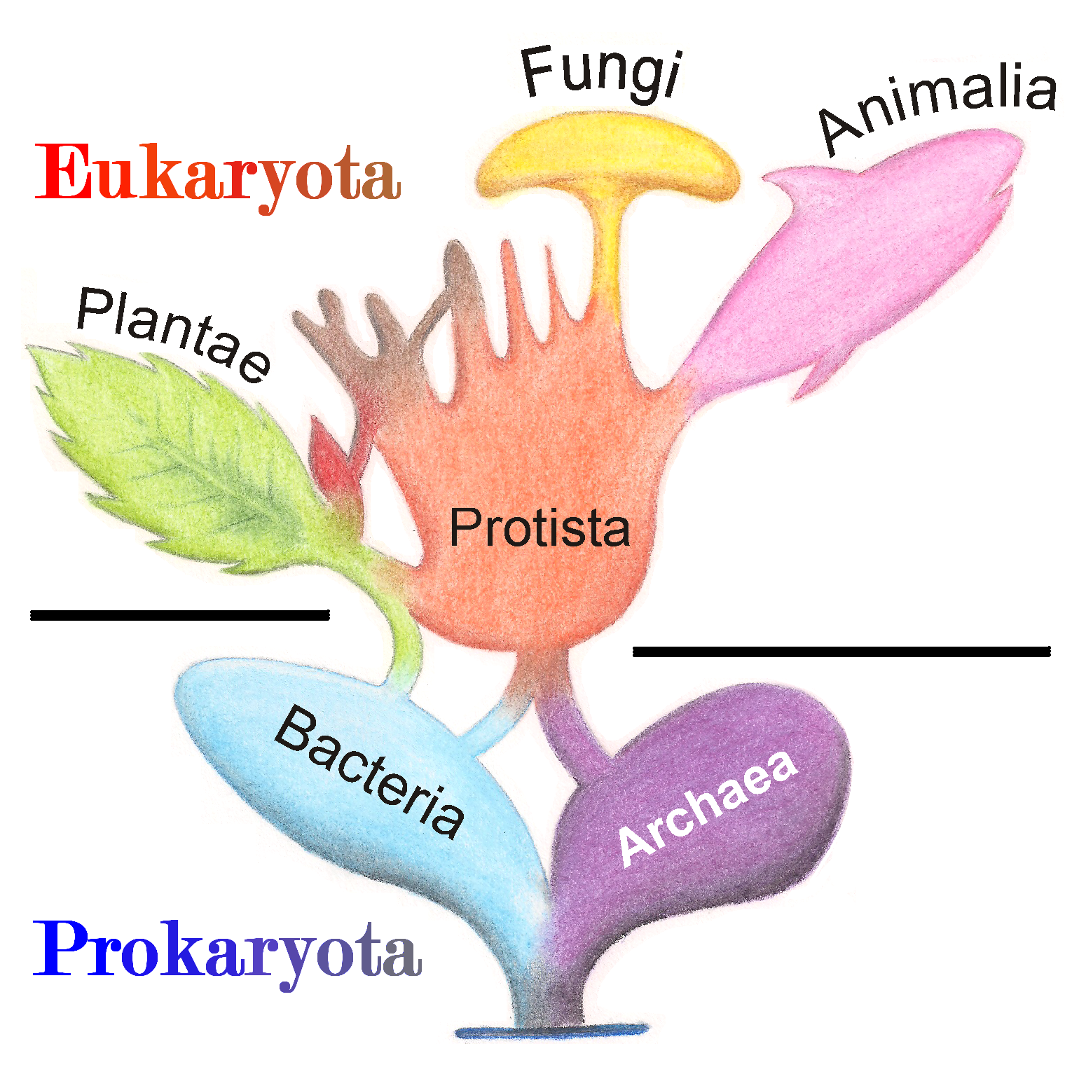
There are 6 kingdoms of classification

Archaea
Bacteria
Fungi
Protista
Plantae
Animalia

*Note* Sometimes you will still see the kingdom bacteria referred to as eubacteria. Also the older term for Archae was Archaebacteria.

There are two major cell types:

Prokaryotic - a smaller, simple type of cell that does not have a membrane-bound nucleus

Eukaryotic - a larger, complex type of cell that does have a membrane-bound nucleus

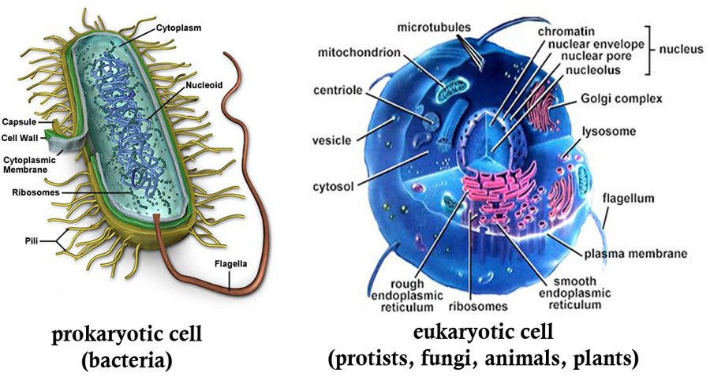

There are 3 domains:

Archae - includes only the kingdom Archae (prokaryotes)

Bacteria - includes only the kingdom bacteria (prokaryotes)

Eukarya - includes the kingdoms: Protista, Fungi, Plantae, and Animalia (eukaryotes)

Background Info & Terms
Unicellular - 1 cell
Multicellular - >1 cell
Heterotroph - has to eat things to get energy, cannot make its own food
Autotroph - can photosynthesize to make its own food
Sexual Reproduction - with a mate
Asexual Reproduction - no mate required
Prokaryotic - few organelles, no nucleus, one plasmid instead of chromosomes
Eukaryotic - organelles, nucleus, more than one chromosome

Classifying Kingdoms

Characteristic | Possible example | Possible example
Nutrition | Heterotrophic  -consumes living or dead organisms to obtain energy | Autotrophic  -uses sun’s energy or chemicals  -makes own food
Number of Cells | Unicellular  -one cell | Multicellular  -more than one cell
Reproduction | Asexual  -offspring produced from a single parent (genetically identical to parent | Sexual  -production of offspring from fusion of 2 sex cells (offspring differ from parents)
Habitat | -where does the organism live?
Cell Type | Prokaryotic  -circular chromosome  -no membrane bound organelles (e.g. no true nucleus)  -very small (less than 2 um)  -reproduce by binary fission | Eukaryotic  -double stranded chromosomes in nucleus  -membrane bound organelles  -larger (10-100 um)  -reproduce by mitosis or meiosis

