Biological Diagram Checklist

Checklist for Biological Diagram Drawing

_____ drawing on blank paper
_____ drawn and labelled using pencil
_____ clear simple diagram
_____ diagram large, off-set to the left, and takes up at least half of page
_____ firm, clear, neat, well-defined, well-formed lines
_____ no shading, only stippling where detail is needed
_____ label lines parallel and do no cross
_____ vertically align the labels
_____ draw horizontal -label lines with a ruler
_____ labels are written at the end of the line (Not on top of it)
_____ diagram labels are written in lowercase
_____ title is centred at top of page, underlined, and in upper case
_____ all spelling is correct
_____ your name, course and date on top right
_____ total magnification used is centred, below diagram, with correct units.
_____ latin name of specimen is written below the drawing and underlined.
_____ Size of cell is calculated on the back (full solution) of the diagram and written below the latin name (under drawing)
_____ Type of stain used is indicated and written below the diagram (where applicable).

_____ magnification of drawing is calculated (on back) and displayed under latin name

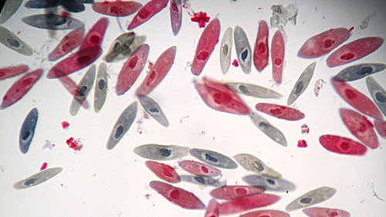

Specimen:
Paramecium

View under High power

Not stained
Figure 1.0: Paramecium viewed under high power magnification

