Open Dreamweaver

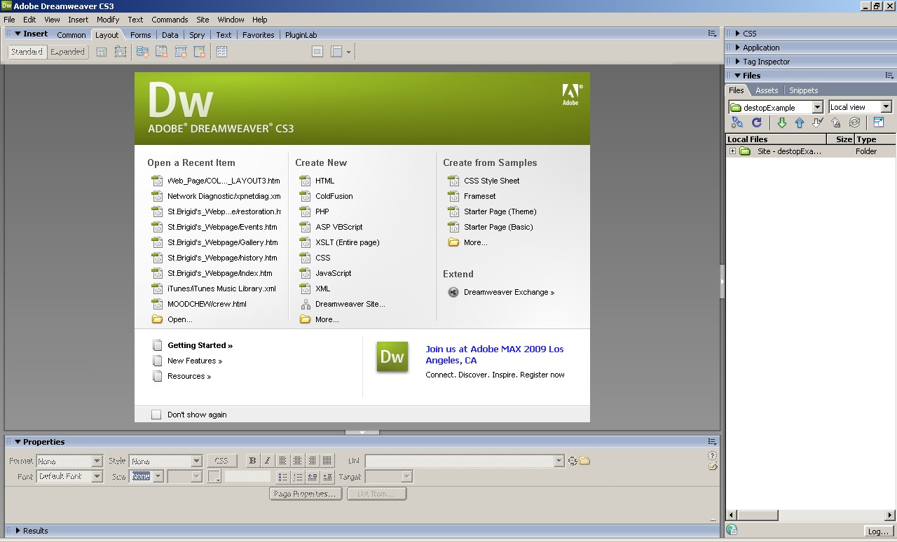

From the pull down select manage sites

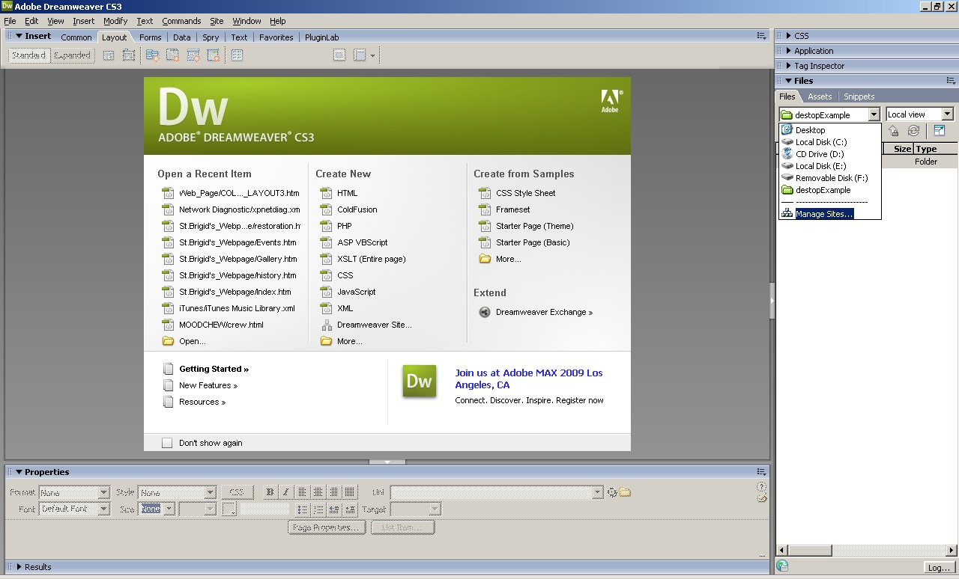
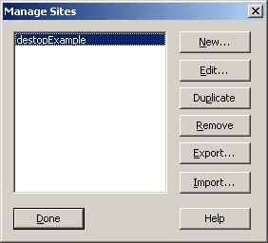

Click on New Site

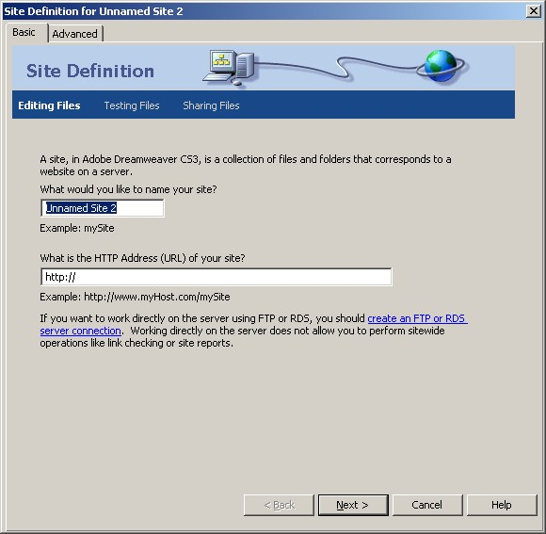

Type in the name of your site.
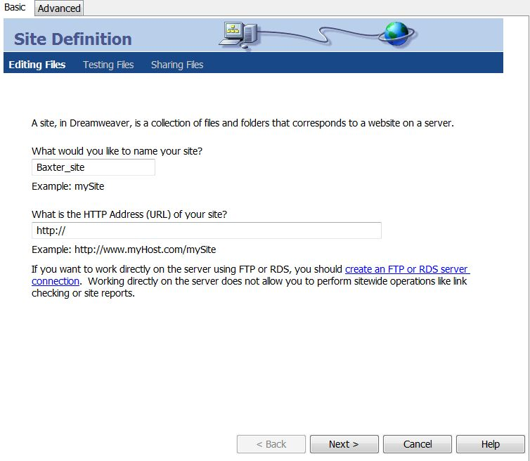

Click next

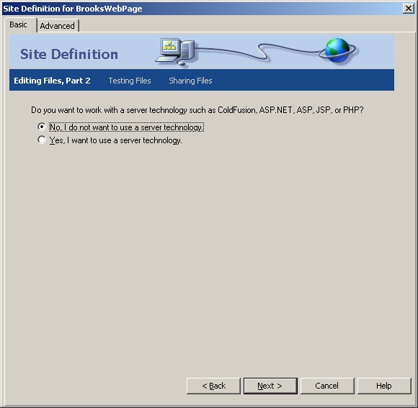

Click next
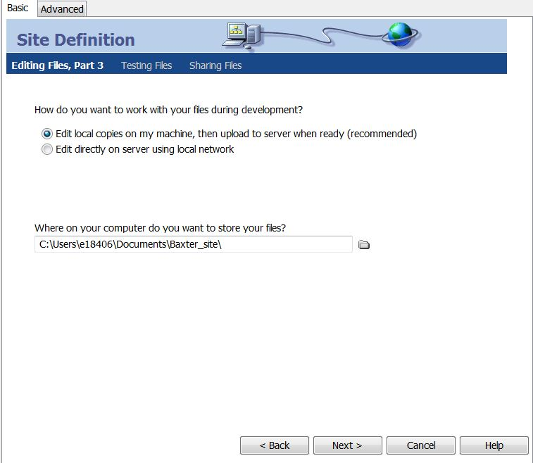

Click on the yellow folder

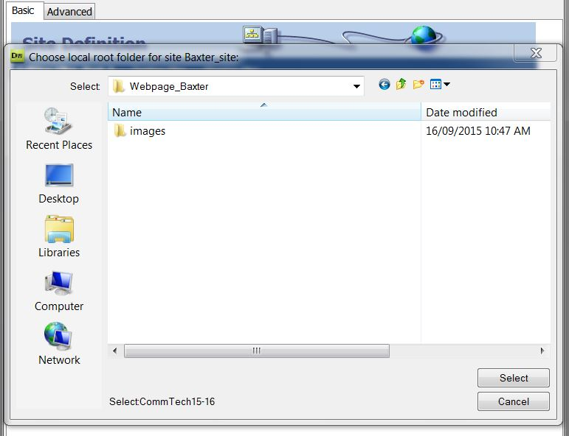

Navigate to your Web page folder, click select. DO NOT click on the images folder. Click next.

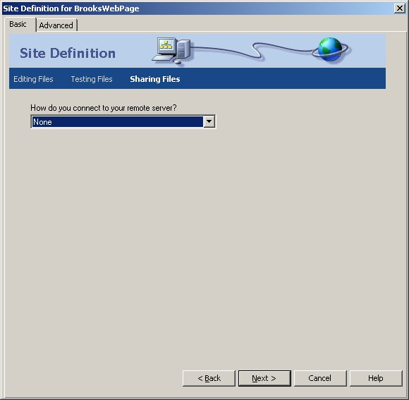

Click NONE and click next.

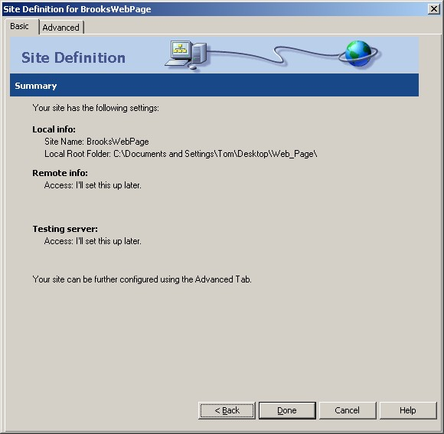
Click Done

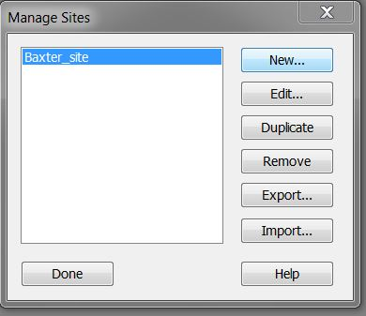

Click Export – This part is very important and often done incorrectly

.

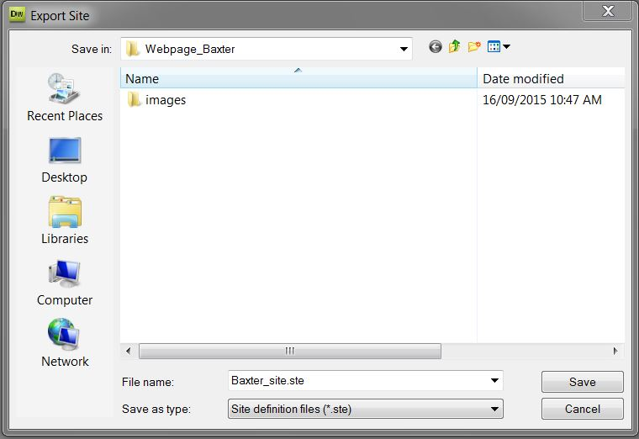

Click save to save your site into your Web Folder.

Click Done.

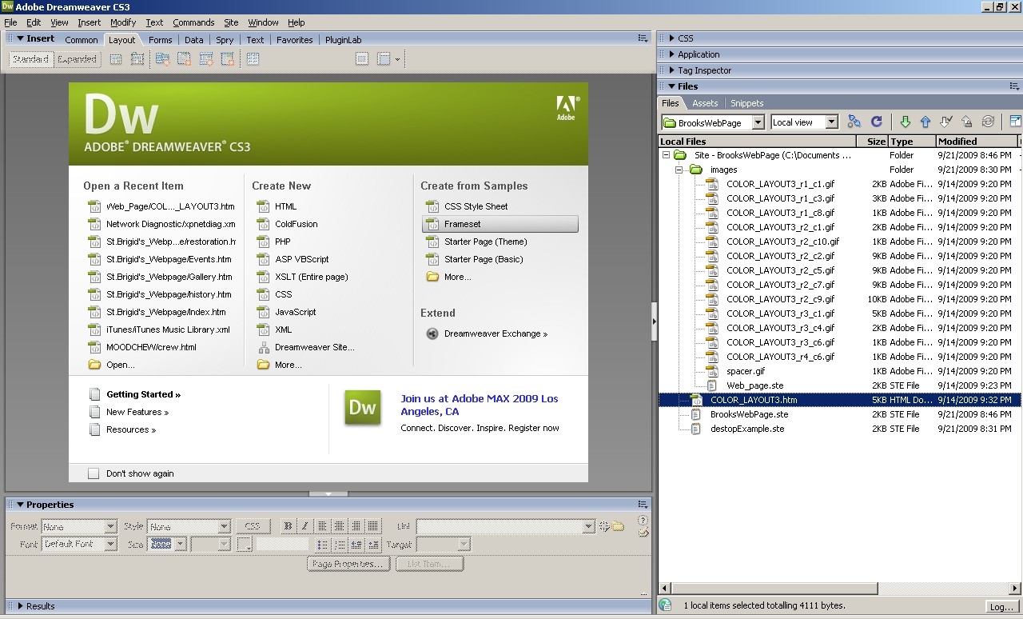

In the right hand column click + beside the site and the image folder to see all your files.
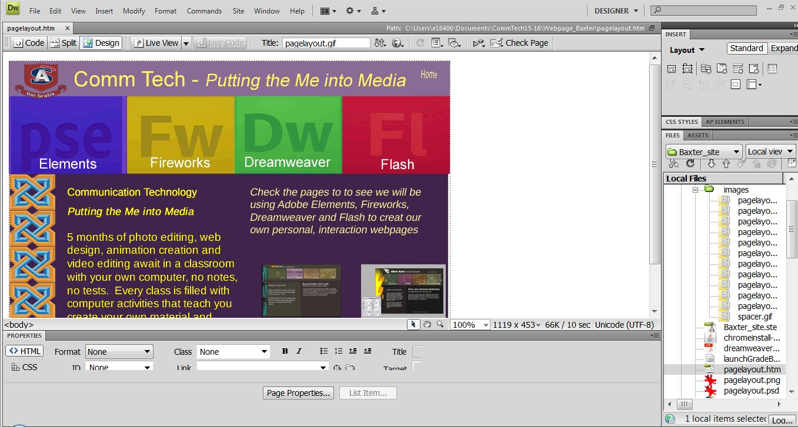

Click on the html file in your manage site folder to display the page.

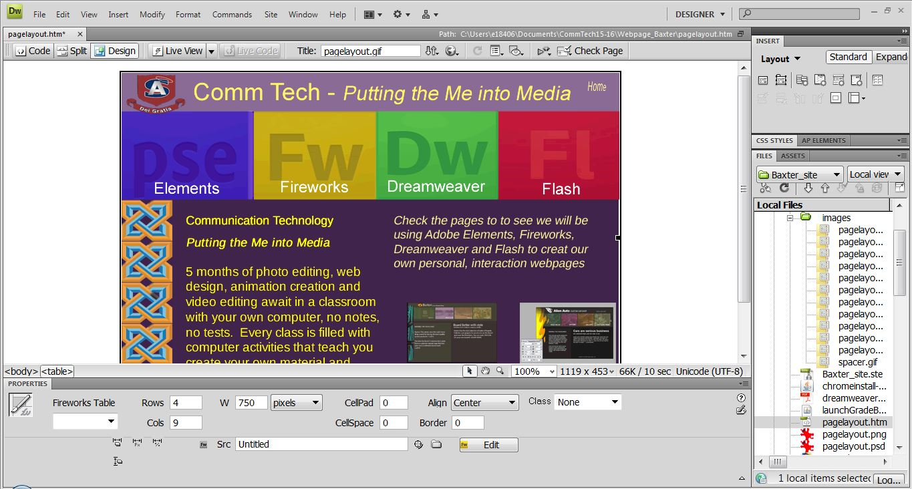

Click hold and drag from the white area onto the table. This will high light it. Find the Align Command at the bottom of the page and center your page.

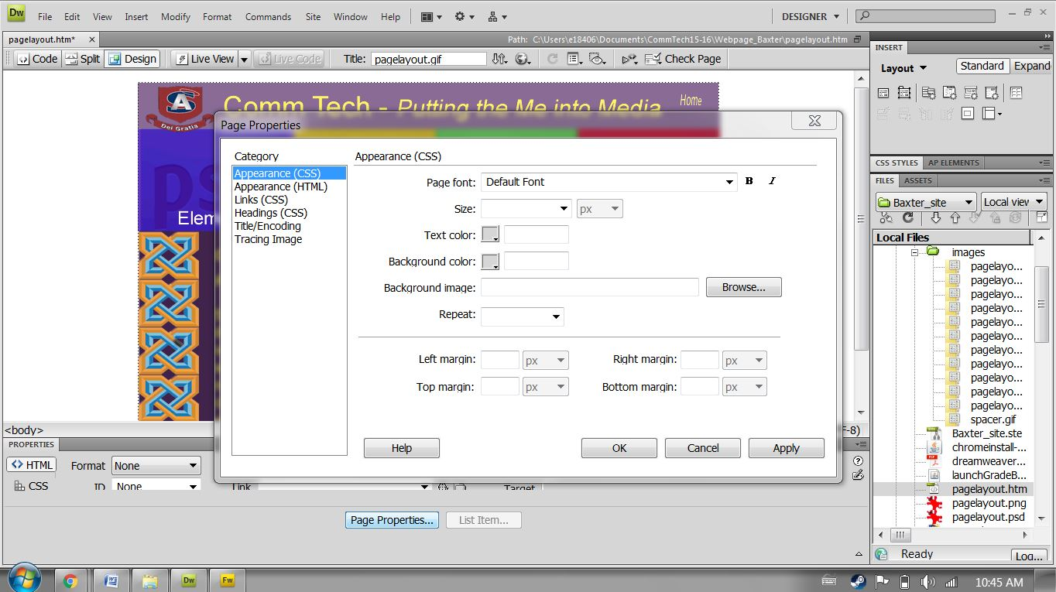

Right click on the white background and select page properties.

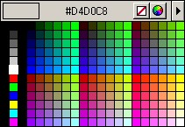

Change the background color and click apply.
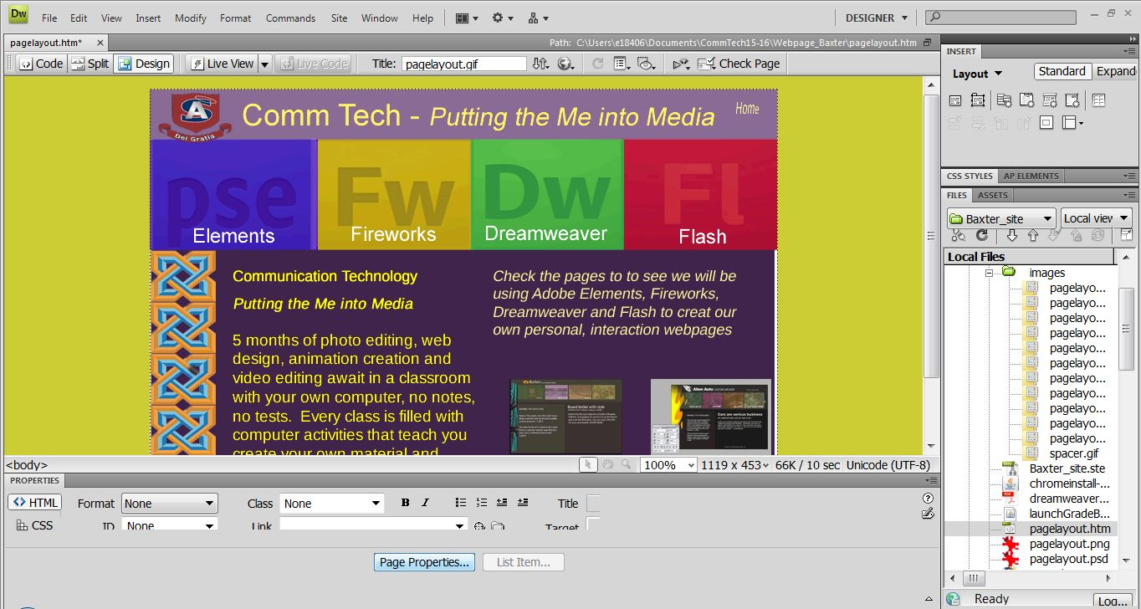

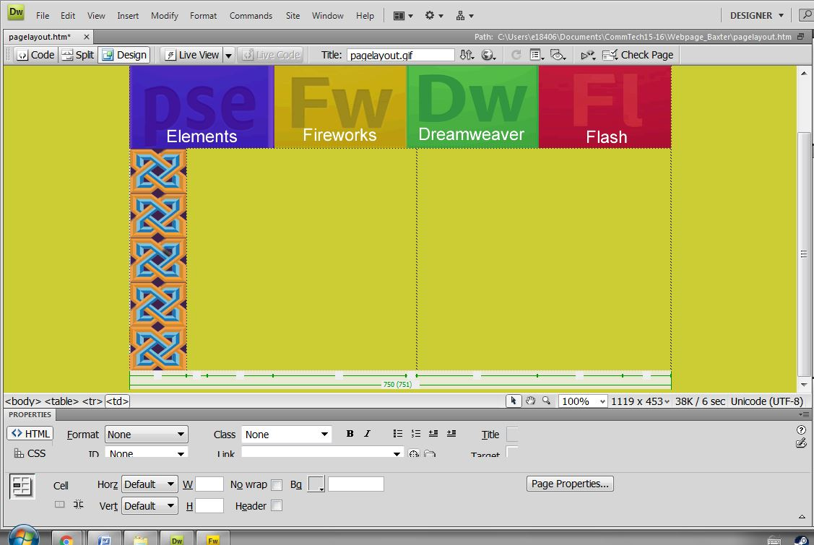

Click on a slice that you will be adding text or images and delete it.

Go to the Windows Icon at the top of the Screen
Click and Find Tag Inspector (F9 is the hotkey for this function)

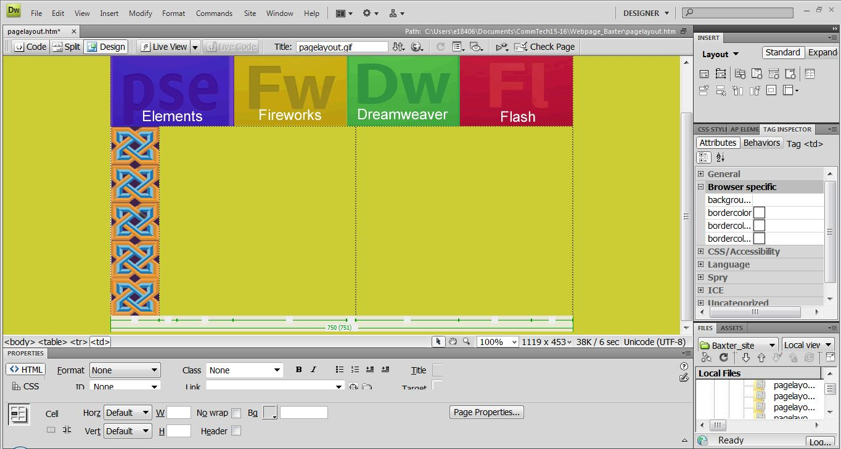

Click on Browser specific and the background box.
A folder will appear that you can open to find the image you want on each section.

You cannot add text or images to your page unless this is done.

The slice will now appear as a background.
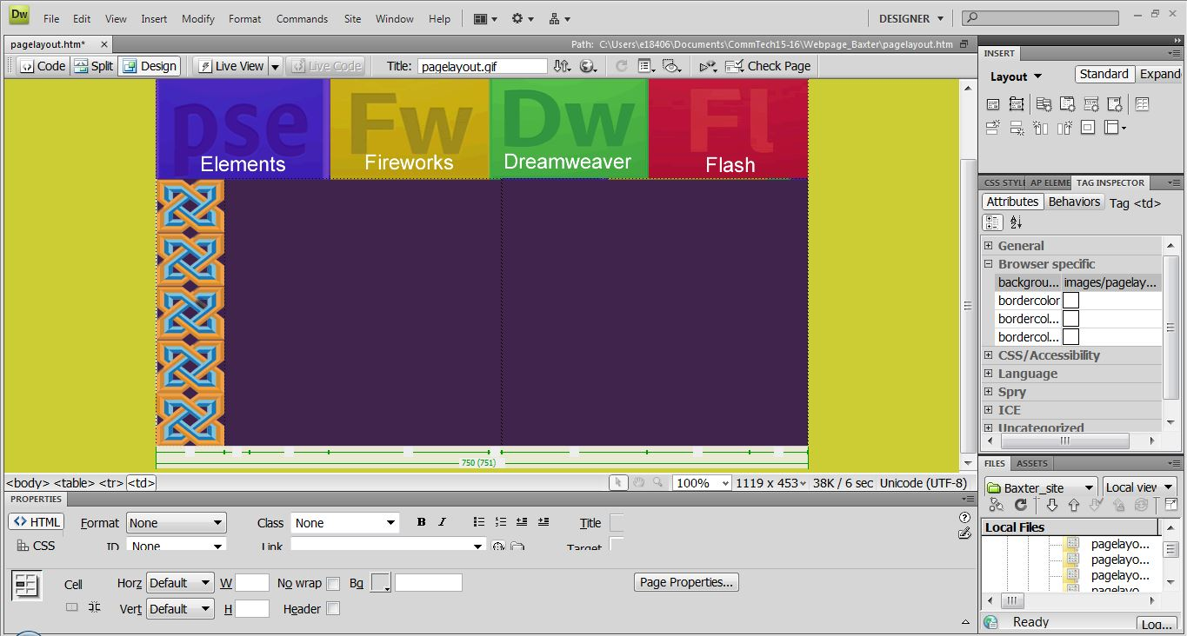

Do this for all boxes that will be edited on you website pages.

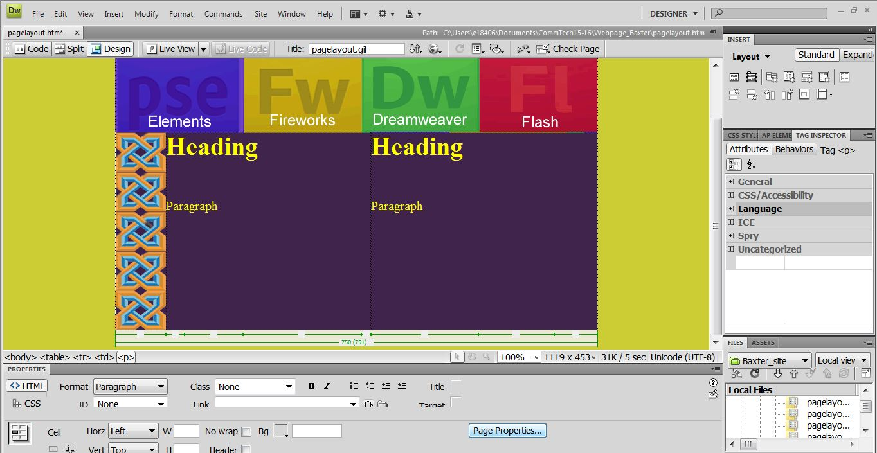
Adding Text
The format button (near the bottom of the screen on the left) will allow you to insert text in different size fonts as headings and paragraph

There are Horizontal and Vertical button below the Format button that allow you to place your cursor where you want it so you can add text or images.

The colour of you text and be adjusted by going to page properties and changing the text colour.

