Website Layout using Photoshop

- Open Elements and create New file
- Create a new document 750 X 500. Divide it into thirds.
- Save it as Color_Layout.psd
- The top third will be the header and navigation bar.
- The bottom 2/3 will be content.

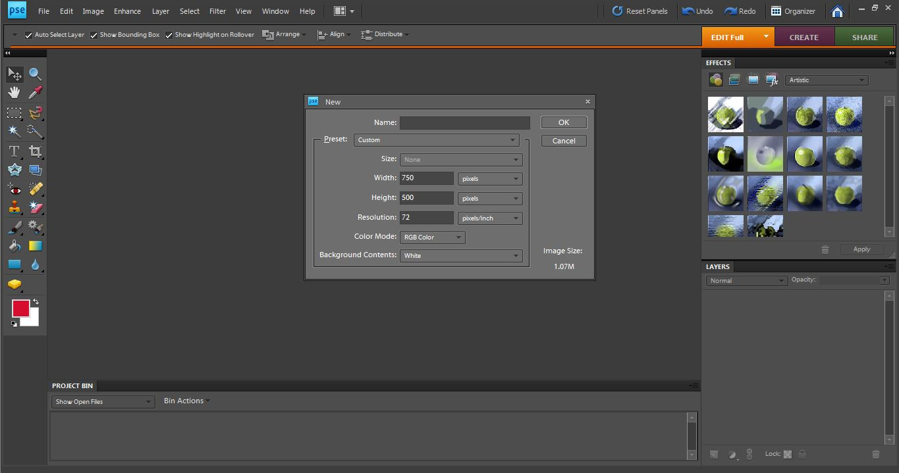

Create a new layer called “block“. Draw a rectangle that divides the content area. Create another layer called “button background”. Create four button rectangles of different colours. The button will link to four pages that will make up your website.

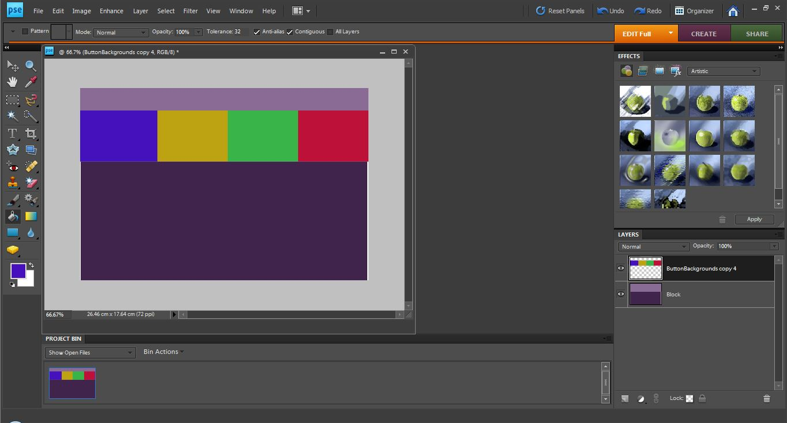

Collect images that represent these pages and save the images as jpgs in your image folder. Remember to use your own photos or images with no copyright and name so you can recognize them.
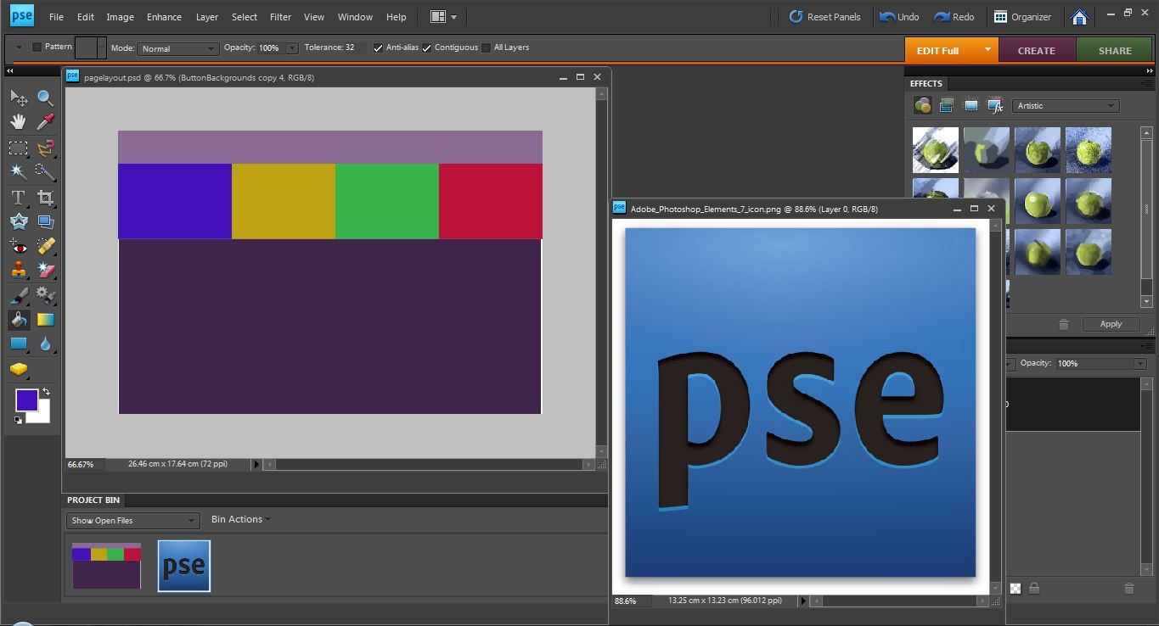

Create a new layer for each image and drag it to the correct spot onto the Colour_Layout.psd.
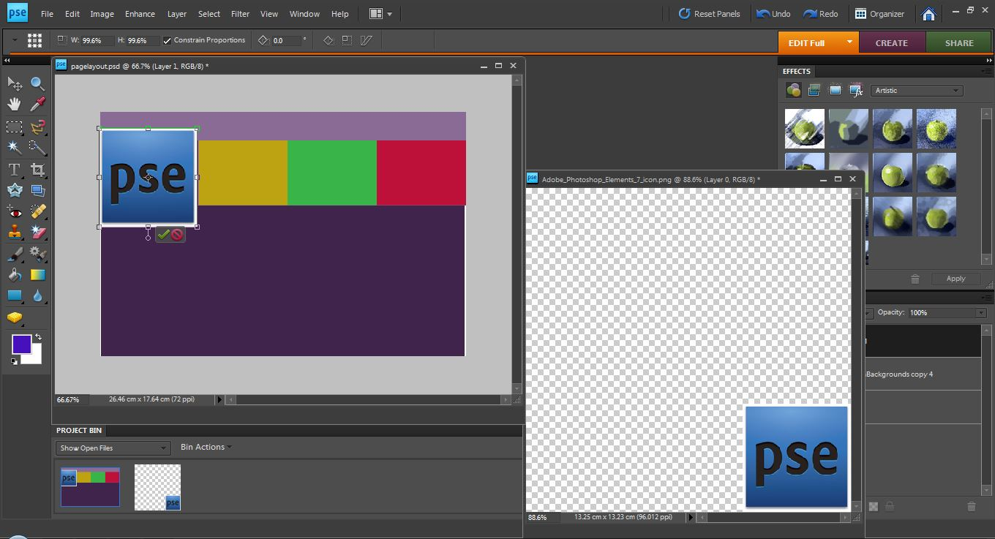

Change the opacity of the button layer to between 40 and 55%.

Drag it above the photo layer. Move and scale the image so it fits under the button and is ready for cropping.
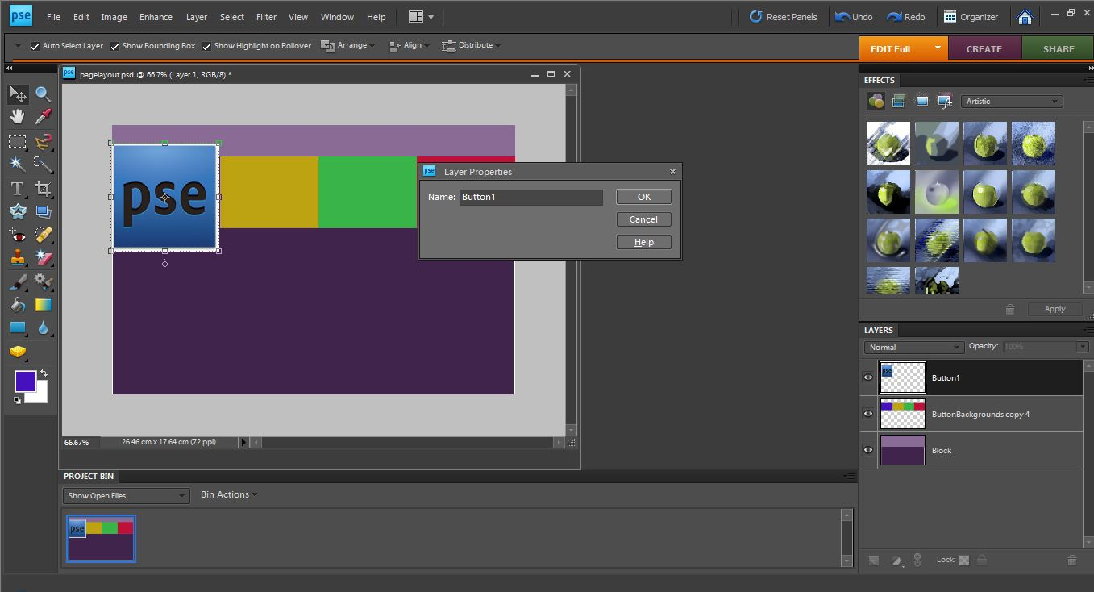

Change the opacity of the button layer to between 40 and 55%.

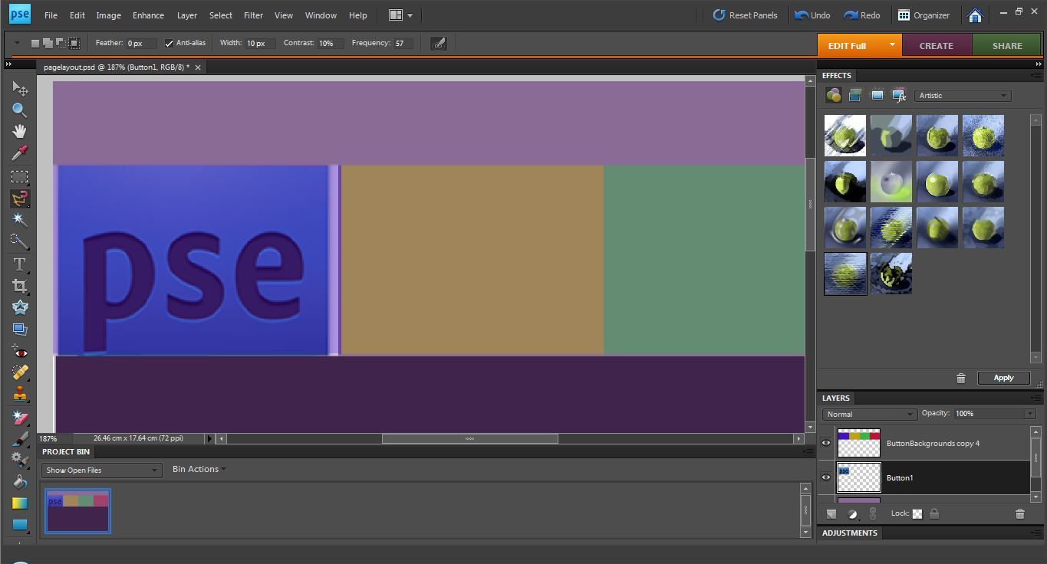

Repeat this procedure for the remaining three buttons.
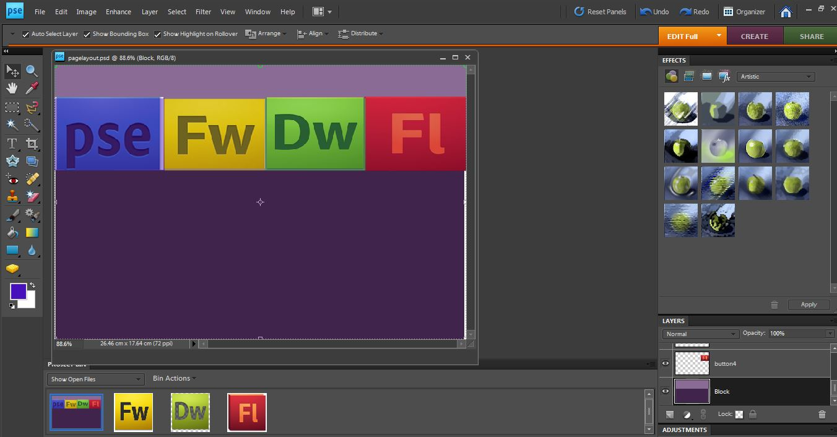

Be sure to rename the layers with appropriate names so you can identify them.

Use file place to bring your original logo and border in.
The border will run down one of the sides of your page
Your simple, original logo will be placed in the top left of your screen.
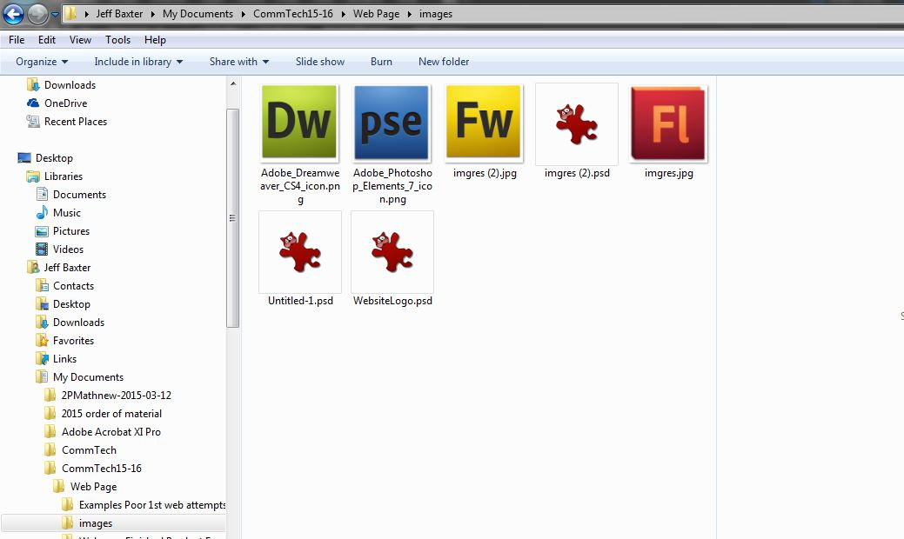
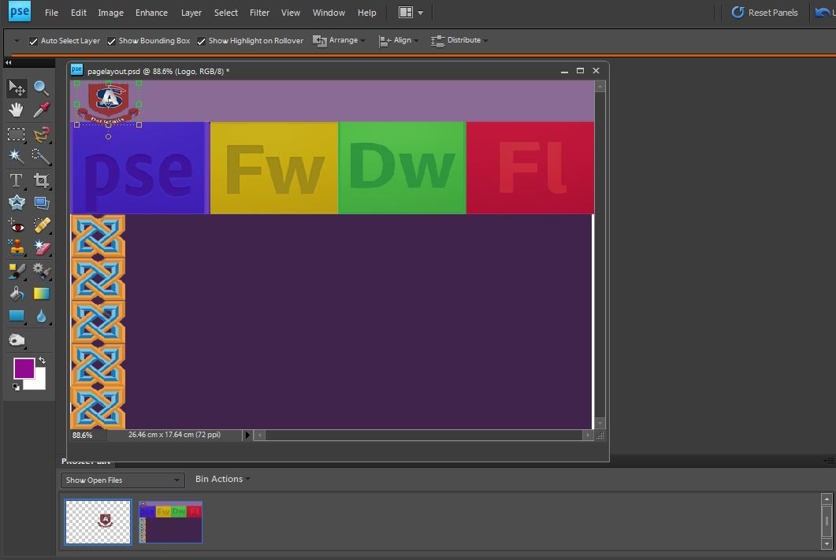

Find a text of a stand out colour that you will have for your title and catch phrase/slogan

The title will be larger/bolder as the slogan will be less defined.

It will be around a size 30 font of Ariel or a Sans
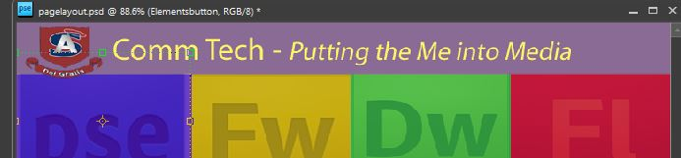

Create text to describe your production company. This is your headline text. This catches the attention of your viewer.

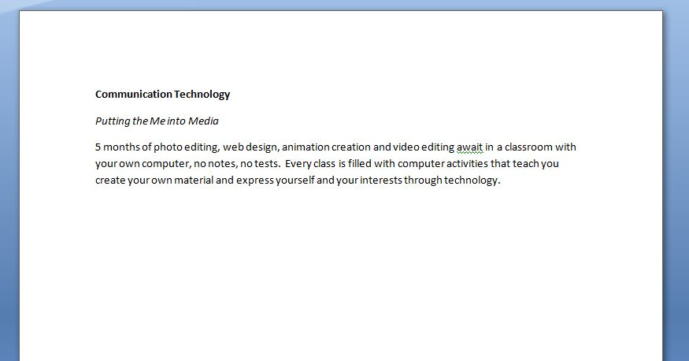

Select the text tool and stretch a text box for a headline.
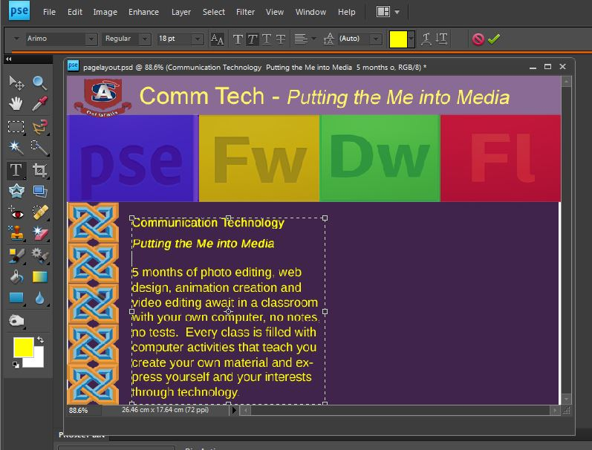

Place in the other text boxes. Add a home button text in the top right of your page.
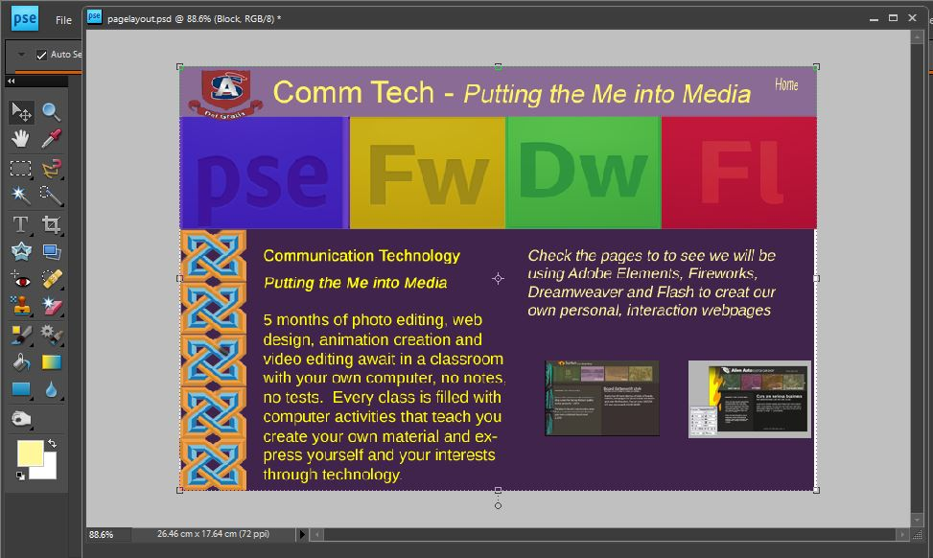
Add extra photos. Add any extra graphic features.

Add the button text on new layers.
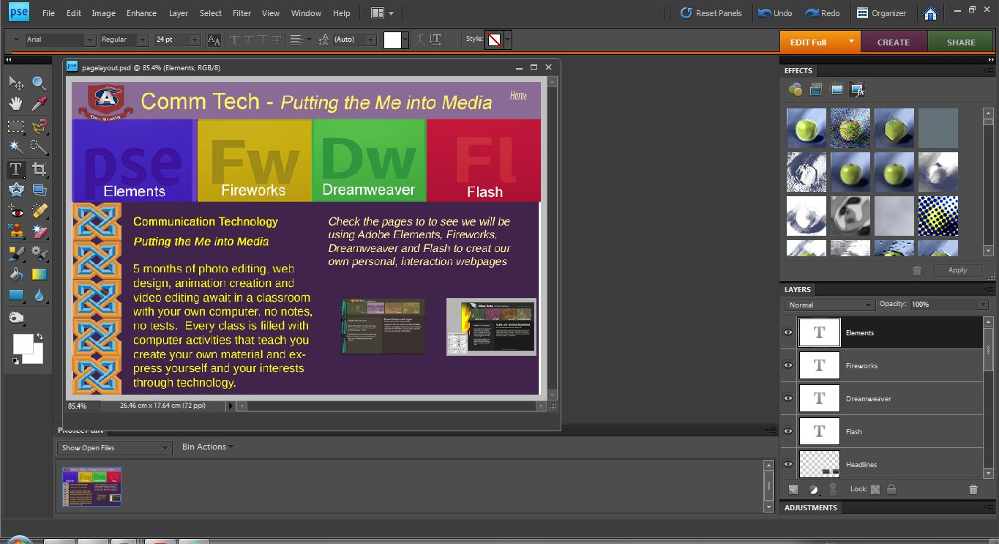

Save as a jpg.

