Flash Splash Page into Dreamweaver
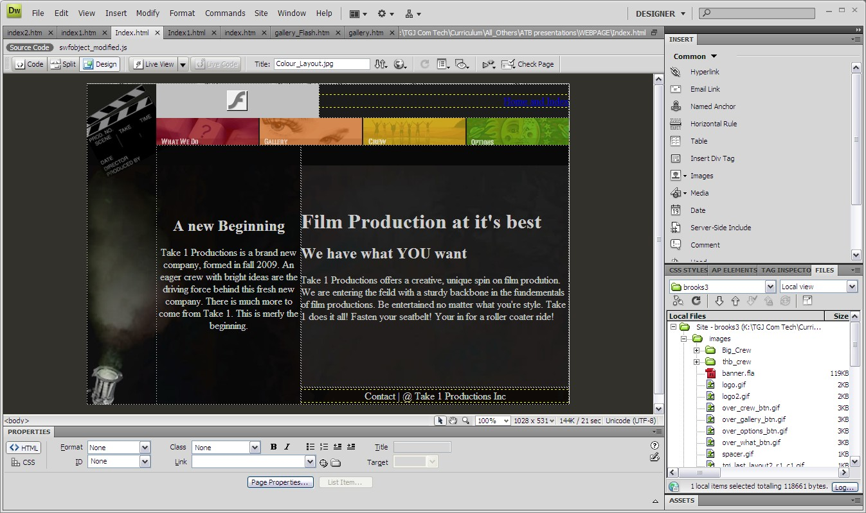

Open Dreamweaver Manage sites and open your Index2. Save as Index. Open the Index page. Select the entire table and delete it.
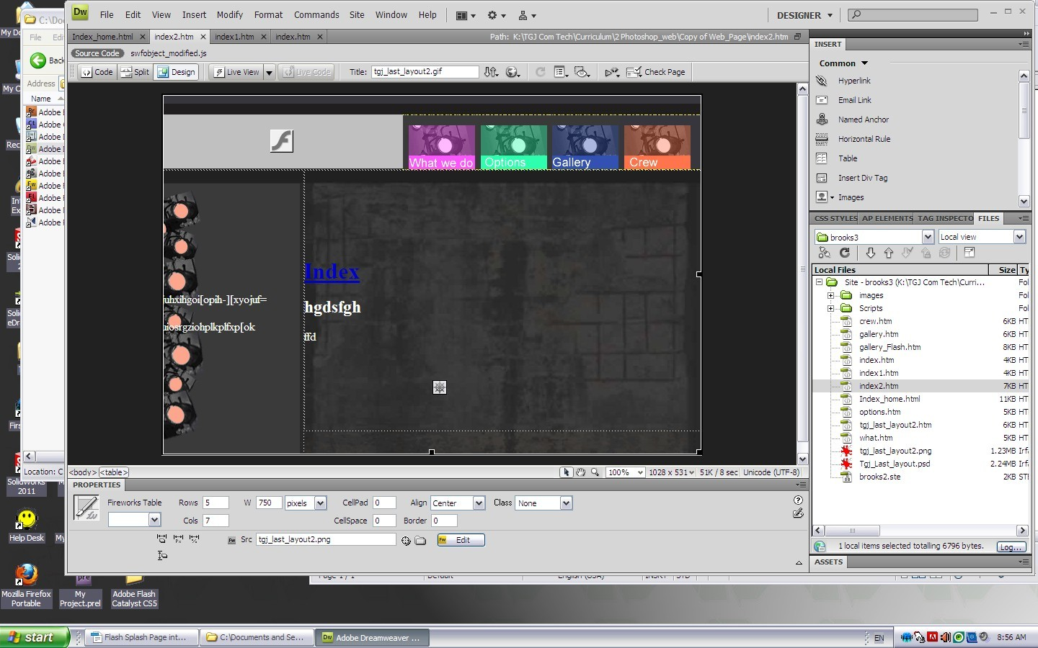

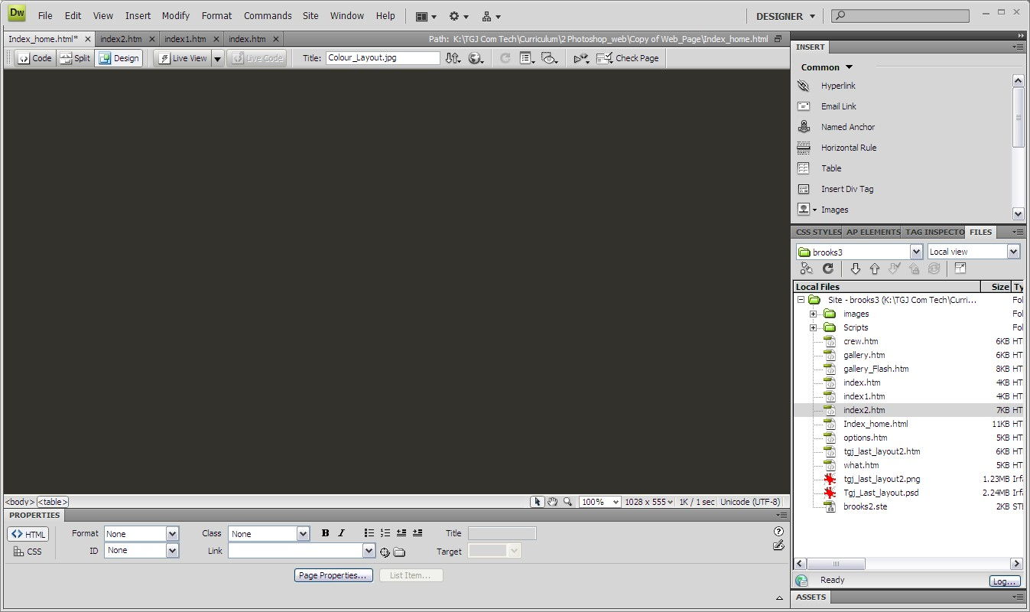
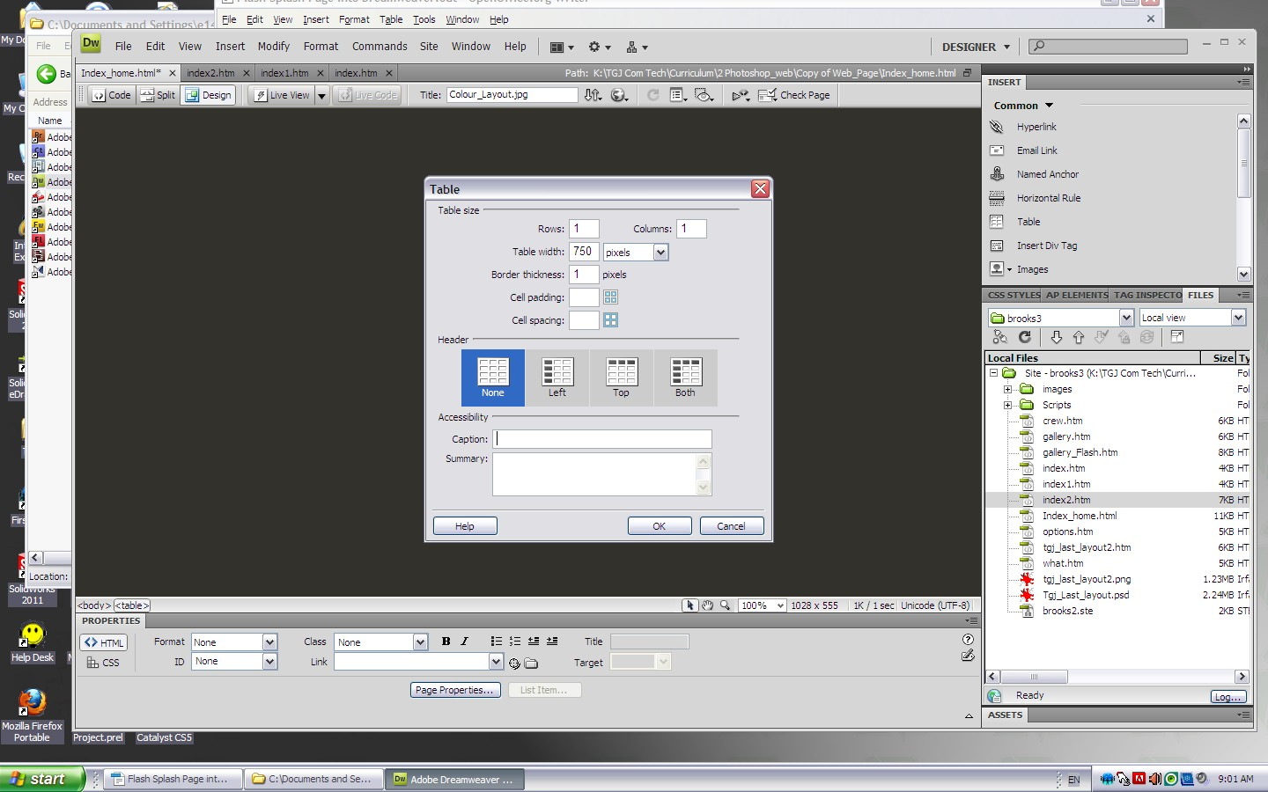

Insert Table. 1 x 1 table width 750. Select OK.

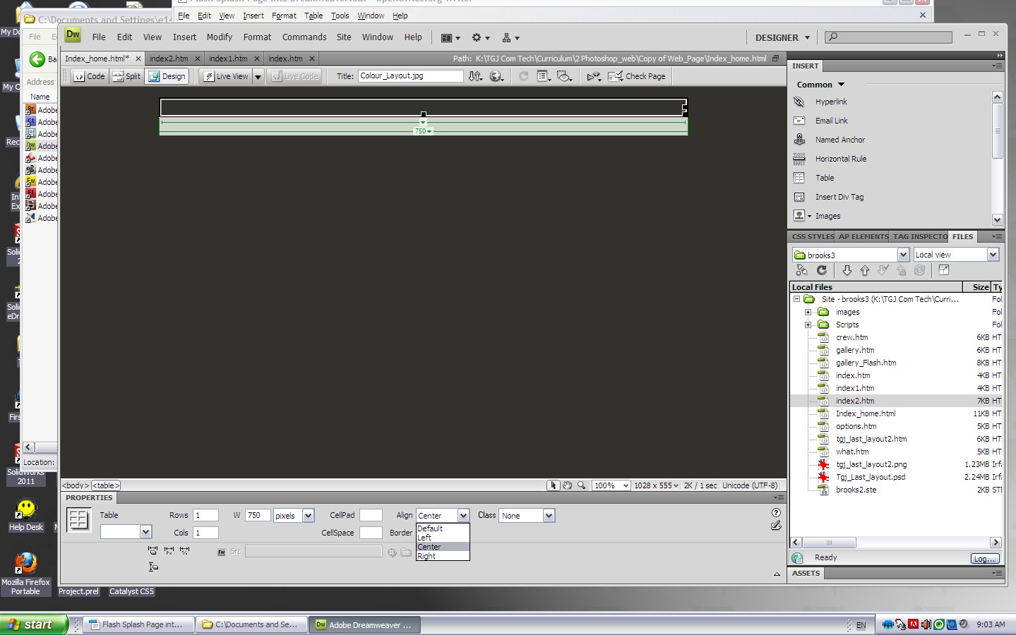

Align Center the table.
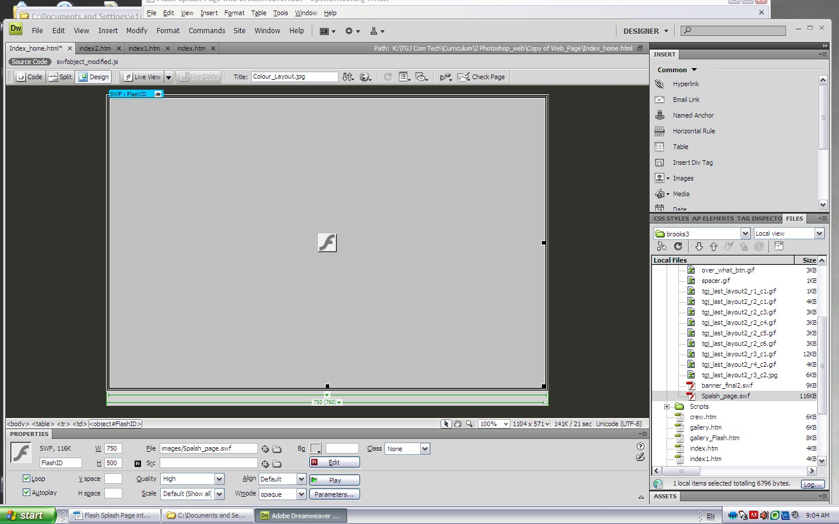

Drag your splash Page swf into the table. Name it splash.

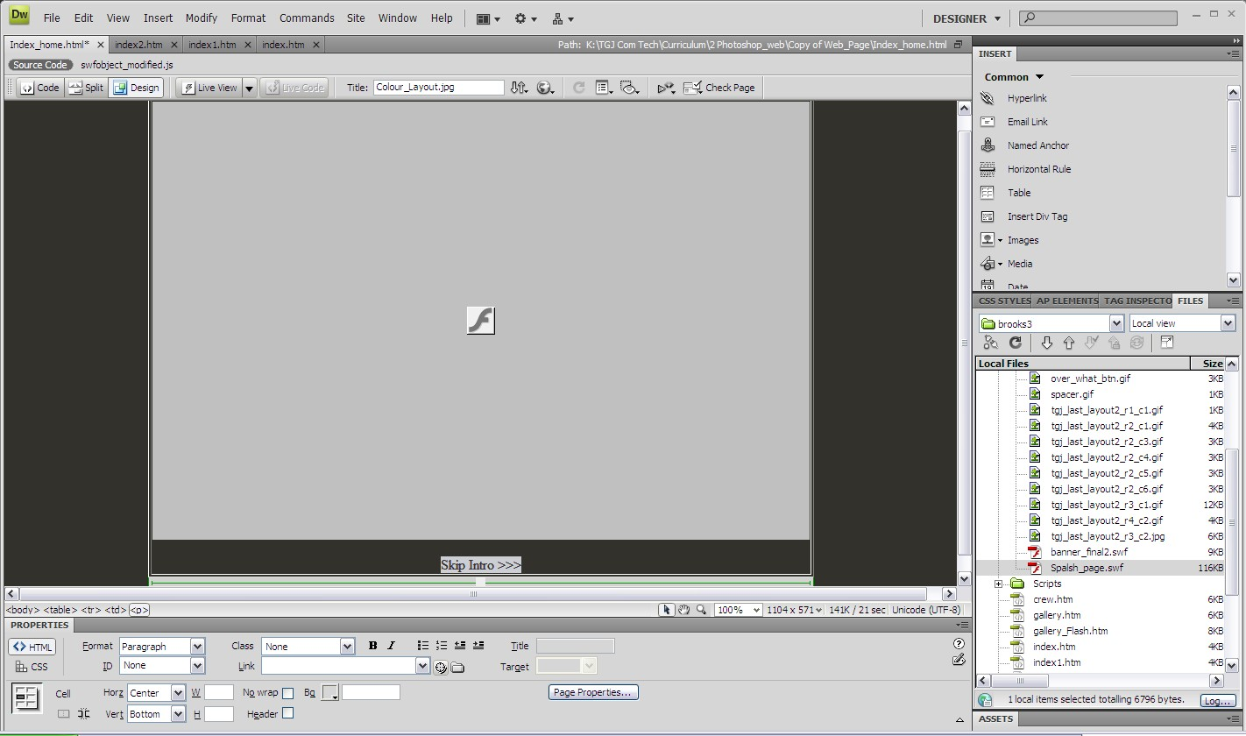

Type “Skip Intro >>”
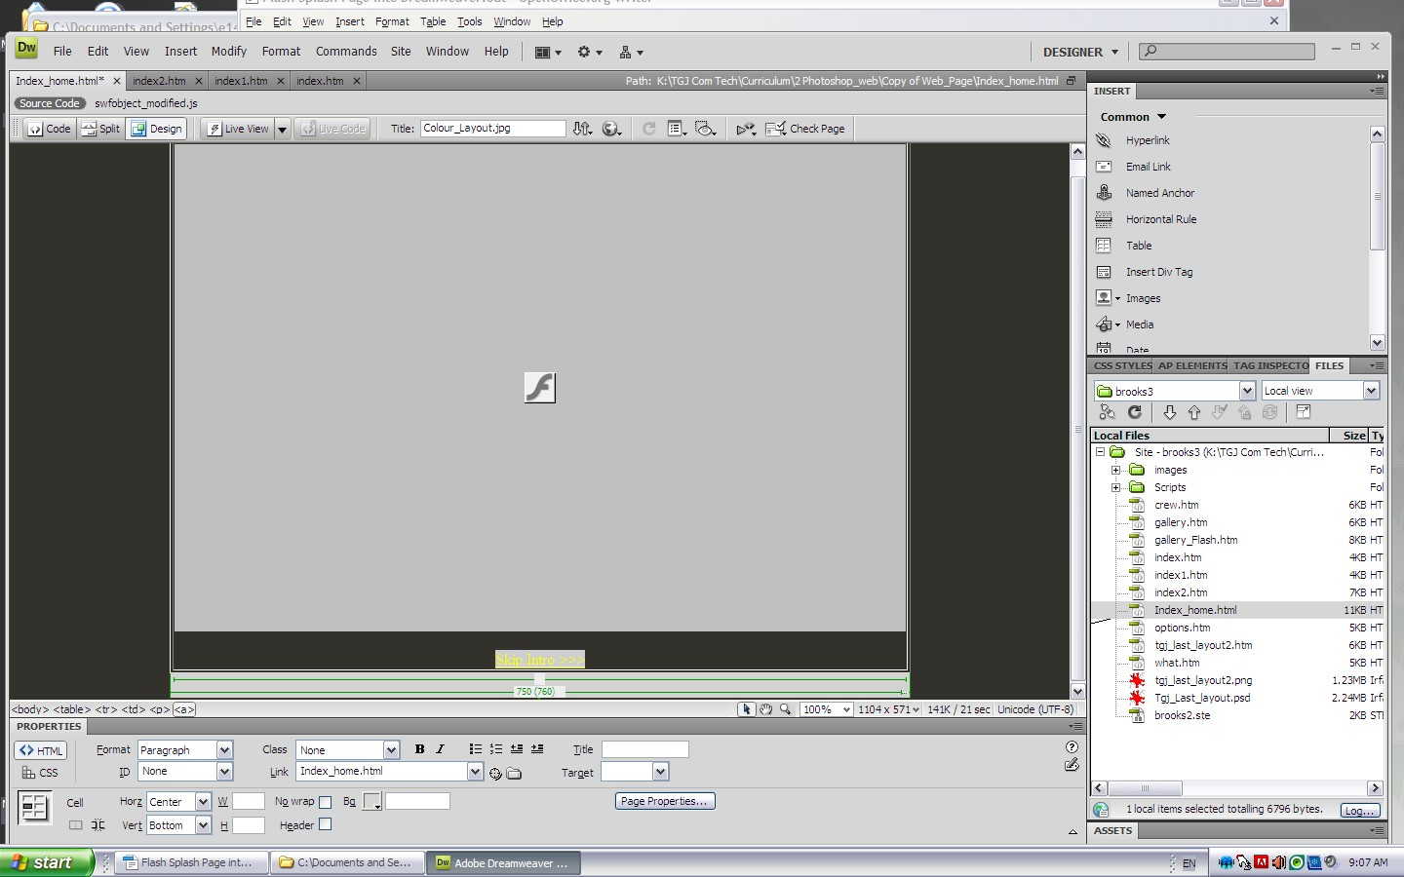
Highlight the text and Link it to the Index_home Page.

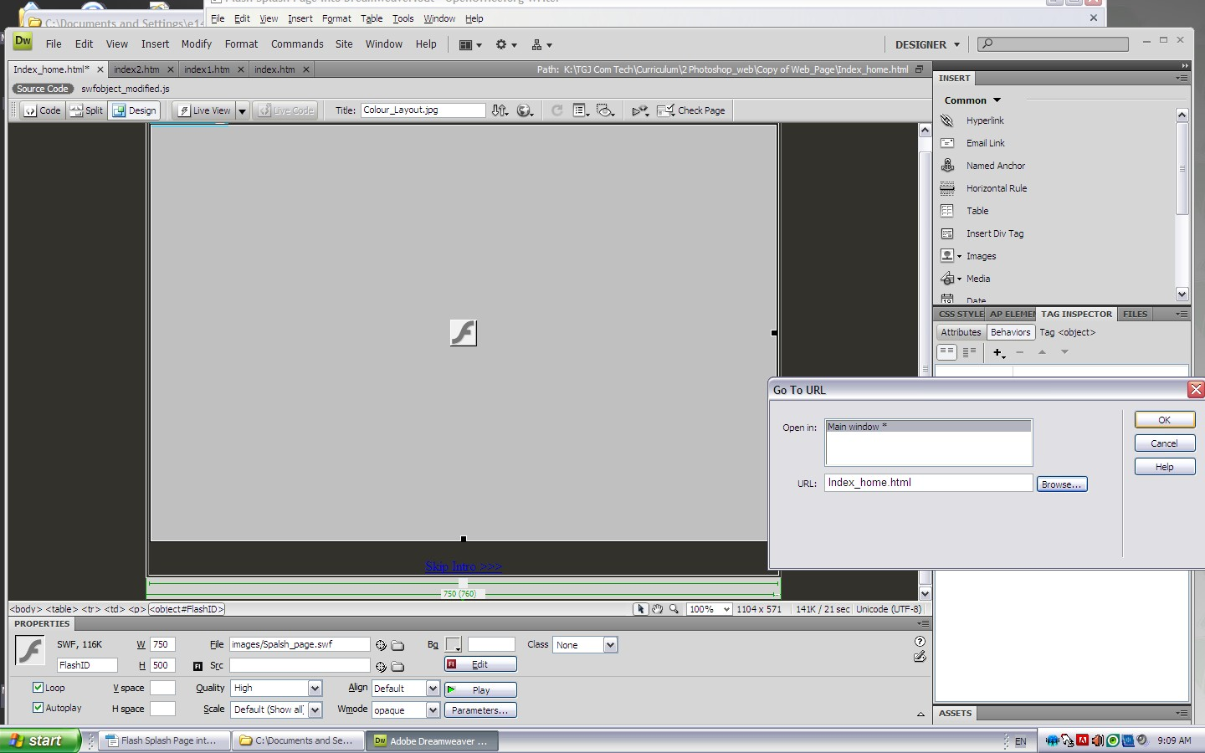

Select the Flash and Click on Tag Inspector Behaviors. Select go to URL. Link to the Index_home page.
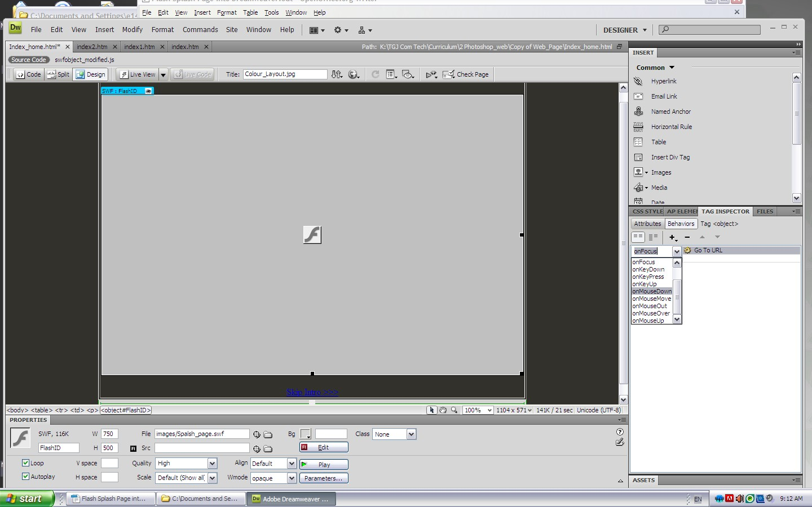
Change the on Focus to onMouseDown. Test the Page.

