Making a Flash Splash Page.

Open Flash. Select action script 2.0 Make a file that is 750 x 500.
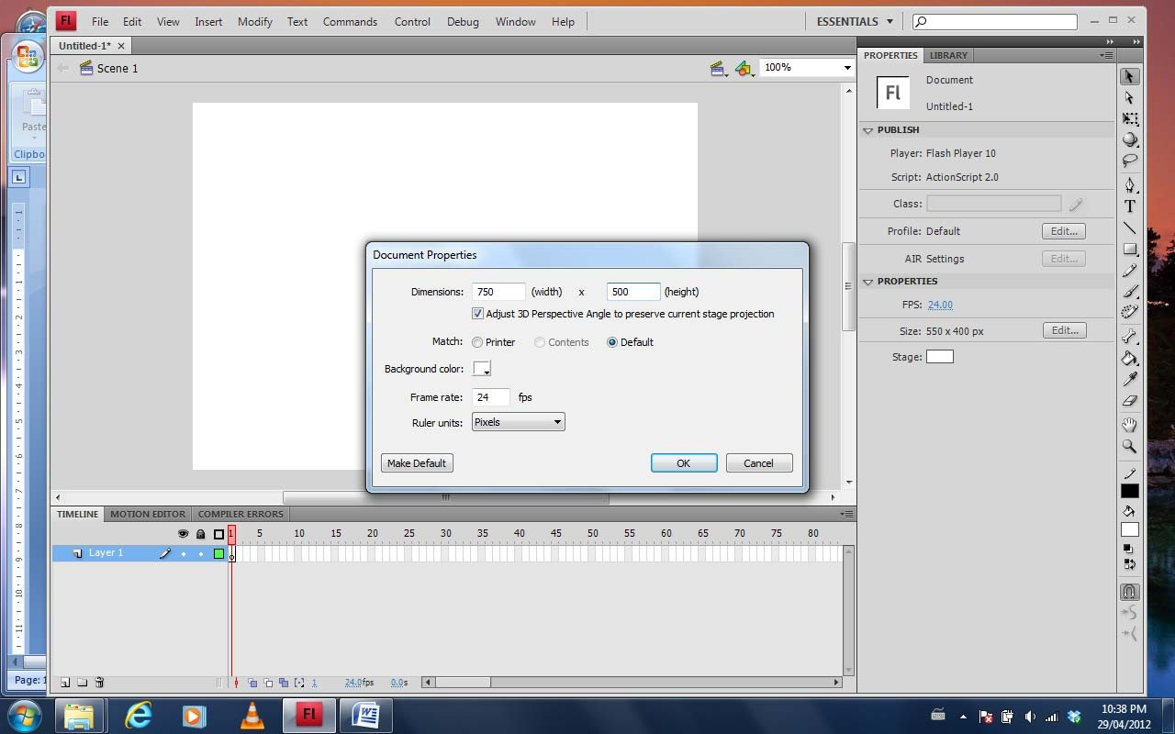
Import you web page slices.

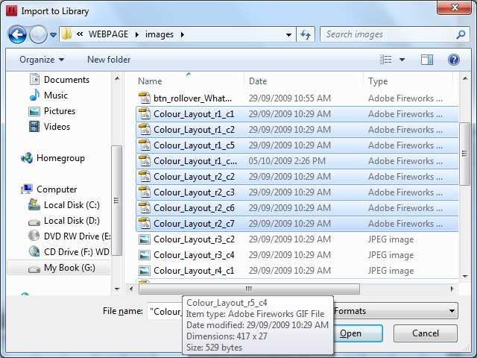

Drag the slices to individual layers

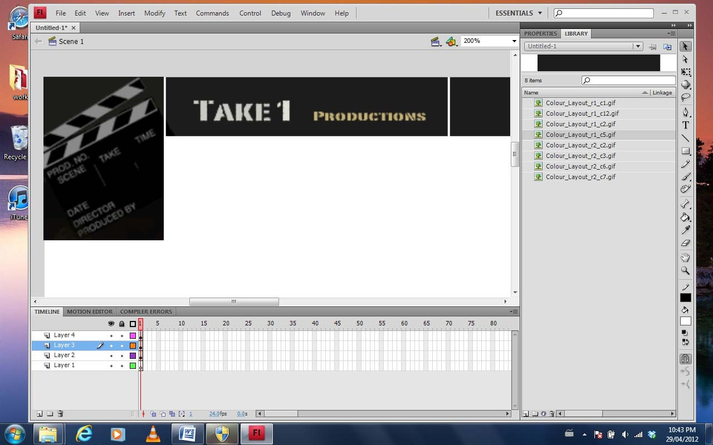

Place motion on the layers

