How to put your banner swf into Dreamweaver
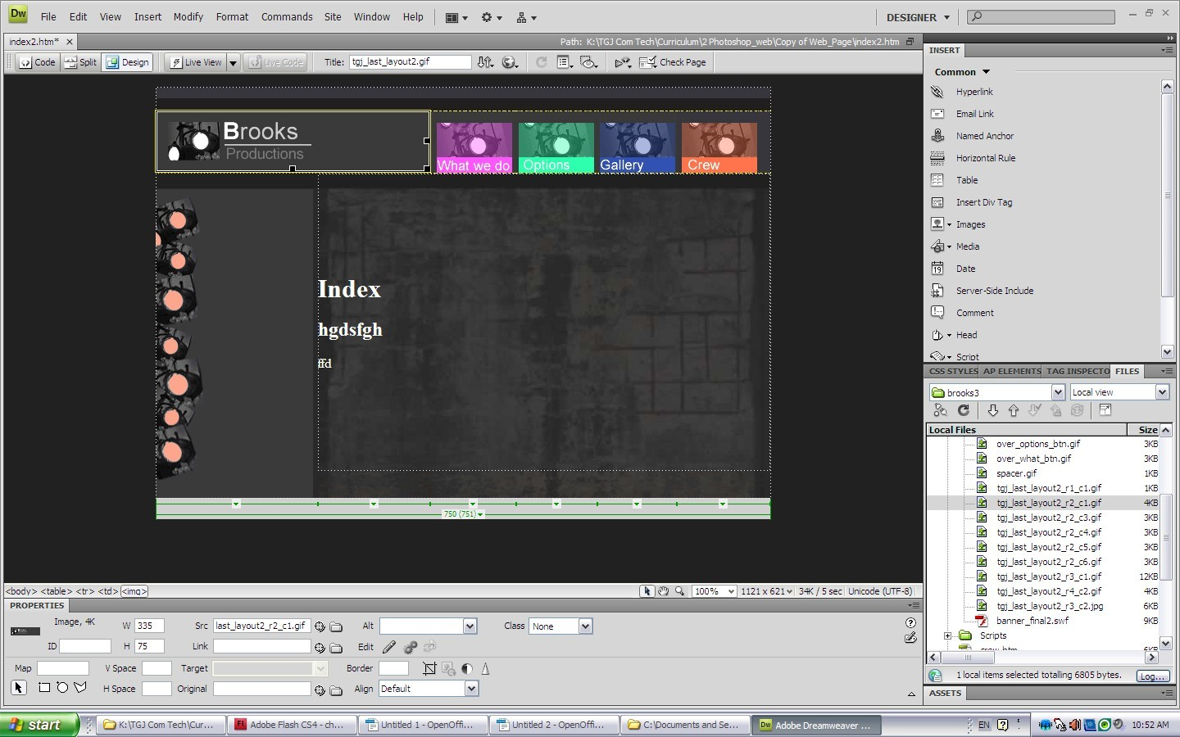
Select the slice and delete it.
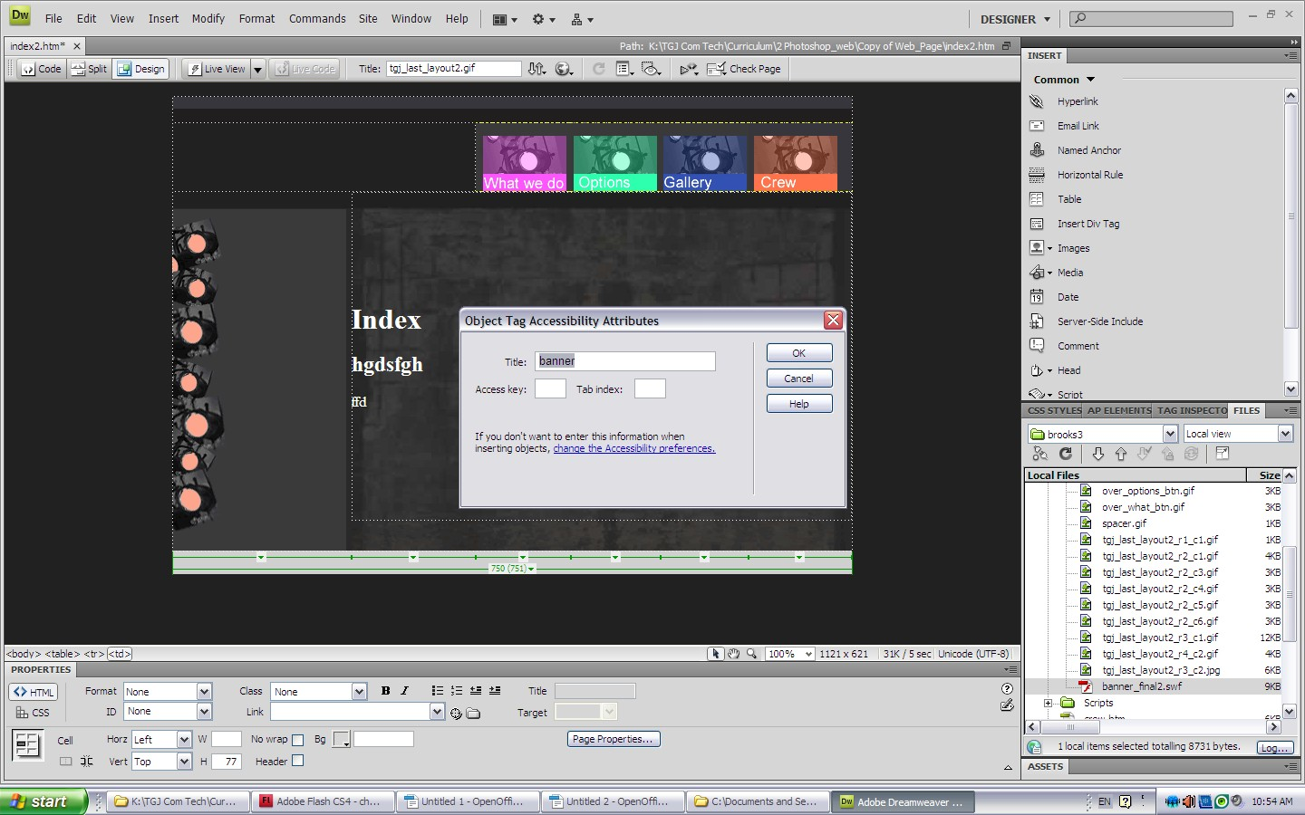
Click hold your banner.swf file and drag it to the banner cell. Name it banner.

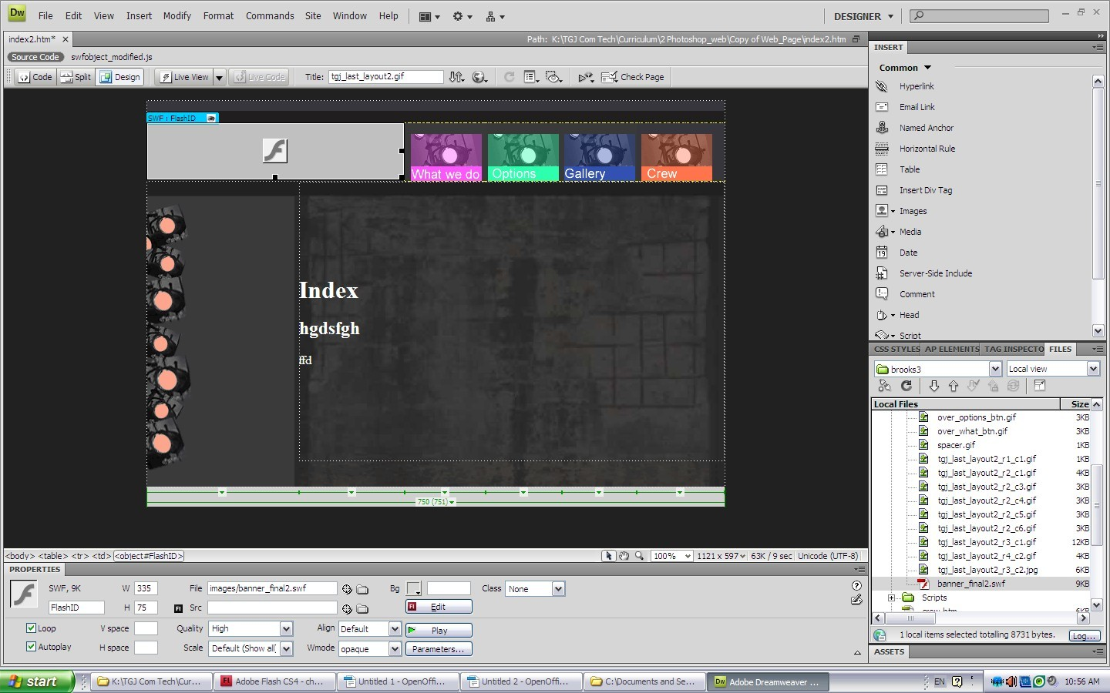

Play or test your website by clicking on live view.

