Exporting your banner. [Creating an .swf from your .fla]
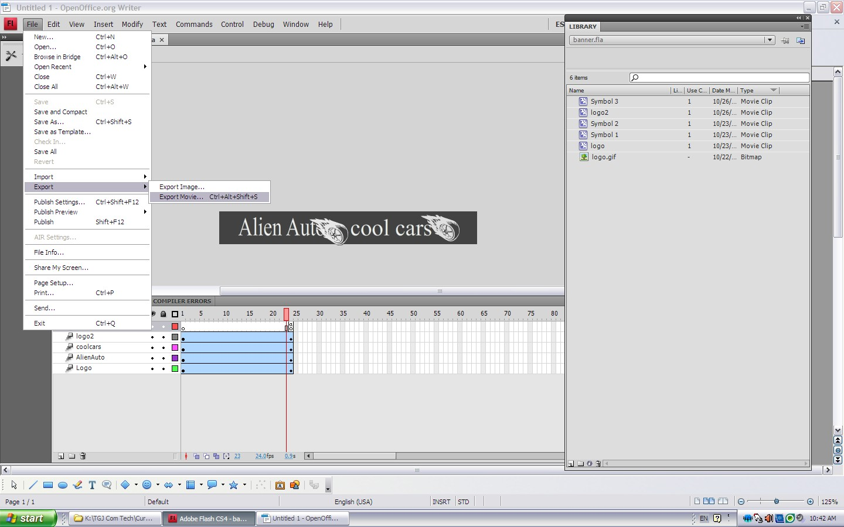
Save the file in your webpage image folder.
