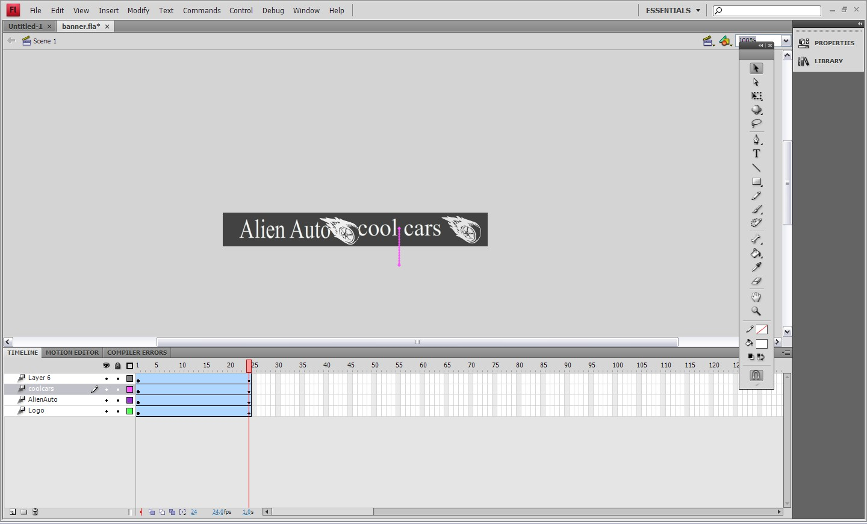
Check the Properties and make sure the Script: ActionScript 2.0 if it is 3.0 edit the default profile.
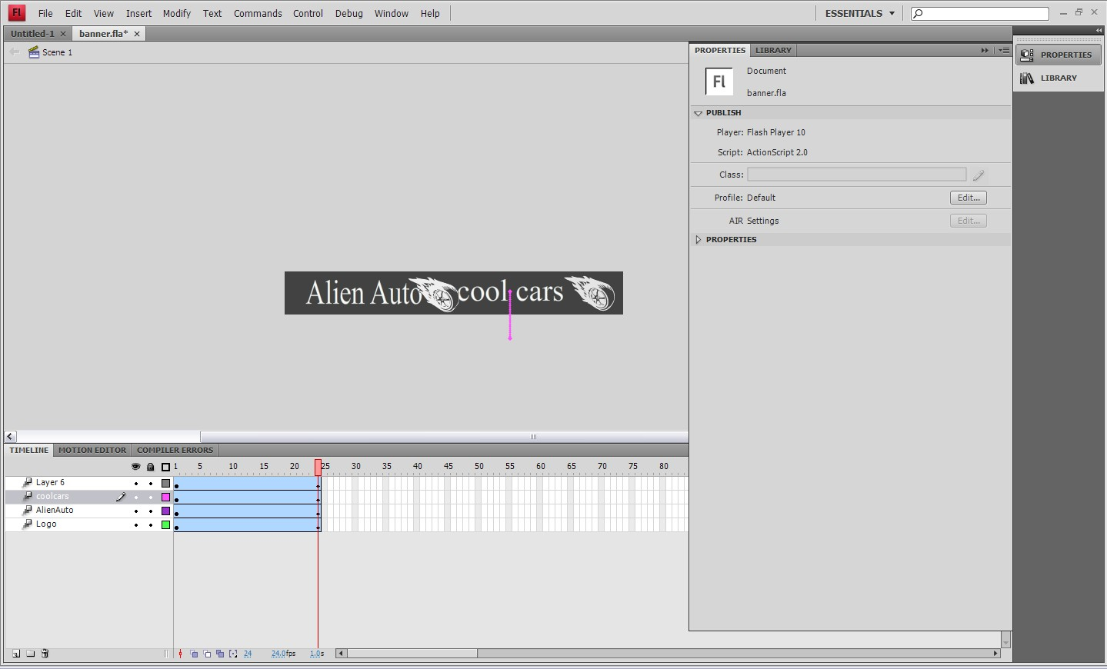
Make a new layer.

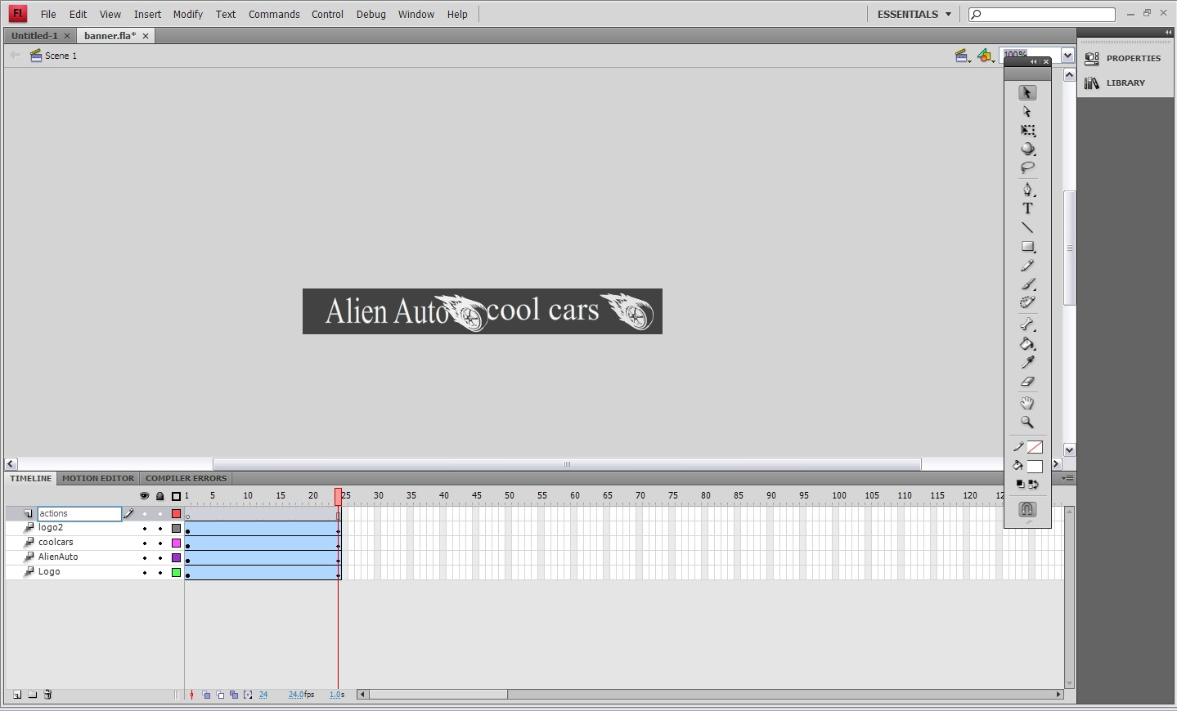
Right click on the last frame of the actions layer and insert keyframe.
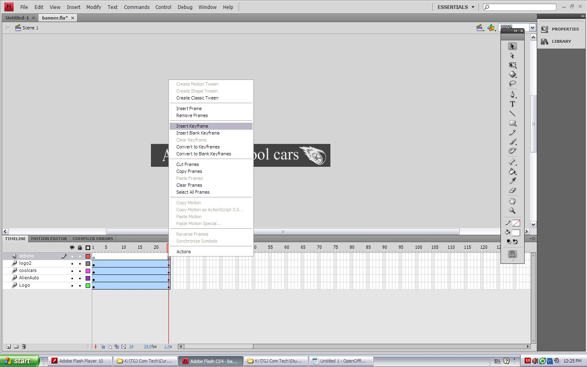

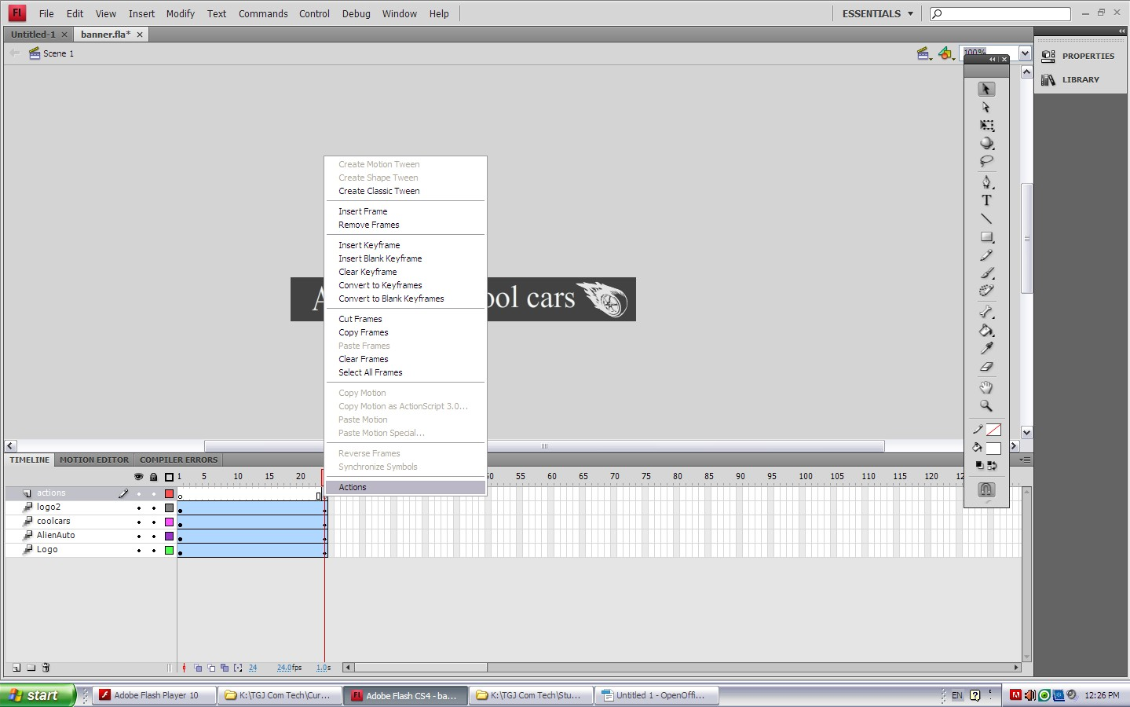
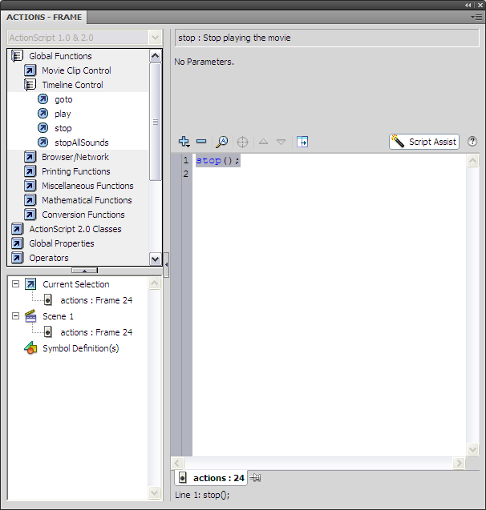Under Global Functions / Timeline Control double click on “stop”

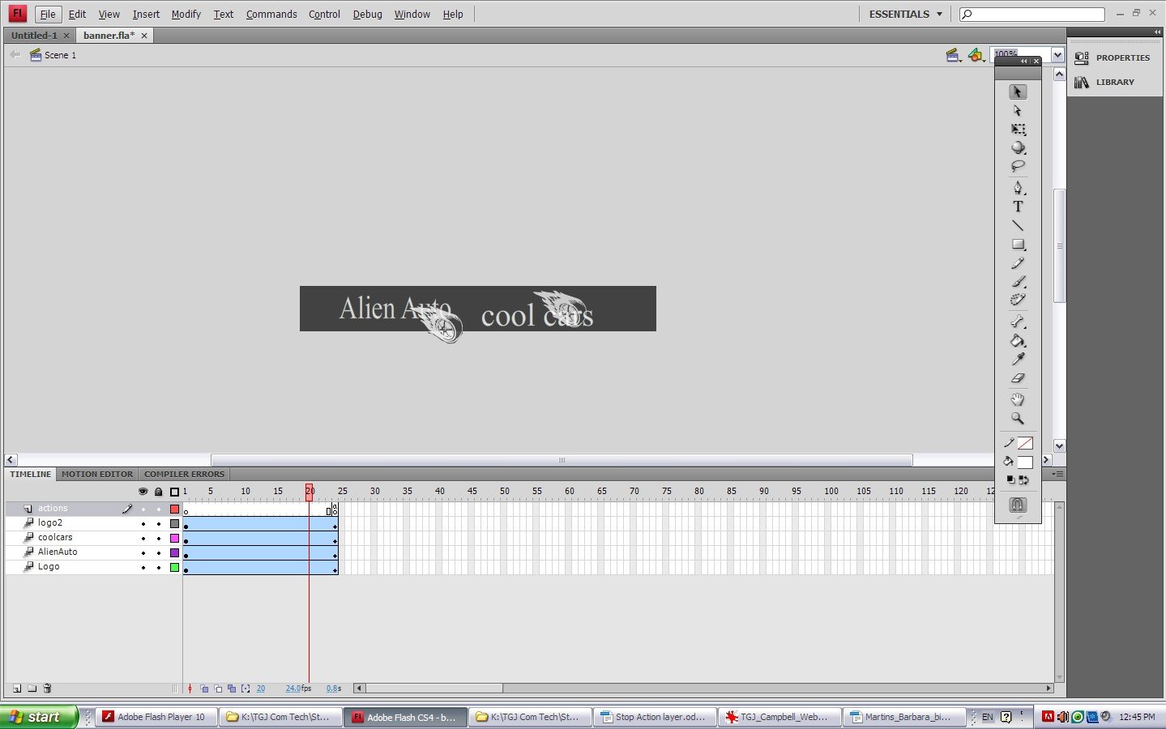

You will now have a layer with called Actions.
The last keyframe will have an open dot with an “a” over it. Test your movie, it will stop at frame 24.

