Creating a flash banner for your Web Page.
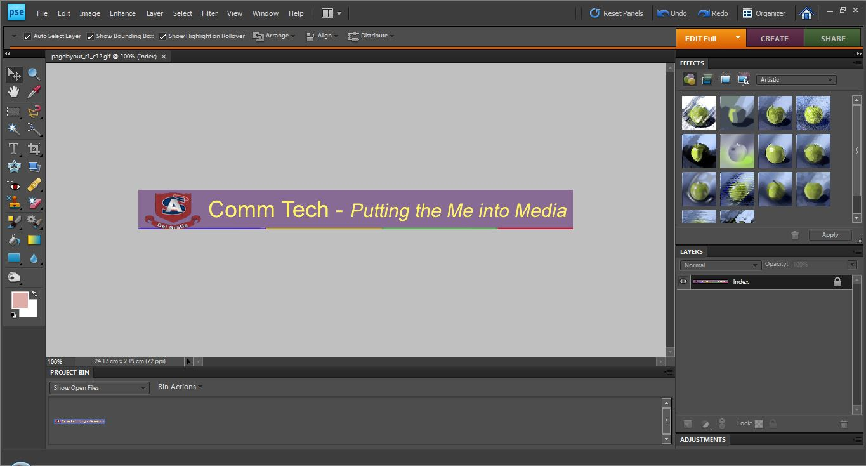
Open your web page slice that included your title and logo in Photoshop and go to image resize to find out the size of the slice.
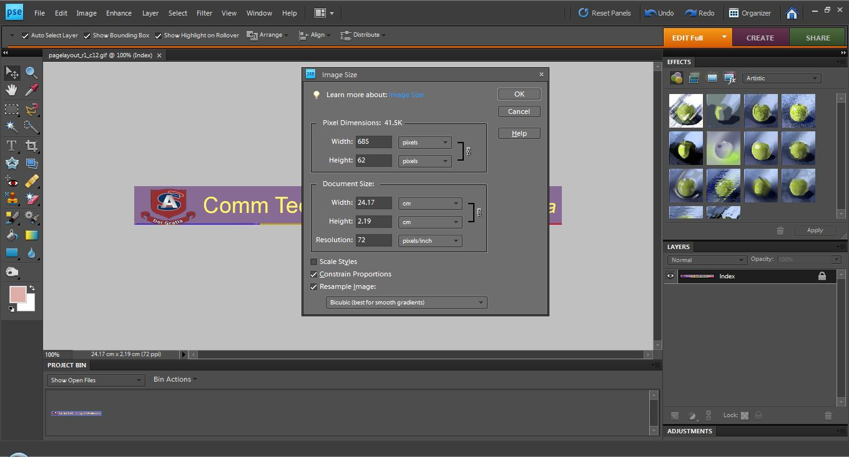

Crop your logo in Photoshop. We will build the text in Flash.
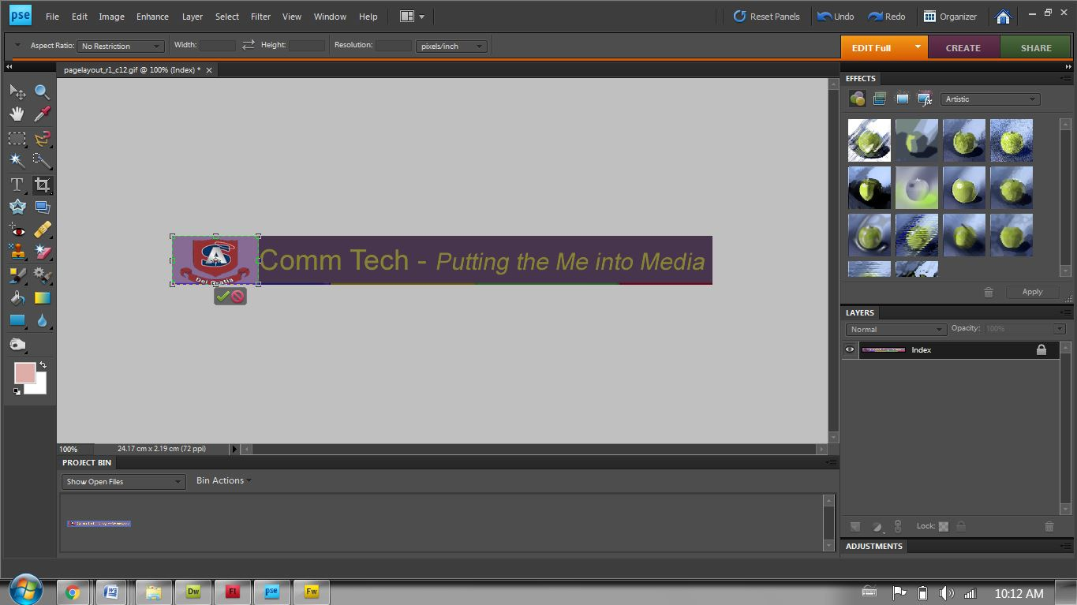

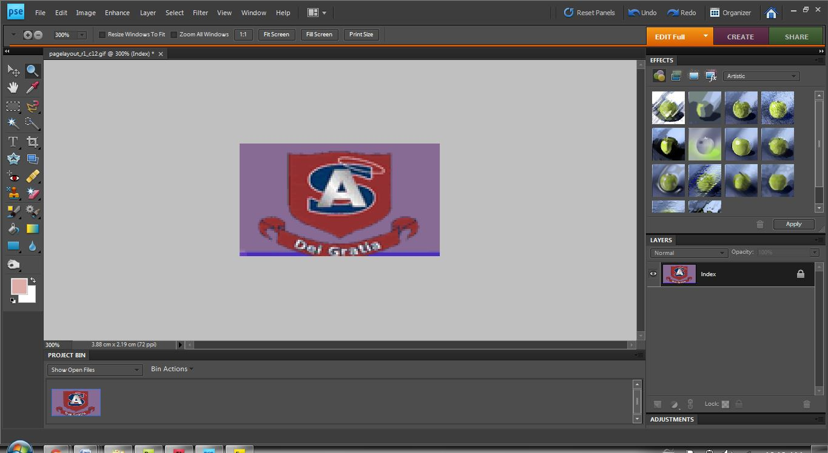

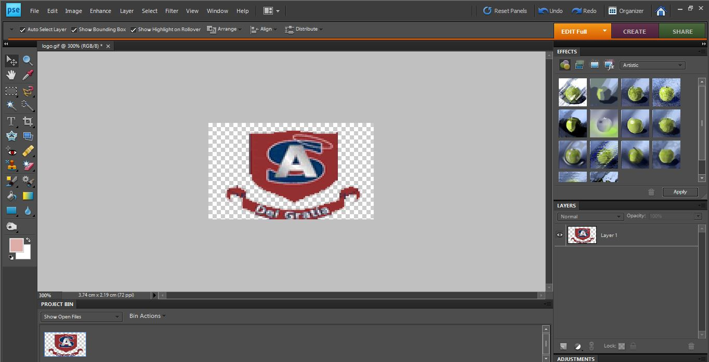
Now use the lasso tool, eraser or the magic wand to remove any background so you will only see the logo.
Save the logo as a gif in your web page images folder.
Title it “logo”.

Note: If you cannot save your photoshop logo as a gif after you edit here is what you do.

Go to image (top menu bar)

Go to Mode

Go to indexed color instead of RGB

Then save as a GIF file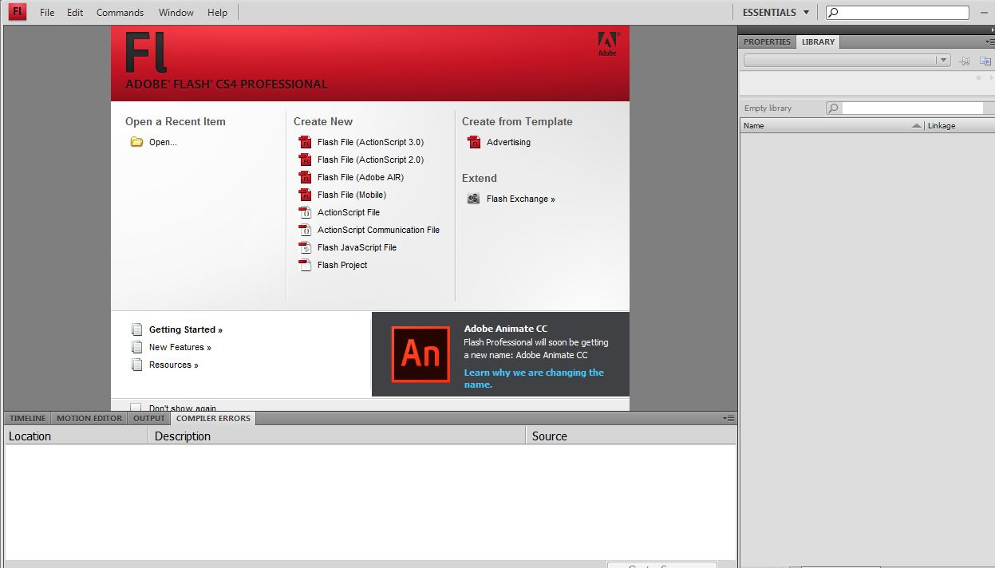

Open flash
Go to create new
Click on action script 2.0

.
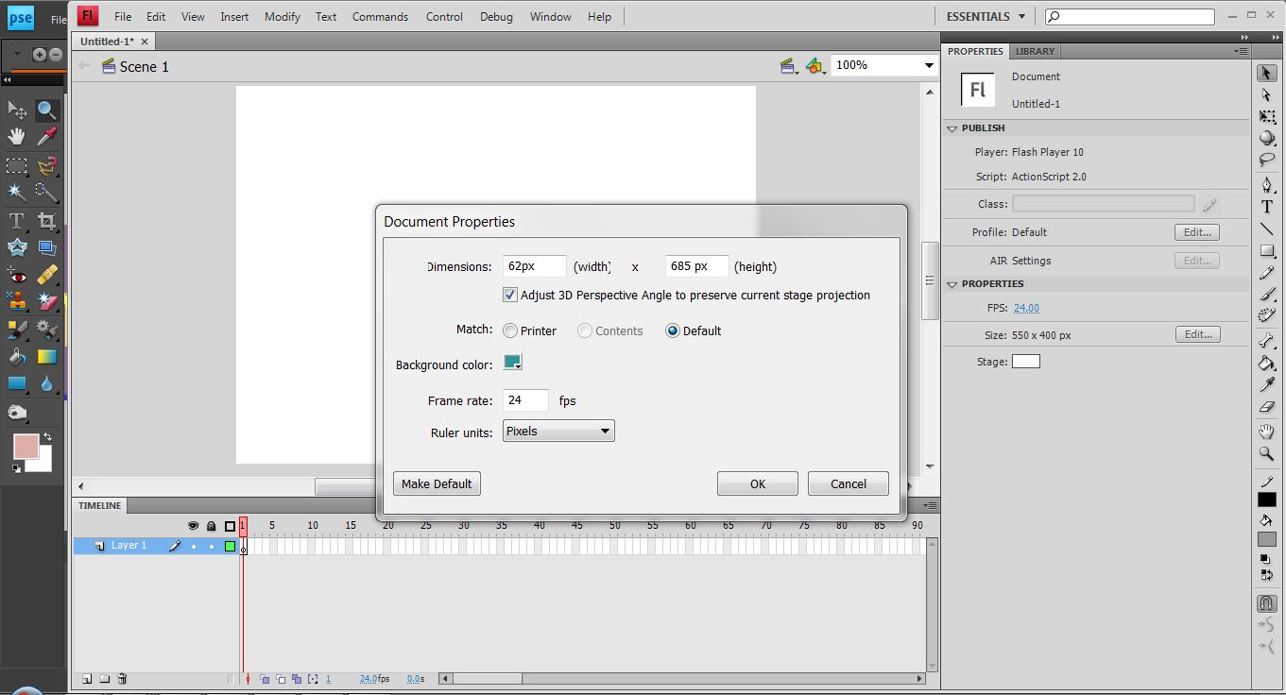
Change the size of the stage to the size of your slice before you cropped it. Change the back ground color so you can better see where the stage is.
Only images within the stage will appear when you run it.
- Go to properties
- Go to size
- Adjust the size of the stage so it matches the size of your logo and title slice.

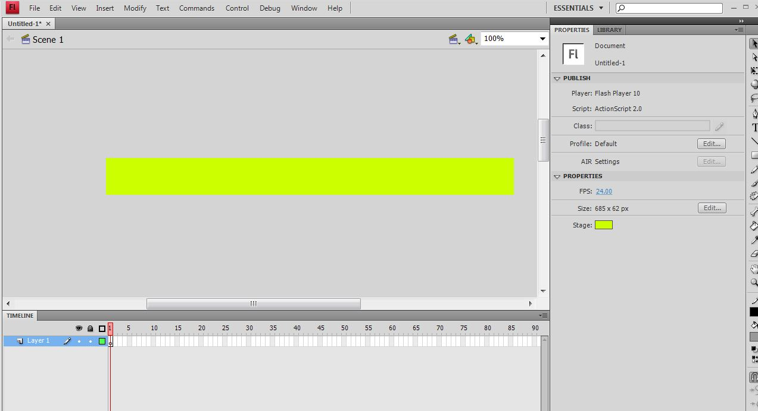

Your screen should resemble what you see above.

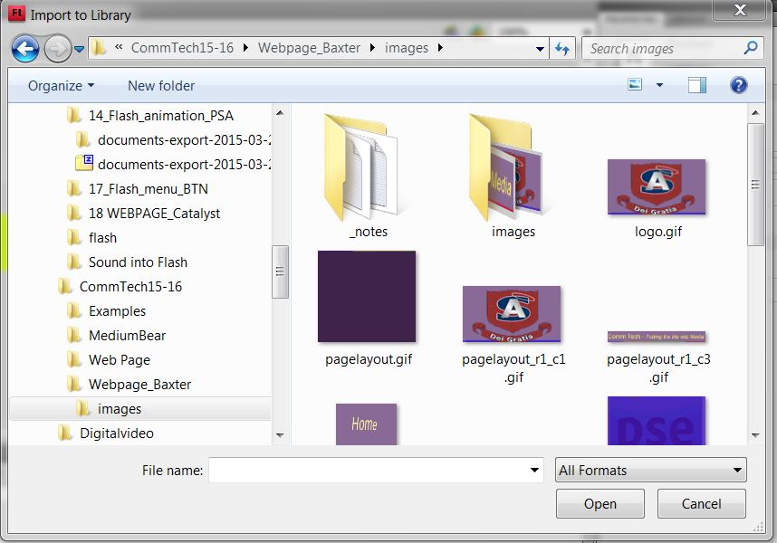

Import to the logo.gif to the Library

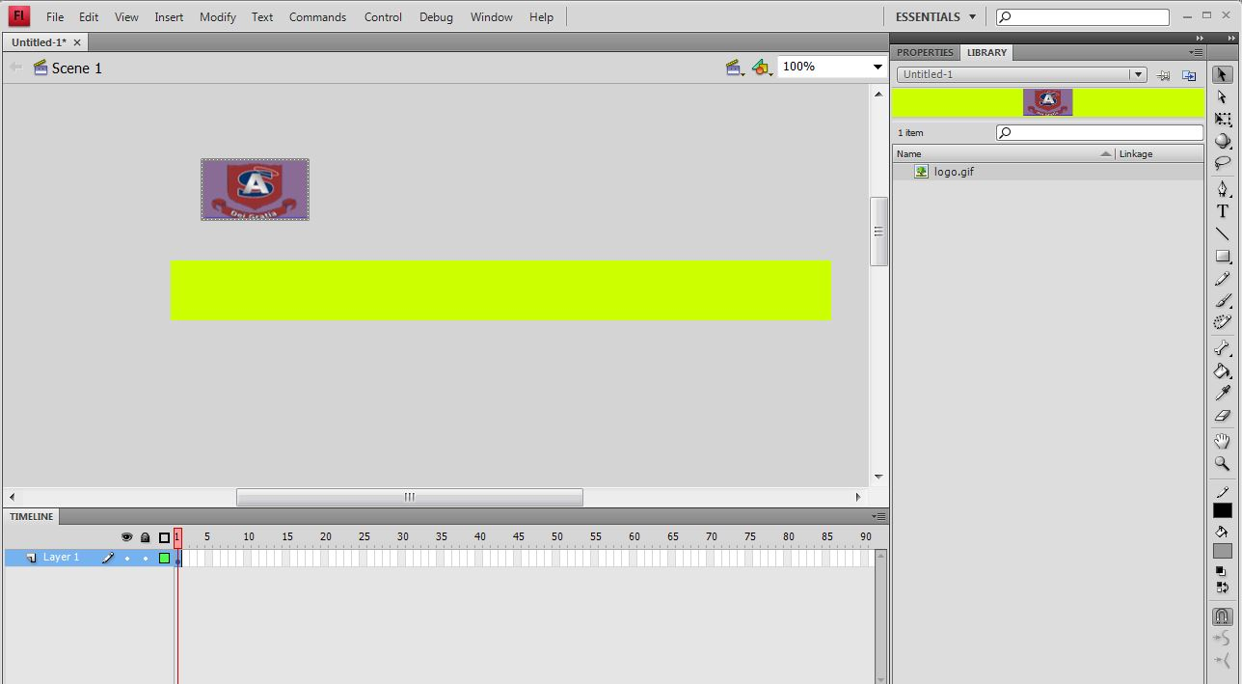

Click and drag the logo onto your workspace.
Notice where you find the library tab to see what images you have to work with in Flash.

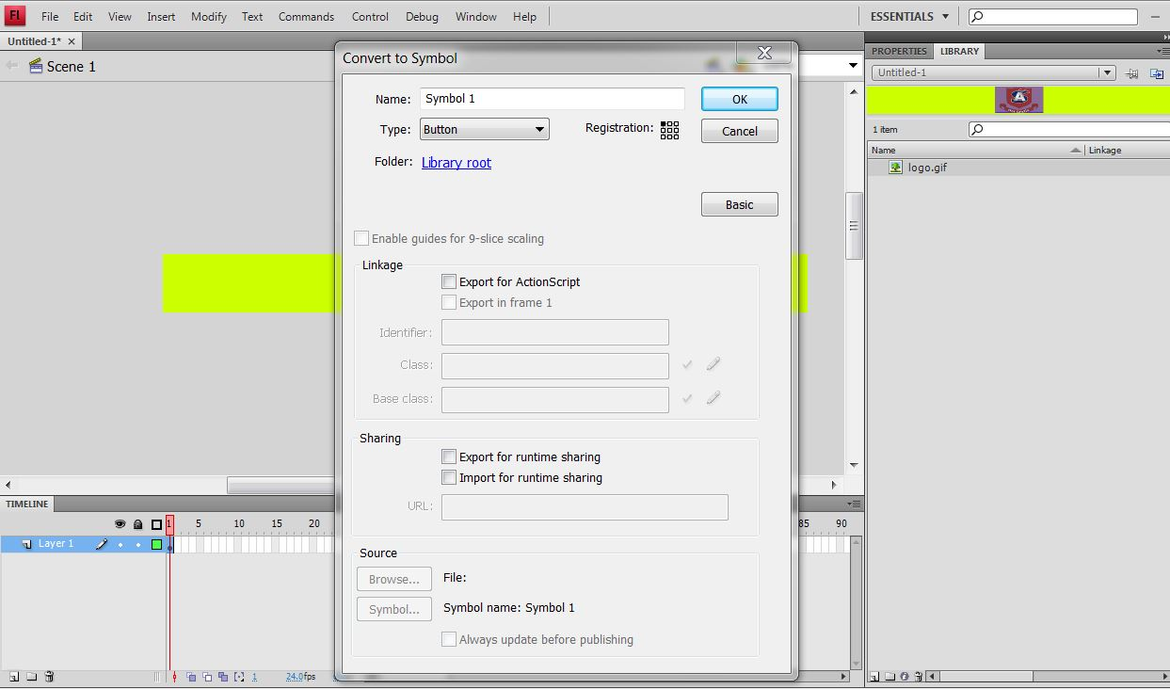

Select the logo and go to the top of the page to Modify.
In modify hit “Convert to symbol” will allow you animate that object.
Be sure to name your symbols – it will make life easier when you get to larger animation with more symbols involved.
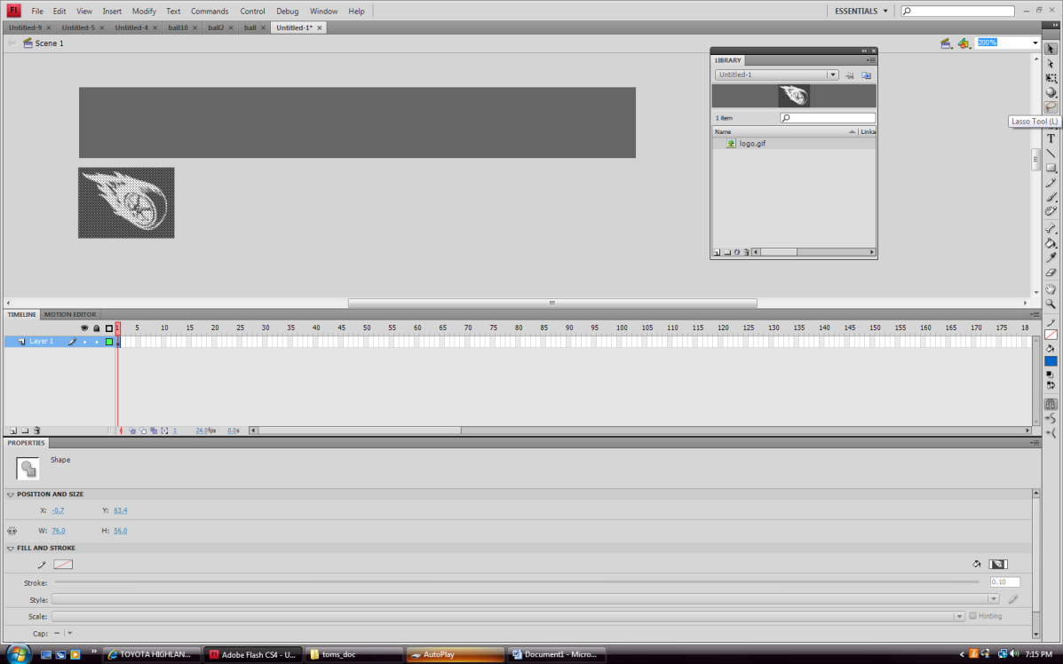

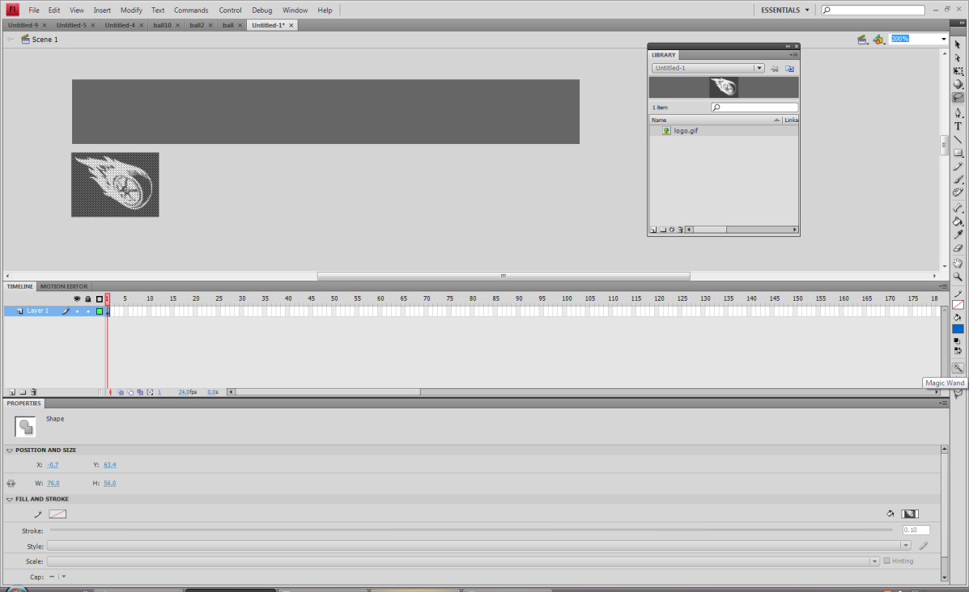

Select the laso tool and then the magic wand.
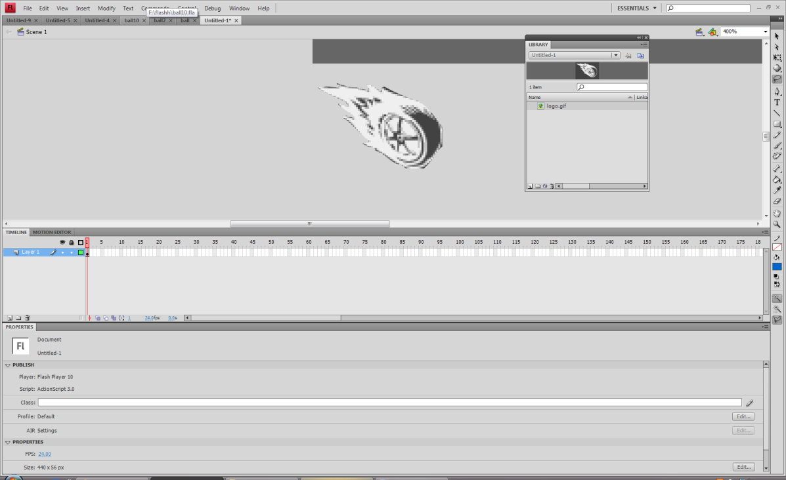

Click on the grey background and hit delete on your key board.

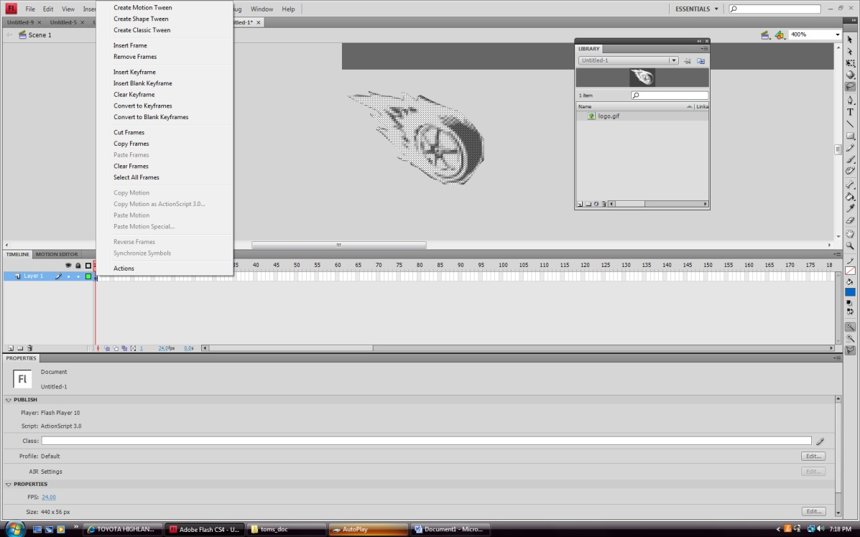

Right click on frame one and select motion tween.

Select OK

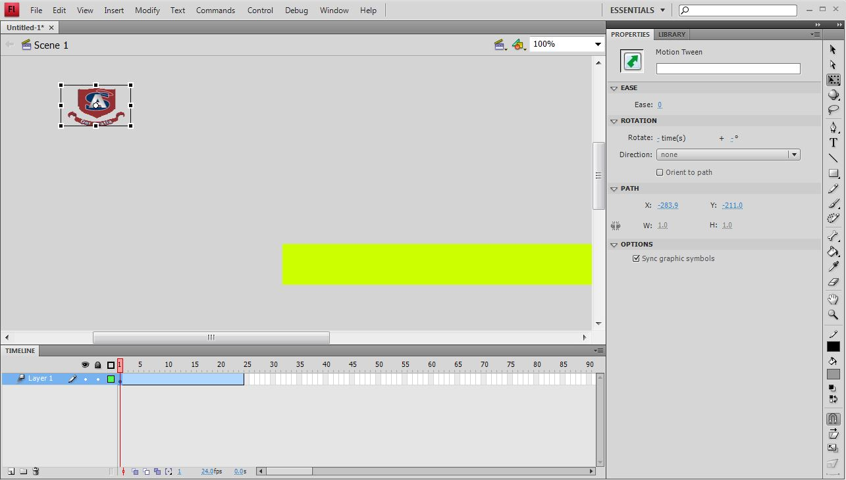
The blue motion Tween bar will appear, stopping at 24 fps.

In the timeline scrub [Move the red rectangle] to frame 24. Click logo on the stage and drag it to the final position. You can also stretch it or rotate it.
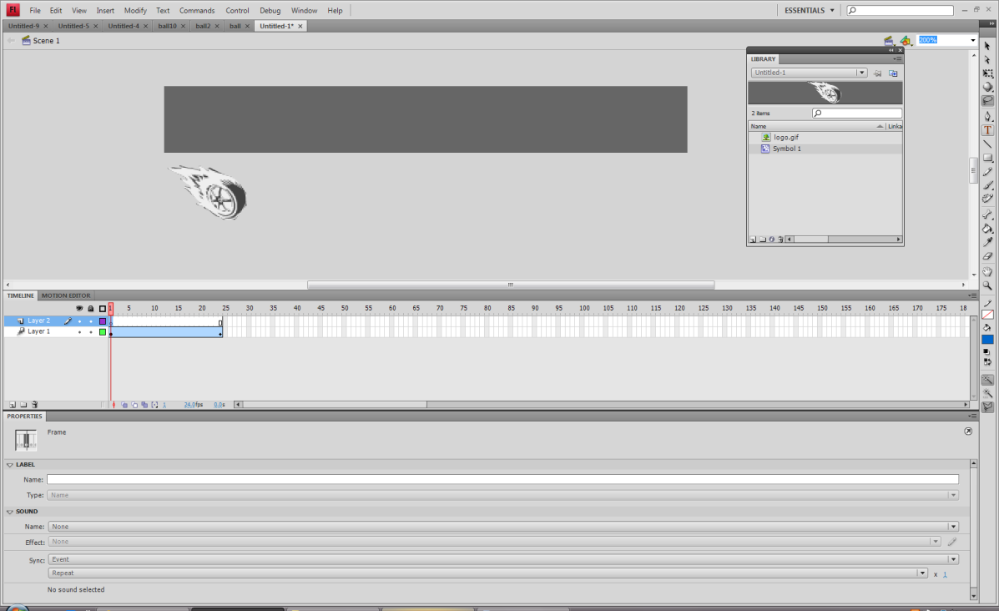

Add a new layer and add text.

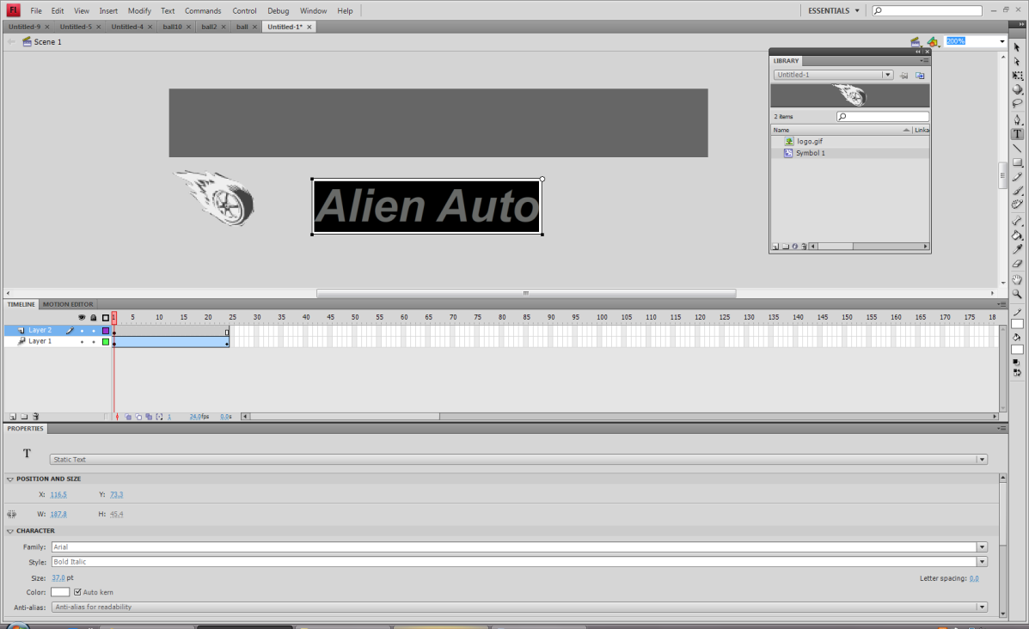
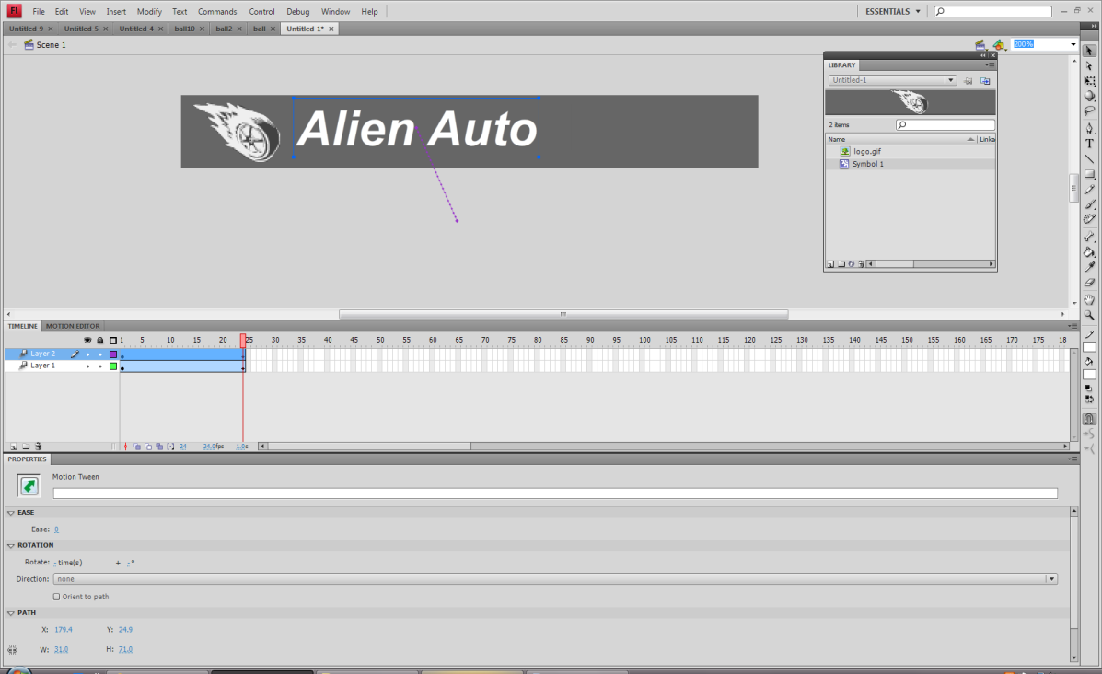

Add the animation.

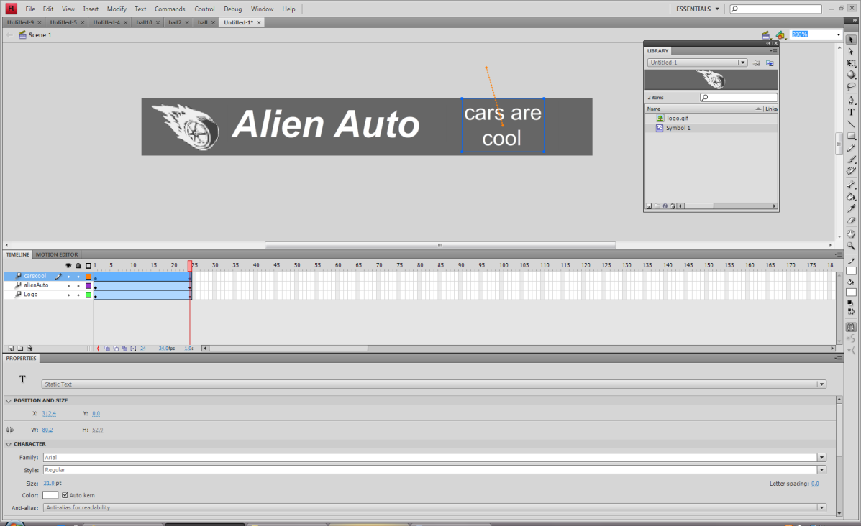

Add the subtitle text.
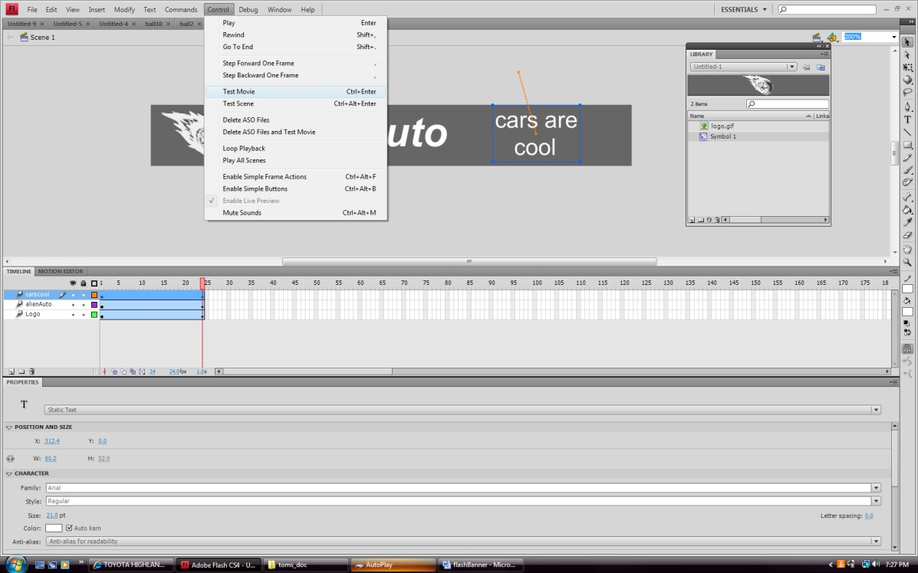
Test your move.

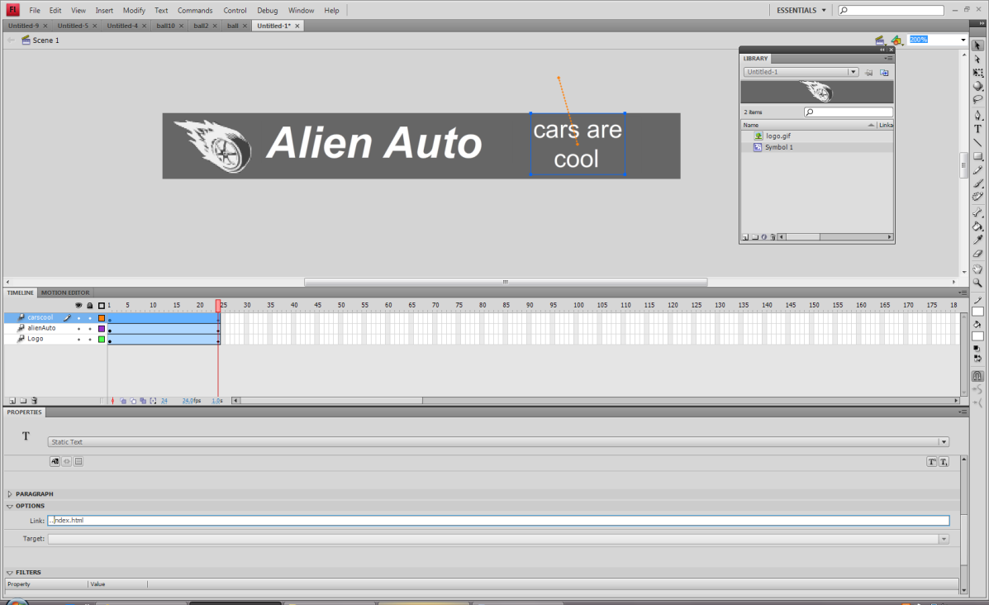
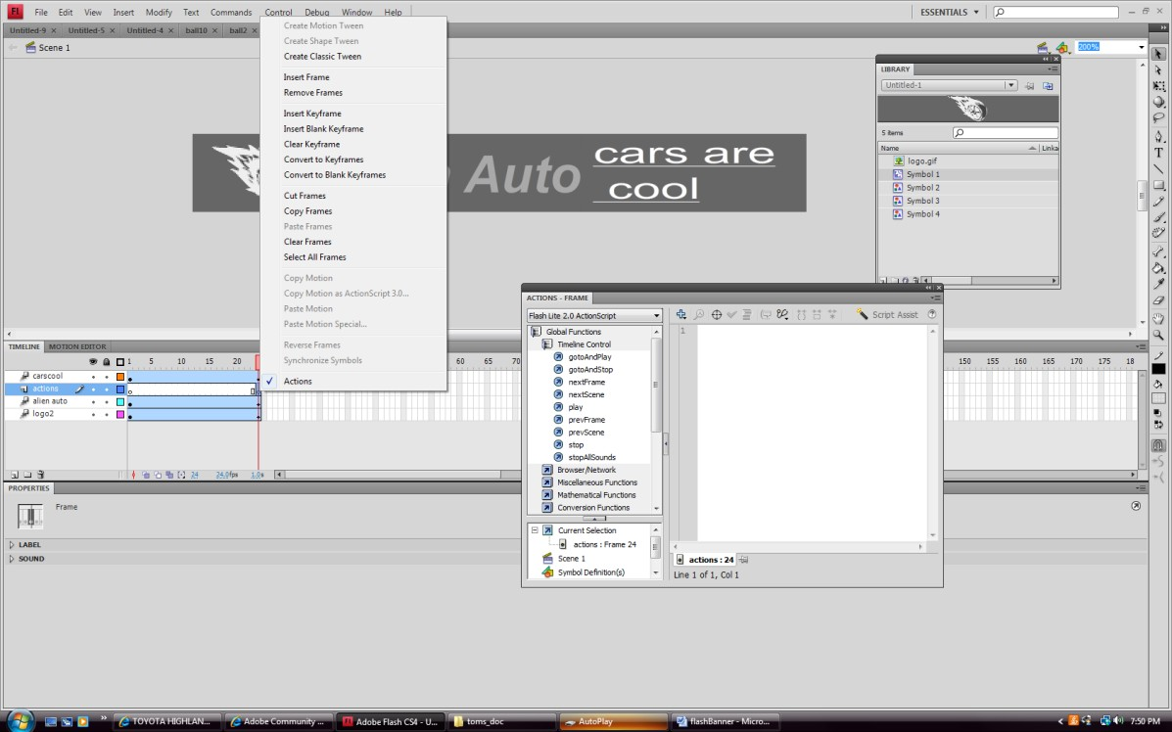

Add a new layer. Name it actions. We will place a stop action on this layer.
Right click on frame 24 of this layer and add a key frame. Right click on this frame and add actions. Under global functions select stop.

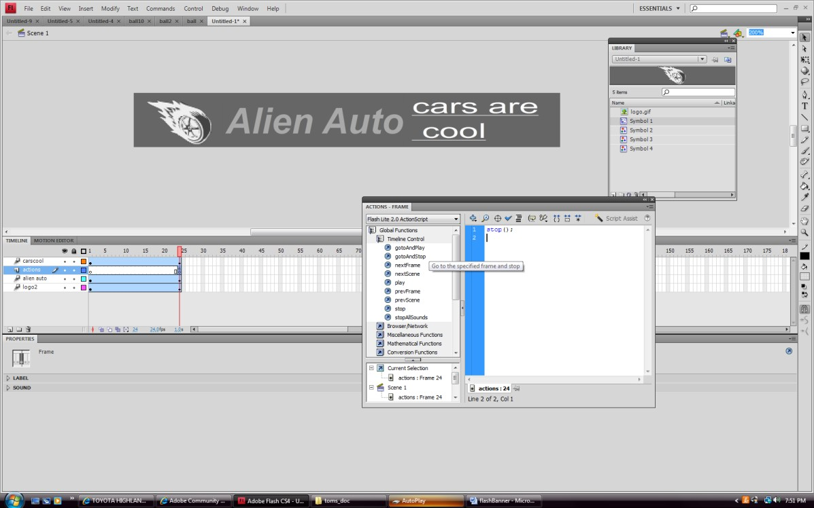
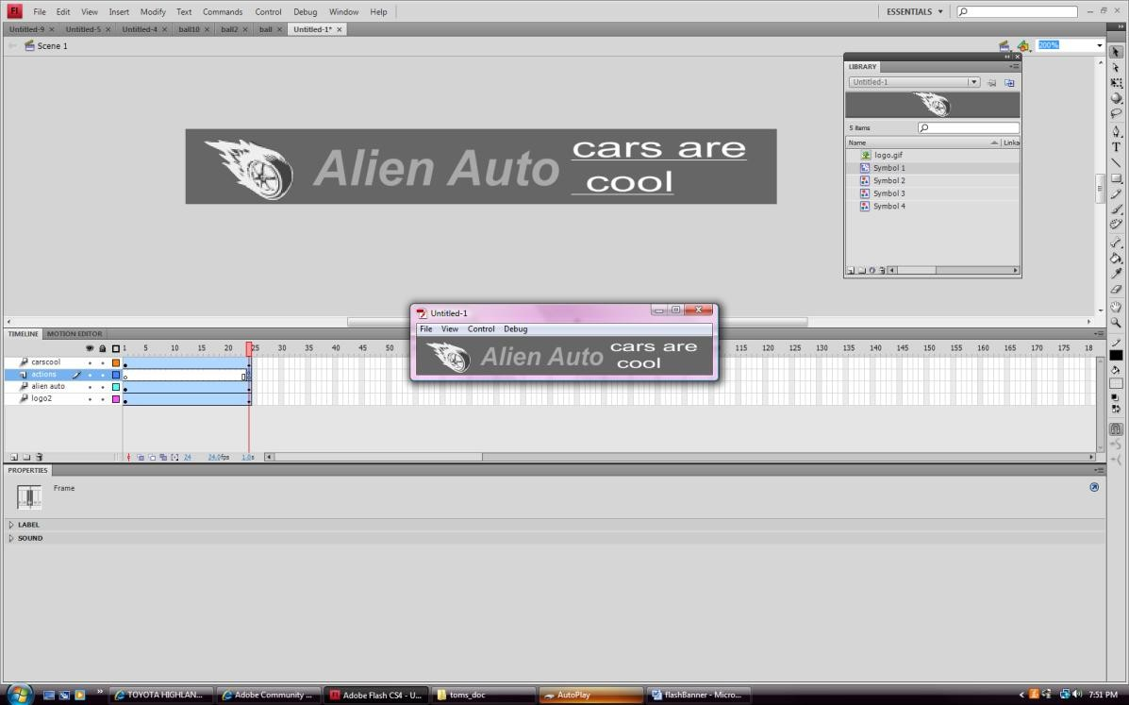

Test your movie.

Putting Alpha [Transparency-Fades] on an object.
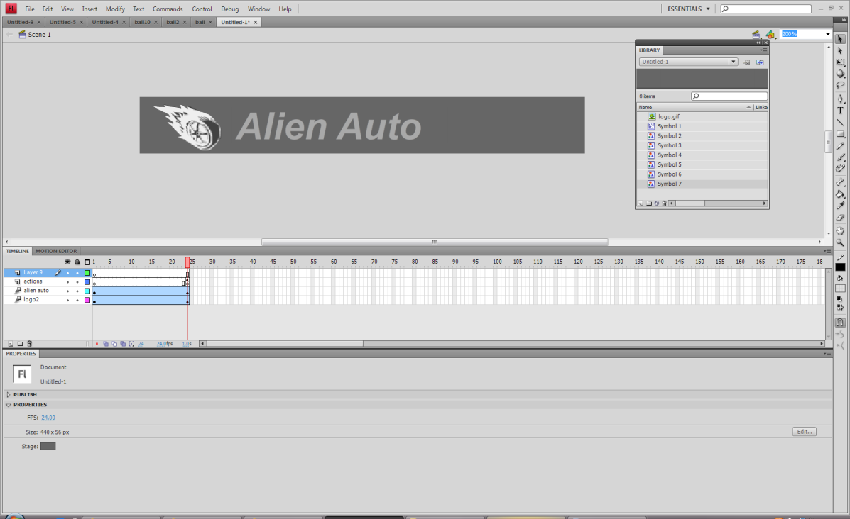
Create a new layer. Click on frame one. Place some text on the stage. [Fades must created in a specific sequence].
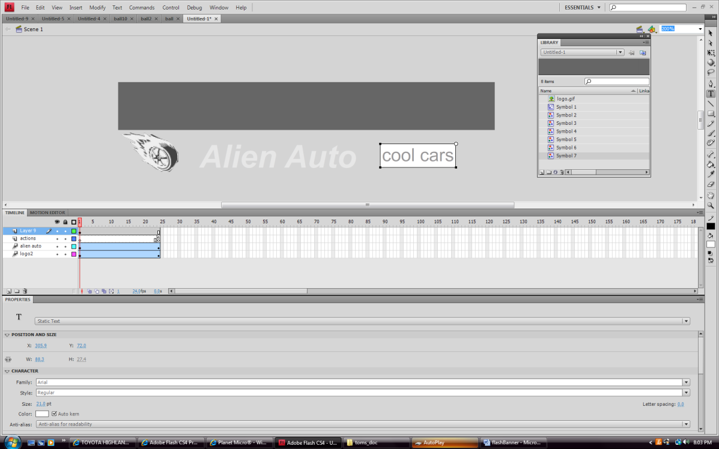

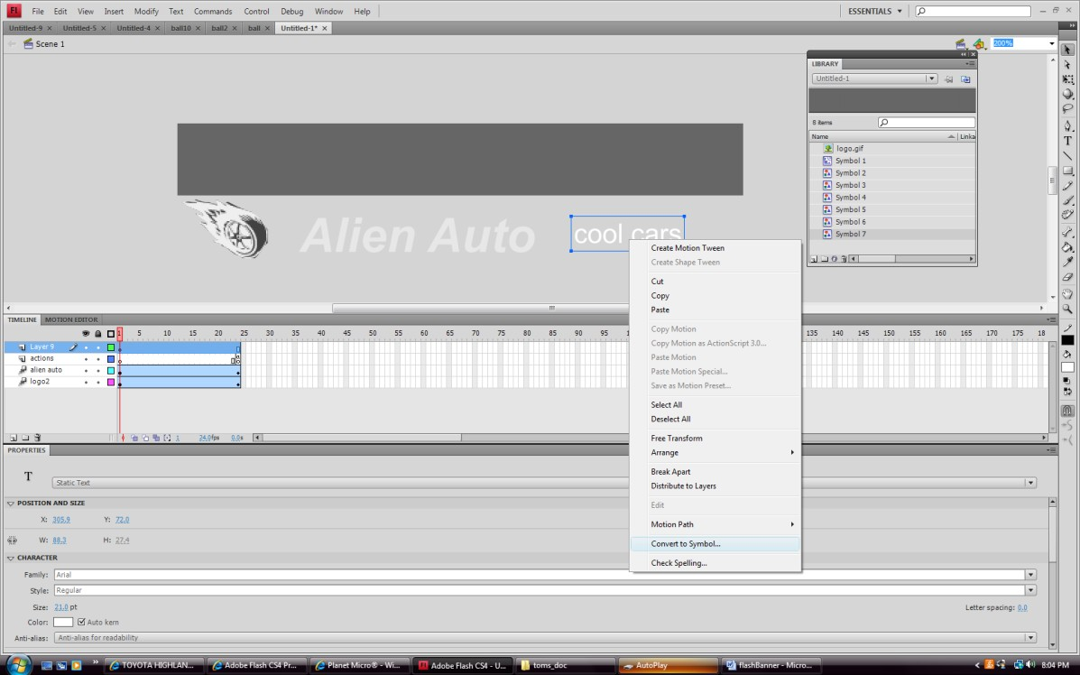

Right click on the symbol on the stage and select convert to symbol.
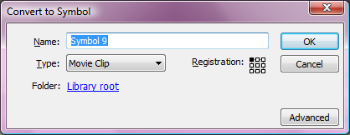

Select movie clip.

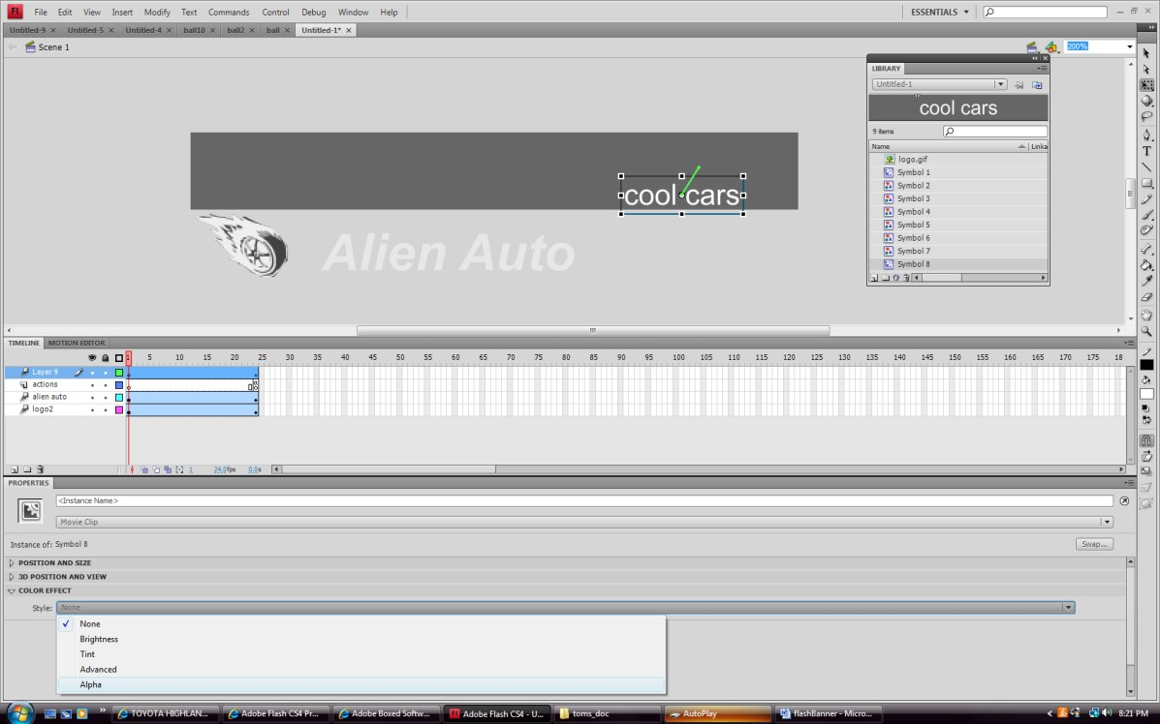

Clip on the text on the stage. Select color effects from the property bar and select alpha.
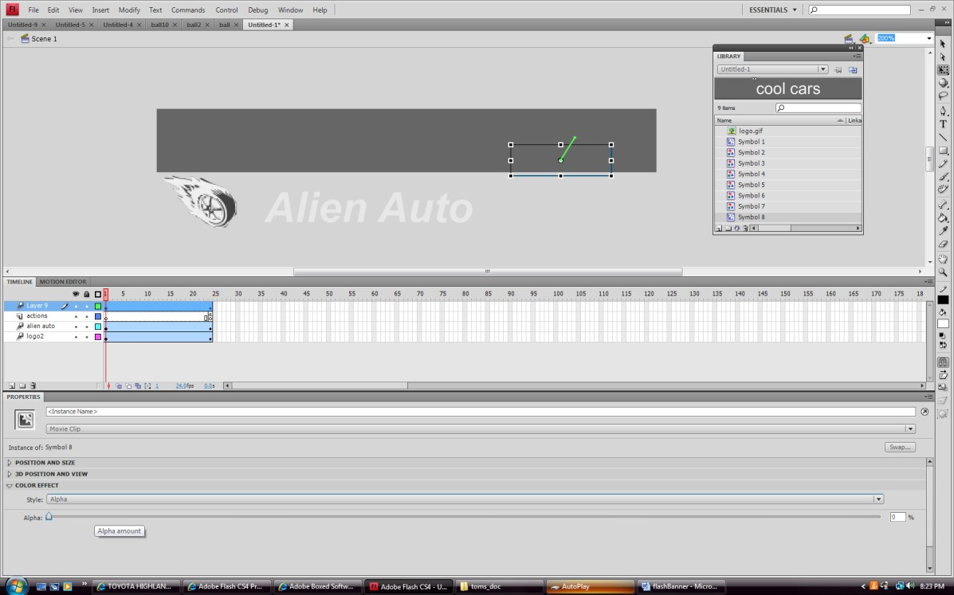
Move the slider to zero alpha. The text will disappear.

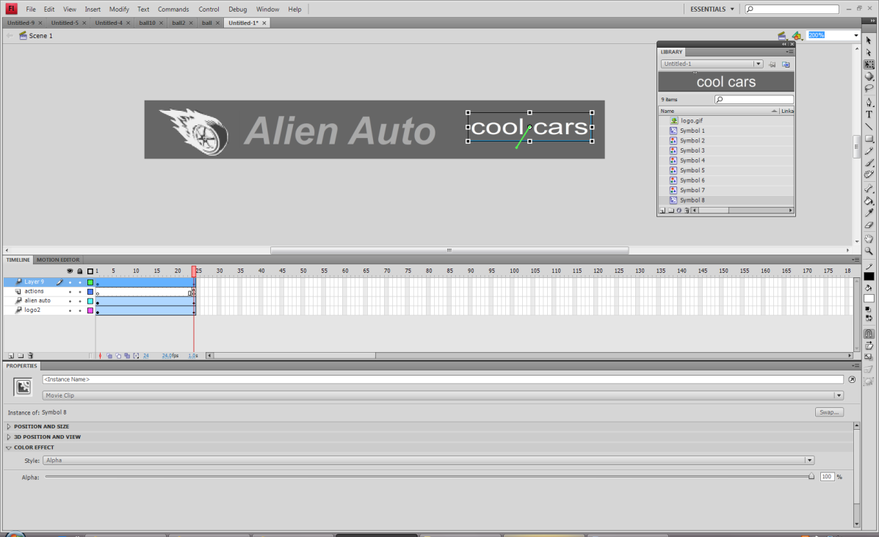
Scrub the time to frame 24 and select the text. Click color effects alpha and slide it to 100%. Test your move.
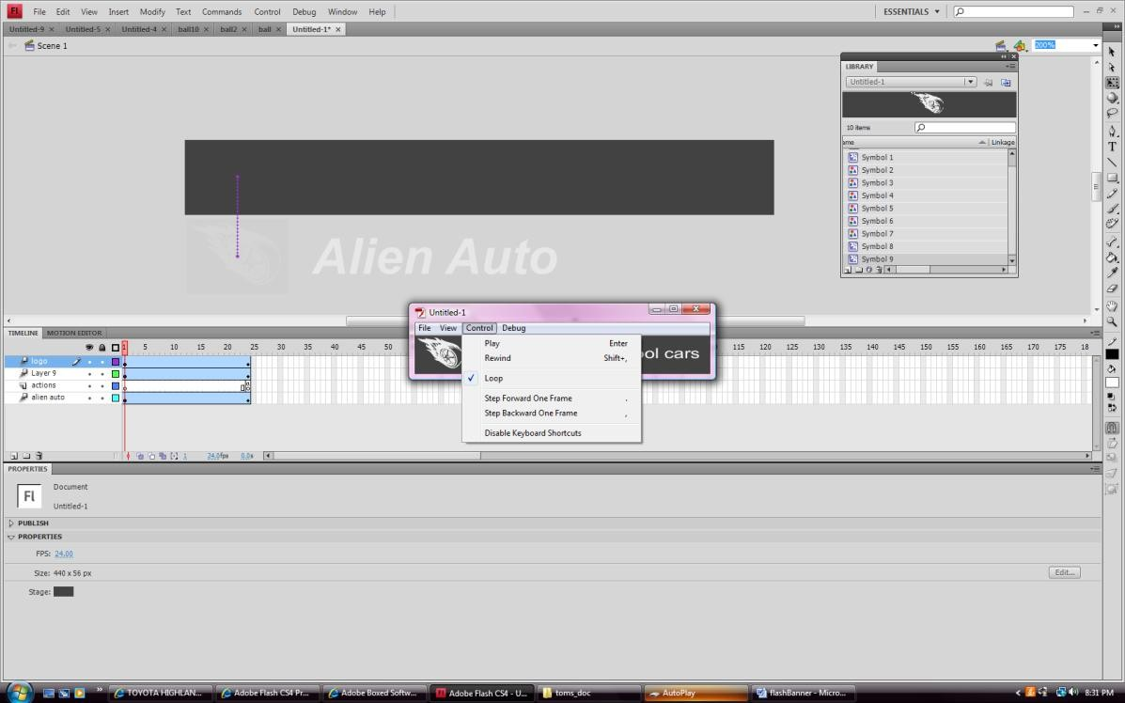
To watch your movie again select rewind and play. NOW YOU MUST GO TO FILE EXPORT MOVIE.
Call the file Banner.swf save it into the images folder of your Webpage Folder.

Open Dreamweaver. Manage Sites.
In your web page click on the cell and remove the old slice. Insert Media Flash and select Banner.swf [F12 to test your page]

