Linking the Other pages: Every button you have made will be creating a link to a new page.

- Open Dreamweaver and manage sites

- Open your page layout .htm (This is going to be your home page)
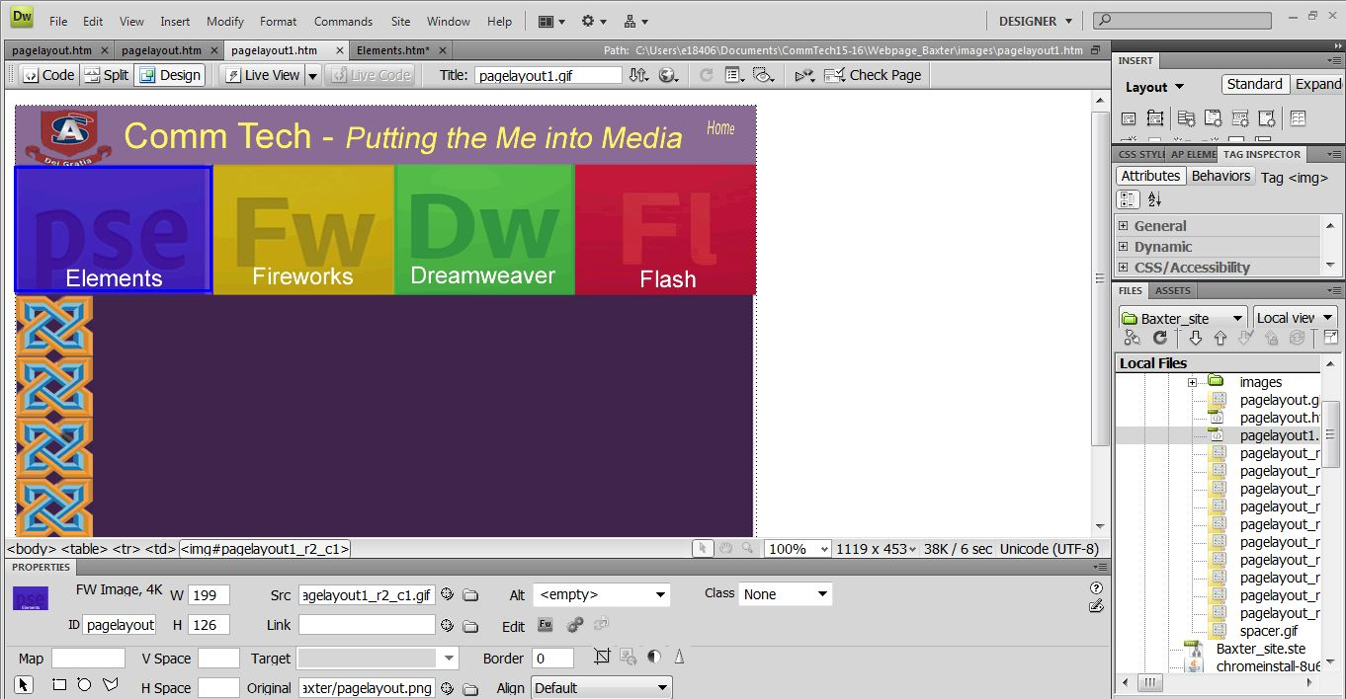

Click on each button slice then click the folder next to the Link box at the bottom middle of the page

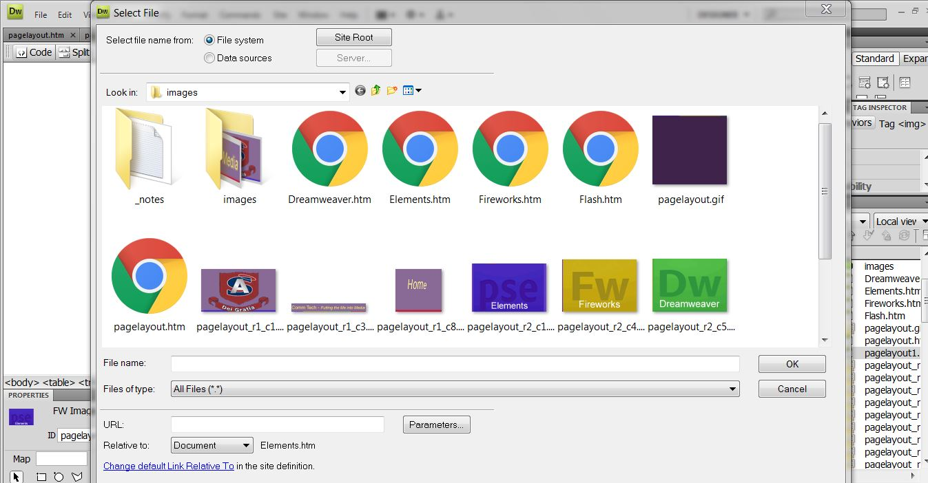

Link the buttons on the other pages:
- Hit OK, then link the next button.

Do this with EVERY page you made or you will not have links on them

