Practice Titration Lab
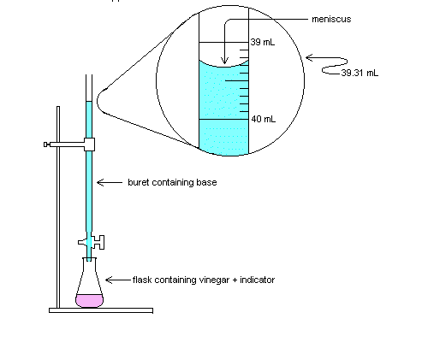.
Flask containing Acid and indicator
Figure 1.
Titration Apparatus
How do we know when the equivalence point has been reached? That is, how do we know when to stop adding base? The answer is that we add an indicator. An indicator is a substance whose color depends on the acidity of a solution. In this experiment we will be using the indicator phenolphthalein. Phenolphthalein is pink in acidic solutions and colourless in basic solutions. The phenolphthalein is added to the vinegar solution before starting the titration. At the equivalence point the indicator changes from colorless to a faint pink colour. The faint pink color at the end-point should persist for at least 30 seconds of swirling to be accepted as genuine.

.
How do we know when the equivalence point has been reached? That is, how do we know when to stop adding base? The answer is that we add an indicator. An indicator is a substance whose color depends on the acidity of a solution. In this experiment we will be using the indicator phenolphthalein. Phenolphthalein is pink in acidic solutions and colourless in basic solutions. The phenolphthalein is added to the vinegar solution before starting the titration. At the equivalence point the indicator changes from colorless to a faint pink colour. The faint pink color at the end-point should persist for at least 30 seconds of swirling to be accepted as genuine.

Purpose: To practice reaching and identifying the endpoint of a neutralization reaction using a burette.
Materials:

- HCl solution (0.5 mol)
- NaOH solution (0.5 mol)
- Phenolphthalein
- 250 mL Erlenmeyer flask
- 250 mL beaker
- Retort stand
- Burette clamps
- 50 mL burette
- Plastic funnel
- graduated cylinder

Procedure:
- Create a table for the observations to show the initial volume, final volume and total volume of sodium hydroxide used to titrate the hydrochloric acid for each trial. Also include the number of drops of NaOH needed to neutralize the HCl.
- Add 10 mL HCl to a 250 mL Erlenmeyer flask along with 100mL of water.
- Add 3 drops of phenolphthalein to the Erlenmeyer flask.
- Add 20 mL NaOH along with 30mL of water to the burette using the beaker and the funnel.
- Titrate the HCl sample with NaOH until a single drop produces a permanent colour change (i.e. a colour change lasting more than 30 seconds after being swirled). If you get a bright colour you have overshot your endpoint. Add one drop at a time and count the number of drops you have added.
- Repeat steps 2-5 until two consistent results are obtained.
- Clean up area, wash buret and glassware with soap and water and put all waste in the appropriate container provided.
- When storing the buret after use, ensure the valve is in the open position to allow evaporation of any water left after rinsing.

Questions Practice Titration Lab
Answer the following questions based on the practice titration lab.
- What is the purpose of the phenolphthalein?

- What other word could you use in place of endpoint?

- Why is it necessary to repeat the steps?

- What conclusion have you reached when comparing the volume of hydrochloric acid needed to titrate a volume of sodium hydroxide?

