Creating the Other pages:

- Open Dreamweaver and manage sites

- Open your page layout page (.html file) (with no text showing so you can easily add and edit the content of each page.

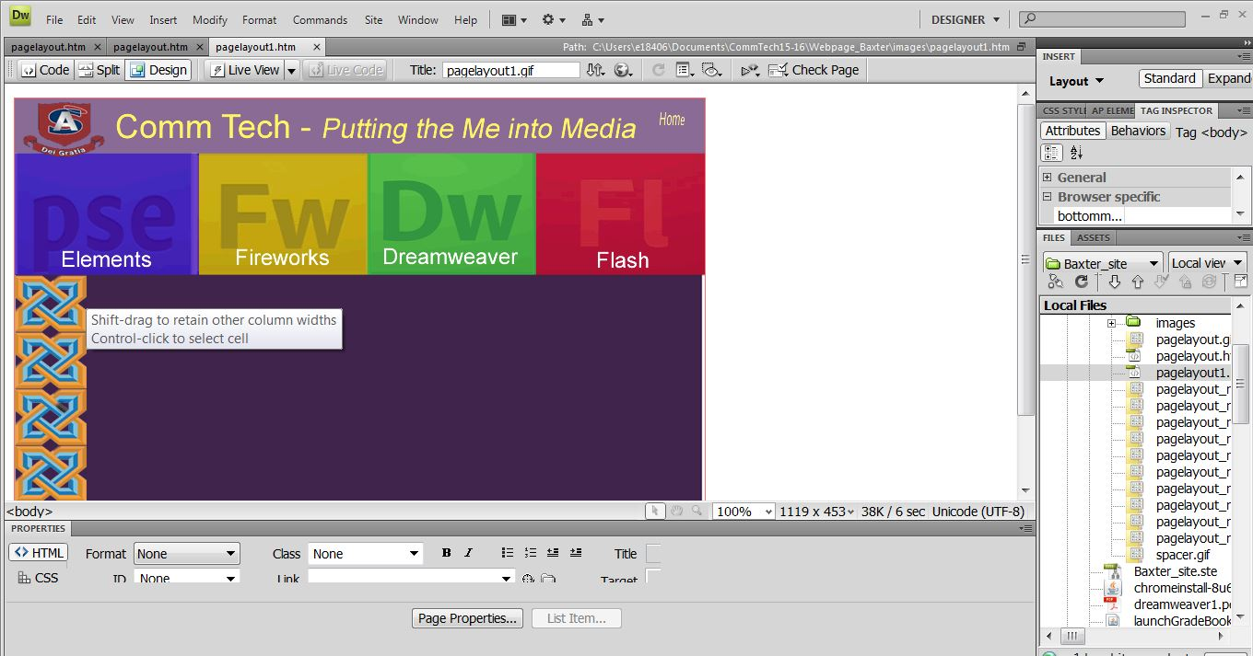

Save as all of the other pages the Other pages:
Be sure to name these pages appropriately and place them into your website folder.

