Creating Button Behaviors In Dreamweaver
Open your main template htm file in Dreamweaver.
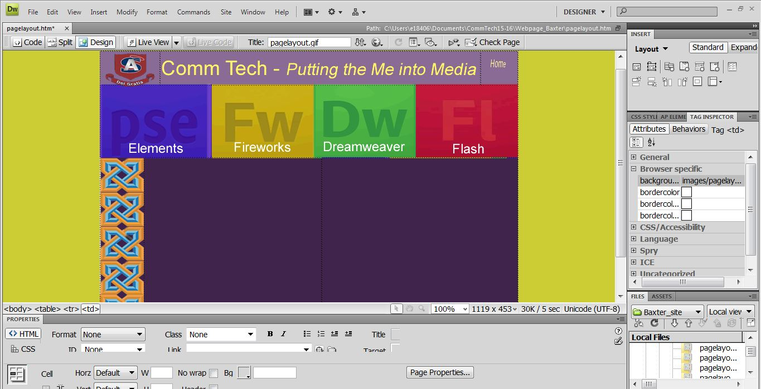

Open the Tag <img> by clicking on the arrow. With your first button selected, click the plus + sign to add a behavior.
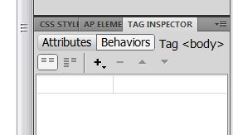
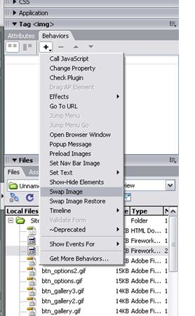

Select swap image from the behaviors list.
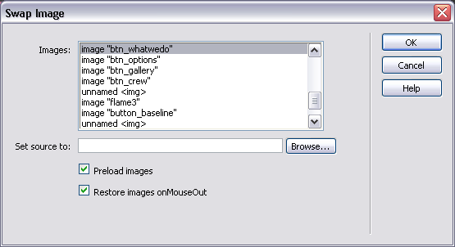

The swap image dialog box comes up. Browse for the replacement image.
Make sure this image you select is in your folder.
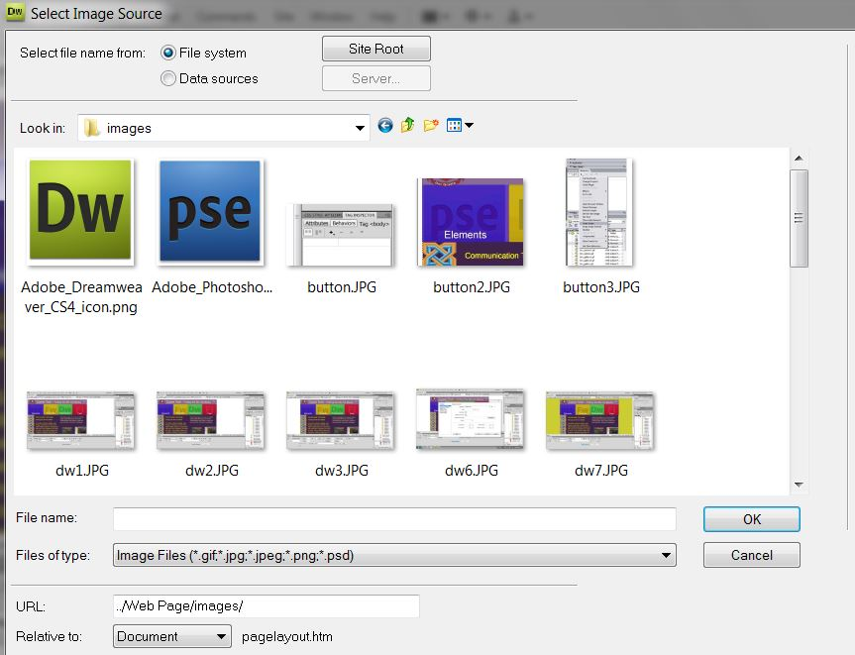

Select the rollover image. Click OK. Repeat this for the other three buttons.

