The Respiratory System
Cellular Respiration
- Cells in your body require _______________ to carry out activities like cell division, sending messages and transporting nutrients
- Where does the energy come from?
  - If you answered ____________, you’re partly right!
- Cells also need _____________ to release energy that is stored in food molecules like glucose
- This is done through a process called ___________ ________________
- Each time you _____________, you take in oxygen that your cells require to carry out cellular respiration
- __________ ________________ and water are produced in the process
- Your body gets rid of carbon dioxide every time you _____________ _______
- The function of the _______________ __________ is to allow this exchange of ____________ gas and carbon dioxide gas to occur
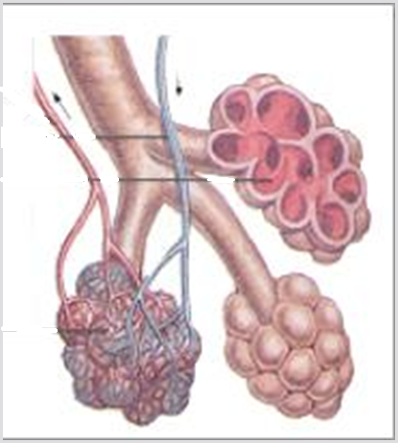
Respiratory System
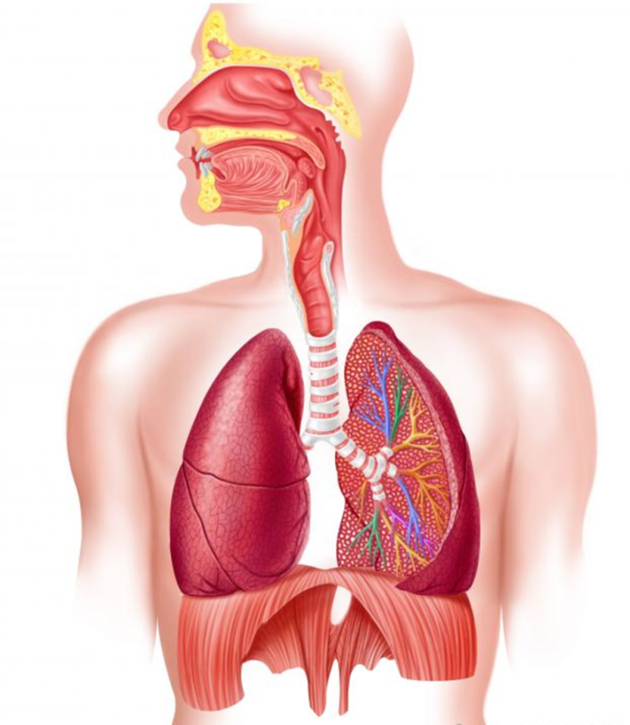

- The respiratory system includes many _____________ that work together to take up oxygen and get rid of __________ _______________
- Air travels through the _________ or mouth into the throat (pharynx) and then the _____________. The larynx contains vocal _________ that produce the sound of your voice as air moves through them
- The air continues down the ____________ and into two ____________ that lead to the left and right lung
- Smaller tubes called _______________ lead to the ____________ which are the site of gas exchange
Gas Exchange
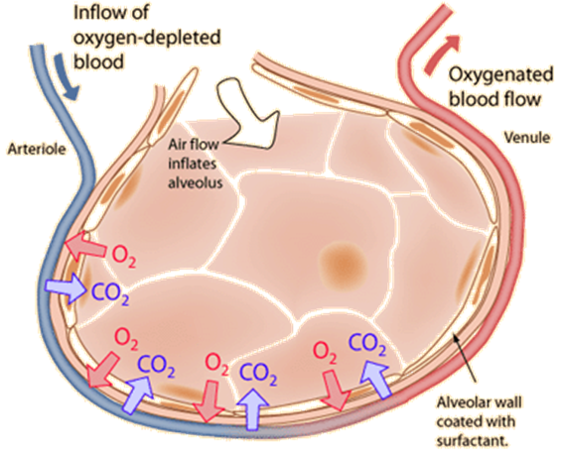
- Alveoli are surrounded by tiny blood vessels called _______________
- ________ _____________ occurs between the air in the alveoli and the __________ in the capillaries
- _______ ___________ cells take up oxygen from the air in the alveoli and give off ____________ _____________ from the body
- This carbon dioxide is _____________ with the next breath
Breathing Movements
Inhalation (inspiration) | Exhalation (expiration)
- Ribs are pulled _____ & _______  - diaphragm contracts and moves _____  - _____________ in lung volume Pressure in lung decreases, leads to _____________ of air  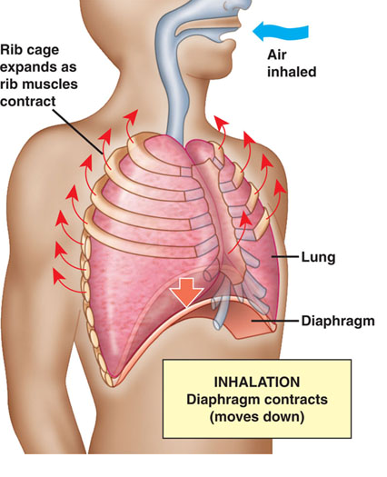 | - Ribcage __________  - Diaphragm _____________ and moves up  - ______________ in lung volume  - Pressure in lung increases, leads to a exhalation of ___________ (carbon dioxide)  

