POPULATION DYNAMICS
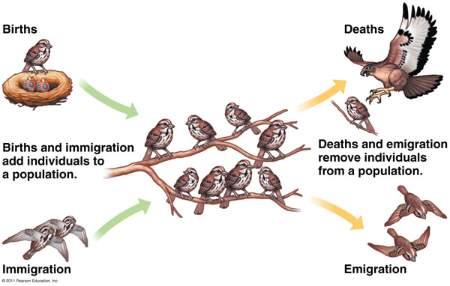
Population
- The __________________ of a species in a given area
Factors that affect population size:
- _____________________ (natality) +
- _____________________ (mortality) -
- _____________________ +
- _____________________ -

Population Growth
Growth = ( ______________ + __________________) - ( ___________________ + __________________)

Ex.) A moose population experiences 15 births and 5 deaths. 7 moose move into the area and 9 move out. What is the population growth?

Population Types
Open Population:
- All __________ factors affect (living things can ________ and _______)
- Eg: humans in Canada

Closed Population:
- Only __________ factors affect (birth/death)
- Living things __________ come and go
- Eg. Humans on earth

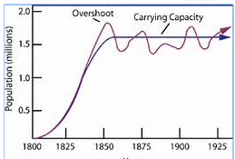
Graphing Population Growth:
- Carrying Capacity: the ______________________ number of individuals an ecosystem can support
- Determined by _________________________ ____________________________

Limiting Factors
- ______________________ that _____________________ the size to which a population can grow
- Density Independent Factors
  - Abiotic
  - ___________ _____________ depend on population size
  - Ecosystem’s ___________________
  - Ex: temperature, precipitation, sunlight, weather, living space, nutrients, water, oxygen
- Density Dependant Factors
  - Biotic
  - Depends on ________________________ _________________
  - Ex:
    - ______________________________ food, water, space
    - Disease
    - ______________________
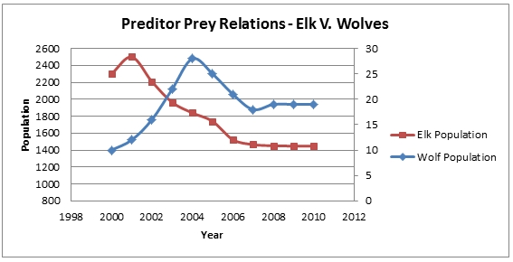
    - parasites
Predator Prey Relationships
What was the effect of killing off wolves in Yellowstone National Park?

How did re-introducing wolves affect Yellowstone National Park?

