Nutrient Cycles
Cycles
- Matter is ________________________ so the nutrients are continually _______________
- Nutrients are elements needed to make _____________, proteins, ___________, etc.
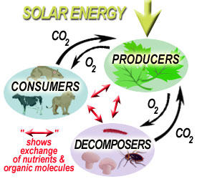
- The four (4) main nutrients needed for life on Earth are:
  - _____________________
  - _____________________
  - _____________________
  - _____________________

Water Cycle
- Water is used in many _________ _________________
- Makes up ______________ of your body!
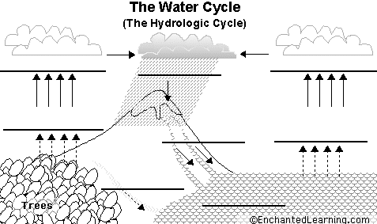
Evaporation: liquid into gas

Condensation: gas into liquid to form ____________

Precipitation: ____________

Run off: water _________ downwards

Accumulation: water ___________

Transpiration: evaporation off of _____________
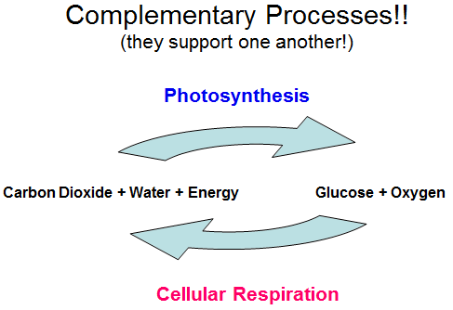

Carbon Cycle
- Carbon cycles through the atmosphere and organisms in _________________________ and ___________ ____________________
Carbon Storage:
- 1) The _______________________ - stored to be used by plants for ______________________________.
- 2) The _____________________ - dissolved so that _____________________ and other aquatic plants can also use it for photosynthesis.
- 3) On _____________________ in organisms, rocks and soil
- 4) The _________________ ______________- become part of ________________________ rock formations such as ______________________ OR stored as _______________ _____________ (coal, oil and natural gas)

Carbon Cycle (continued)
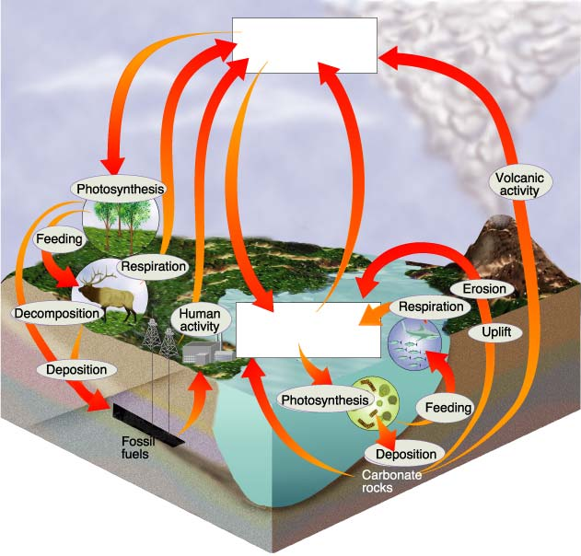
Human impacts on the Carbon Cycle
- By burning ________________ ____________ we are releasing large amounts of CO₂ into the atmosphere.
- Carbon dioxide is a ________________ ______ which increases the greenhouse effect (global warming)
- By cutting down _____________ we eliminate plants that can remove CO₂ from the atmosphere.

The Nitrogen Cycle
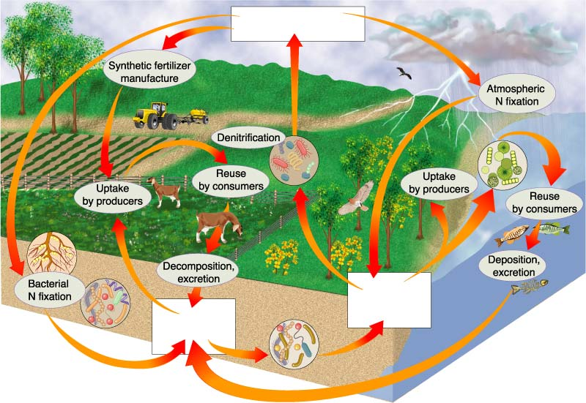

- ______________ of the atmosphere is nitrogen, but plants and animals _______________ use it in that form
- Special _____________ in the soil convert nitrogen into a form that plants can use
- Consumers (like us!) get our nitrogen by _____________________ those plants or other animals
- Nitrogen is often added to the soil with _______________________, but too much nitrogen can cause problems!

