The Lorax and Sustainability
Before Watching
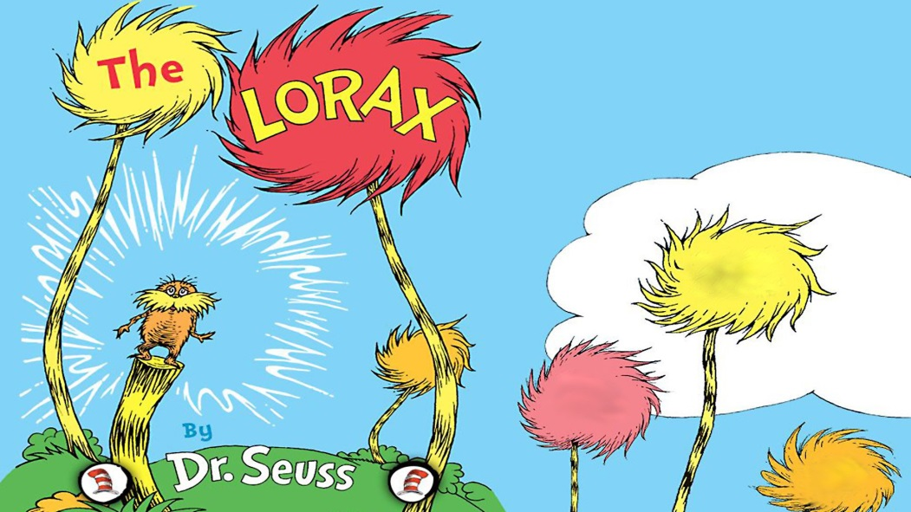
- Biodiversity: a measure of the __________________ of species on earth
  - The ___________________ the biodiversity, the more ________________ the ecosystem
- Sustainability: a biological environment that is able to thrive and __________________ itself ___________________

Questions (during and after watching)

- What is the natural resource that the Once-ler found?

- The Once-ler used the natural resource to start a business and sell a product. What was the product? How was it used by buyers?

- “I laughed at the Lorax, you poor stupid guy! You never can tell what some people will buy.” Do you agree with the Once-ler’s statement? Give an example of a real life “thneed”

- The use of natural resources often has an effect on the environment. How did the production of thneeds affect the biotic (Living) components of this ecosystem:

- Brown Bar-ba-loots

- Swomee-Swans

- Humming Fish

- Do you think the construction of the neighbourhood you live in had a negative effect on the ecosystem?

- Did the Once-ler try to prevent or stop the environmental effects of producing thneeds? Explain.

- Explain why the Once-ler’s business failed. How could he have sustained his business?

- Many human economic activies are planned only for the short term. Provide an example of a short term and a long term business. Which do you think is more beneficial?

- In the end the Lorax lifted himself away. Was this a good or bad decision? Explain.

- Before leaving, the Lorax left a final message “UNLESS.” What do you think he meant by it?

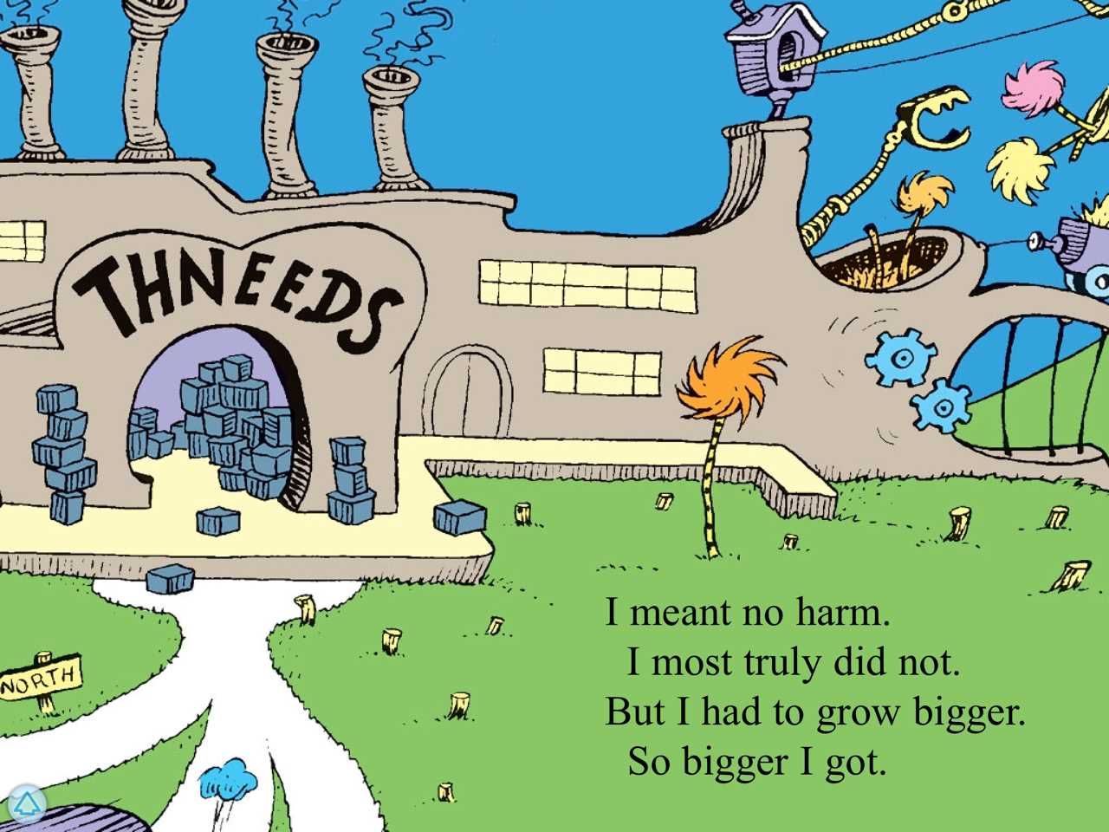

- Explain the overall message you think the movie was hoping to send.

